OPCAT Report
Report on an unannounced inspection of Tāwhirimātea Rehabilitation Unit, Rātonga-Rua-O-Porirua Campus, under the Crimes of Torture Act 1989
October 2021
Peter Boshier
Chief Ombudsman
National Preventive Mechanism
A3.a

OPCAT Report: Report on an unannounced inspection of Tāwhirimātea Rehabilitation Unit, Rātonga-Rua-O-Porirua Campus, under the Crimes of Torture Act 1989
ISBN: 978-1-99-115269-5 (PDF)
Published October 2021

This work is licensed under the Creative Commons Attribution 4.0 International License. To view a copy of this license, visit https://creativecommons.org

Office of the Ombudsman | Wellington, New Zealand | www.ombudsman.parliament.nz
Contents
Executive summary 7
Background 7
Summary of findings 7
Recommendations 9
Feedback meeting 9
Consultation 10
District Health Board response 10
Facility facts 12
Tāwhirimātea Rehabilitation Unit 12
Region 12
District Health Board 12
Operating capacity 12
Last inspection 12
The inspection 14
Inspection methodology 14
Inspection focus 15
Treatment 15
Protective measures 15
Material conditions 15
Activities and programmes 15
Communications 15
Health care 16
Staff 16
Evidence 16
Recommendations from previous report 16
Treatment 18
Torture or other cruel, inhuman or degrading treatment or punishment 18
Client accommodation 18
Seclusion 19
Seclusion policies and events 21
Restraint 22
Restraint training for staff 23
Electro-convulsive therapy 23
Sensory modulation 23
Clients’ views on treatment 24
Recommendations – treatment 25
Tāwhirimātea comments 25
Protective measures 26
Complaints process 26
Records 26
Recommendations – protective measures 28
Tāwhirimātea comments 28
Material conditions 29
Accommodation and sanitary conditions 29
Outdoor areas 29
Food 30
Recommendations – material conditions 31
Tāwhirimātea comments 31
Activities and programmes 33
Outdoor exercise and leisure activities 33
Programmes 34
Cultural and spiritual support 34
Recommendations – activities and programmes 35
Communications 36
Access to visitors 36
Access to external communication 36
Recommendations – communications 36
Tāwhirimātea comments 36
Health care 38
Primary health care services 38
Recommendations – health care 38
Staff 39
Staffing levels and staff retention 39
Recommendations – staff 39
Acknowledgements 40
Appendix 1. List of people who spoke with Inspectors 41
Appendix 2. Legislative framework 42

Tables
Table 1: Seclusion events 1 January 2020 – 30 June 2020 21
Table 2: Restraint data (exclusive of seclusion data) 1 January 2020 – 30 June 2020 22
Table 3: Unit occupancy 27
Table 4: List of people who spoke with Inspectors 41

Figures
Figure 1: Wooden partition separating a client’s bed from the hallway 18
Figure 2: Client’s storage (view from their bed) 18
Figure 3: Client’s room without natural light or adequate ventilation 19
Figure 4: De-escalation room in Te Whare Watea 20
Figure 5: Courtyard for Te Whare Watea 20
Figure 6: Female Sensory Modulation Room, being used for storage 24
Figure 7: Bathroom floor (due for renovation) 29
Figure 8: Renovated bathroom 29
Figure 9: Male outdoor area 30
Figure 10: Activities room 34

Executive summary

Background
Ombudsmen are designated as one of the National Preventive Mechanisms (NPMs) under the Crimes of Torture Act 1989 (COTA), with responsibility for examining and monitoring the conditions and treatment of clients detained in secure units within New Zealand hospitals.
Between 14 and 16 July 2020, two Inspectors — whom I have authorised to carry out visits to places of detention under COTA on my behalf — made an unannounced inspection of Tāwhirimātea Rehabilitation Unit (the Unit), which is located in the grounds of Rātonga-Rua-O-Porirua Campus, Porirua.

Summary of findings
My findings are:
- There was no evidence that clients had been subject to torture or other cruel or inhuman treatment or punishment.
- My Inspectors saw staff providing empathetic, tailored and responsive care to clients in de-escalation.
- There was a significant decrease in the use of seclusion since my 2016 Report.
- There was a significant decrease in the use of restraint since my 2016 Report.
- Clients reported feeling safe on the Unit and that staff treated them with respect.
- Information about the District Inspector, the Health and Disability Commissioner's Code of Health and Disability Services Consumers' Rights and the Unit’s complaints process was displayed across the Unit.
- Clients were invited to attend their Huihui Multi-Disciplinary Team Meetings (Huihui) and were provided with feedback of the outcomes of these meetings.
- Inspectors attended Huihui and observed them to be comprehensive and client-centred.
- There was a range of activities available to clients, both on and off the Unit.
- Cultural and spiritual support was evident and well received by clients.
- Access to visits and communication was good, including during COVID-19 Alert Levels 4, 3, and 2. Male clients had individualised phone plans and could make calls in private.
- Clients had access to primary health care services.
- Staff were identifiable on the Unit.
The issues that needed addressing are:
- Clients were sleeping in hallways, in a sensory modulation room, and in an office space without natural light, privacy or sufficient ventilation. In my opinion this may amount to degrading treatment and a breach of Article 16 of the United Nations Convention against Torture and other Cruel, Inhuman or Degrading Treatment or Punishment (‘Convention against Torture’).
- Multiple staff were not up-to-date with Safe Practice Effective Communication (SPEC) training at the time of inspection.
- Sensory modulation rooms were not operational during the inspection.
- The Unit’s process for stand-down periods was not clear to clients.
- Complaint forms were not available to clients without staff assistance.
- Not all files contained consent to treatment forms.
- Female clients without leave could not freely access the courtyard without staff supervision, due to a lack of fencing around the female outdoor area.
- Two clients’ bedrooms did not have privacy blinds.
- Some of the Unit’s furnishings were damaged, dirty and in need of repair or replacement.
- There was a blanket restriction on access to the kitchen, which adversely affected clients’ ability to access hot water for drinks.
- Female clients could not access the telephone independently of staff.

Recommendations
I recommend that:
- Clients are never accommodated in hallways, sensory modulation rooms, or rooms without natural light or sufficient ventilation. This is an amended repeat recommendation.
- All relevant staff are up-to-date with their SPEC training.
- Both sensory modulation rooms are operational, advertised and available to clients throughout the day.
- The Unit clarifies its policy and procedures for stand-down periods, and shares this information with clients.
- Complaint forms are available to clients, independent of staff.
- Clients’ consent to treatment forms are completed on admission and any other time consent is sought, and any refusal of consent is recorded in their files. This is an amended repeat recommendation.
- The Unit erect fencing around the female outdoor area to enable clients to freely access the courtyard without staff supervision.
- Clients’ bedrooms have internal privacy blinds installed in the observation panel.
- Clients’ bedrooms have appropriate storage facilities where clients can store their belongings.
- Clients can freely access hot drinks, unless deemed unsafe based on individual risk assessment.
- All clients have access to a telephone, independent of staff, unless deemed unsafe based on individual risk assessment.

I intend to monitor the implementation of my recommendations, including conducting follow-up inspections at future dates.

Feedback meeting
On completion of the inspection, my Inspectors met with representatives of the Unit’s leadership team, to outline their initial observations.
The Service’s Operations Manager and the Acting Director of Area Mental Health Services Forensic and Rehabilitation Service provided Inspectors with additional information about this and two other Te Korowai Whāriki Units inspected at the same time.
They told my Inspectors they faced challenges with COVID-19, recruitment, and service demand. They were aware of a growing waitlist of acutely unwell people in prisons and the community, compounded by patients being directed to the Service by Courts. They said this resulted in:
- patients being admitted to the Service with high needs, requiring more staff attention than those admitted in a timely manner;
- a shortfall of beds, leaving patients accommodated in spaces other than bedrooms, affecting their dignity and privacy;
- increased risks to patients and staff, and
- diminishing staff morale.

Consultation
A provisional report was forwarded to the District Health Board for comment as to fact, finding or omission prior to finalisation and distribution.

District Health Board response
The Capital and Coast District Health Board (the DHB) received a copy of my provisional report and were invited to comment. The DHB responded and I have had regard to that feedback when preparing my final report.
The DHB’s letter and comments responded to a number of common themes from my inspections of the Unit and two other units in the DHB which were conducted at the same time, in particular around the use of seclusion rooms as bedrooms and ongoing reliance on night safety procedures (NSPs).
The DHB emphasised that they considered the reports provided evidence of unmet need within the forensic mental health services. The DHB noted the legal requirement to admit from court and the high acuity of the prison waitlist are such that the bed capacity in the forensic mental health service is continually exceeded. Many of the responses to the recommendations also highlight significant financial pressure on the DHB and indicate the need for additional funding to achieve the recommendations.
While I acknowledge that funding may be a barrier, my role as an NPM is to report on the conditions and treatment for people who are being detained, as they are at the time of the inspection. I have, however, highlighted these concerns with the Ministry of Health. I also intend to conduct follow up inspections of all the Units.

Facility facts

Tāwhirimātea Rehabilitation Unit
Tāwhirimātea Rehabilitation Unit (the Unit) is a 29-bed rehabilitation mental health unit, with a focus on recovery and extended rehabilitation.
Clients receive mental health services provided by Capital and Coast District Health Board’s (DHB’s) Te Korowai Whāriki – Regional Rehabilitation and Extended Care Inpatient Service (The Service).
Admission to the Unit is from other forensic inpatient units in the central region of New Zealand. Clients are admitted under the Mental Health (Compulsory Assessment and Treatment) Act 1992 (MHA) or the Criminal Procedure (Mentally Impaired Persons) Act 2003 (CPMIP Act).
The Unit is a locked facility. There is an area for male clients with 23 beds and an area for female clients with six beds. The de-escalation area (Te Whare Watea) has three rooms: two used for de-escalation and one used for seclusion.
The Unit is located in the grounds of Rātonga-Rua-O-Porirua Campus in Porirua.

Region
Wairarapa, Hutt Valley, Capital & Coast, Hawke’s Bay, Midcentral, Whanganui, and Tairāwhiti

District Health Board
Capital and Coast District Health Board

Operating capacity
29 beds (plus one seclusion room and two de-escalation rooms)

Last inspection
Unannounced inspection – February 2016
Unannounced follow up inspection – June 2012
Unannounced inspection – September 2011

The inspection
Two Inspectors conducted the inspection of the Unit between 14 and 16 July 2020. On the first day of the inspection, there were 29 clients on the Unit, comprising 23 males and six females. The average length of stay for the preceding six months was 707 days.
At the time of inspection, New Zealand was at COVID-19 Alert Level 1.

Inspection methodology
At the beginning of the inspection, Inspectors met with the Acting Team Leader, before being shown around the Unit.
Inspectors requested the following information during and after the inspection:
- a list of clients and the legal authority for their detention (at the time of the inspection);
- the seclusion and restraint data from 1 January 2020 to 30 June 2020, and the seclusion and restraint policies;
- any meetings/reports relating to restraint, seclusion minimisation, and adverse events;
- records of staff mandatory training, including Safe Practice Effective Communication training (SPEC);
- client absent without leave (AWOL) events from 1 January 2020 to 30 June 2020;
- complaints received from 1 January 2020 to 30 June 2020, a sample of responses and associated timeframes, and a copy of the complaints policy;
- copy of minutes of client group meetings from 1 January 2020 to 30 June 2020;
- activities programme;
- information provided to clients and their whānau on admission;
- incident reports relating to medication errors from 1 January 2020 to 30 June 2020;
- staff sickness and retention data for the previous three years;
- staff vacancies at time of inspection (role and number); and
- data on staff, categorised by profession.

Inspection focus
The following areas were examined to determine whether there had been torture or other cruel, inhuman or degrading treatment or punishment, or any other issues impacting adversely on clients.

Treatment
- Torture or other cruel, inhuman or degrading treatment or punishment
- Seclusion
- Seclusion policies and events
- Restraint
- Environmental restraint
- Restraint training for staff
- Electro-convulsive therapy (ECT)
- Sensory modulation
- Clients’ views on treatment

Protective measures
- Complaints process
- Records

Material conditions
- Accommodation and sanitary conditions
- Food

Activities and programmes
- Outdoor exercise and leisure activities
- Programmes
- Cultural and spiritual support

Communications
- Access to visitors
- Access to external communications

Health care
- Primary health care services

Staff
- Staffing levels and staff retention

Evidence
In addition to the documentary evidence provided at the time of the inspection, Inspectors spoke with a number of managers, staff, clients, and whānau.
Inspectors also reviewed client records, were provided additional documents upon request by the staff, and observed the facilities and conditions.

Recommendations from previous report
Inspectors also followed up on eight recommendations, following an inspection to the Unit in 2016 (2016 Report), which were:
  - As a matter of urgency, a more appropriate facility needs to be sourced for the client living in a seclusion room on a permanent basis.
  - The seclusion register and de-escalation register should be fully maintained and a quality assurance framework applied to the completion of all seclusion and de-escalation paperwork.
  - Section 76 reviews should be completed in a timely manner.
  - A copy of the clients’ consent to treatment form should be placed in their personal file.
  - The DHB’s complaints process should be readily available in the Unit.
  - Office space should not be used (as a bedroom) to accommodate clients when there are no beds available in the main Unit.
  - The door leading into the garden should remain open throughout the day and clients should have greater access to the games room.
  - Staff should be easily identifiable to clients and visitors.
The Unit’s adoption, or not, of these prior recommendations is referred to in the relevant sections of this report.

Treatment

Torture or other cruel, inhuman or degrading treatment or punishment
There was no evidence any client had been subject to torture or other cruel or inhuman treatment or punishment. However, I found evidence of degrading treatment.

Client accommodation
On the first day of inspection, two clients were each living at the end of two hallways in the male area of the Unit. Inspectors were told these clients had been sleeping in hallways for at least four weeks because of renovations on the Unit. Staff told Inspectors this was a pragmatic solution to complications caused by the renovations.
These clients had no privacy, with a small wooden barrier partly separating their beds from the rest of the hallway. The clients’ belongings were stored in filing cabinets, and the hallway windows did not have curtains. Because there were no lockable doors or duress alarms, these two clients had no physical security from other clients on the Unit.
Inspectors raised concerns about this with senior DHB management on the first day of inspection. They said they were unaware of clients being accommodated in the hallways of the Unit. By the second day of inspection, the Unit had moved these clients to other facilities across the Service.
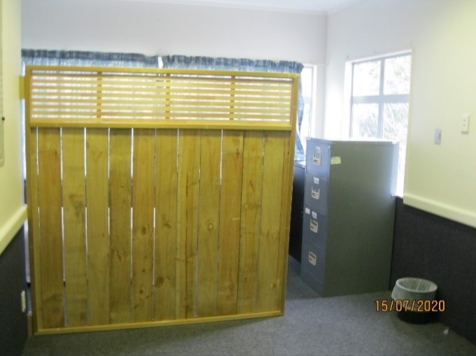 |  | 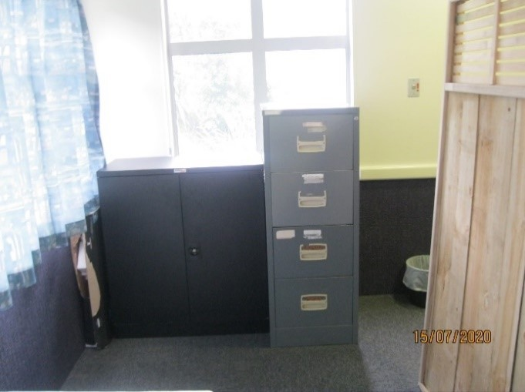
Figure 1: Wooden partition separating a client’s bed from the hallway |  | Figure 2: Client’s storage (view from their bed)
During the inspection, another client was living in the sensory modulation room in the male area of the Unit. This client’s belongings were stored on a table and in a filing cabinet. Staff told Inspectors this was also because of the renovation work on the Unit.
The Unit was also accommodating a client in a room designed as an office. The room was stark, without any natural light or adequate ventilation. It was located off a busy thoroughfare, and there was no storage for the client’s belongings. Inspectors were told this client was in the process of transitioning out of de-escalation into the male area.
I consider it inherently degrading for clients to sleep in a hallway, sensory modulation room, or other space not designed as a bedroom. Moreover, these living situations had the potential to cause significant physical and psychological harm, and compromise the dignity and wellbeing of these clients.
Accordingly, I consider that the use of hallways, sensory modulation rooms, and other non-designated rooms as bedrooms in this instance may amount to degrading treatment and a breach of Article 16 of the Convention against Torture.
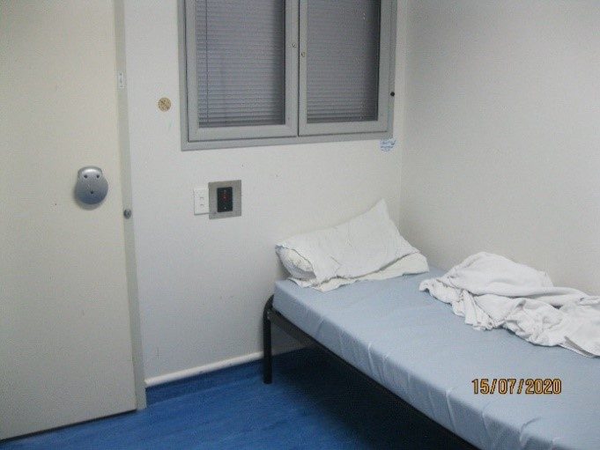
Figure 3: Client’s room without natural light or adequate ventilation

Seclusion

Seclusion and de-escalation facilities: Te Whare Watea
The Unit had one dedicated seclusion room. Since my 2016 Report, the Unit had decommissioned two seclusion rooms and had converted them into de-escalation rooms.
The seclusion room and the two de-escalation rooms were located in Te Whare Watea, a separate area within the Unit. Repairs and painting had been carried out in this area since my last inspection.
While the seclusion room was basic, it had adequate light, heat, and ventilation.
Each of the de-escalation rooms in Te Whare Watea had a bed plinth, a mattress and bedding. The rooms had adequate natural light and ventilation. However, at the time of inspection, the rooms were noticeably colder than the rest of the Unit. One client was using a towel to block a draught.
Neither the seclusion room nor the two de-escalation rooms had toilet facilities. Inspectors were told that clients in seclusion were escorted to the toilet when needed, even if three staff were required to escort the client. A review of recent seclusion paperwork showed clients were escorted to the bathroom when needed.
Te Whare Watea was equipped with an external courtyard and a lounge. At the time of inspection, the courtyard door was open and clients could freely access fresh air. The roof of the courtyard was open, covered in wire mesh for security. While the courtyard in Te Whare Watea was clean and well-maintained, and had a small vegetable garden, it was otherwise stark and dreary.

Care of clients in Te Whare Watea
There were two clients under 1:1 continuous observations during the inspection. My Inspectors saw staff providing empathetic, tailored and responsive care to these clients.
I was pleased to find that the lounge area in Te Whare Watea was well utilised. During the inspection, Inspectors saw clients eating meals in the lounge area. Additionally, clinical notes indicated that clients often relaxed, watched television, and engaged with staff in the Te Whare Watea lounge.
No clients were in seclusion at the time of inspection.
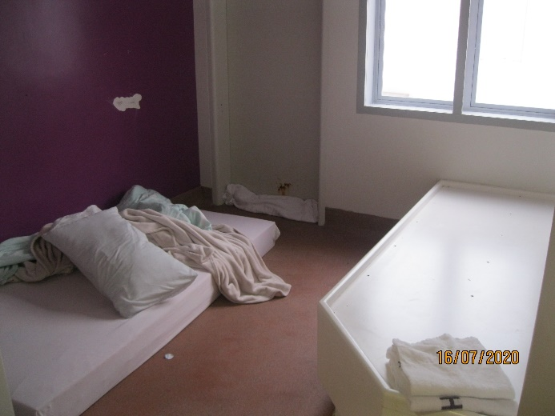 |  | 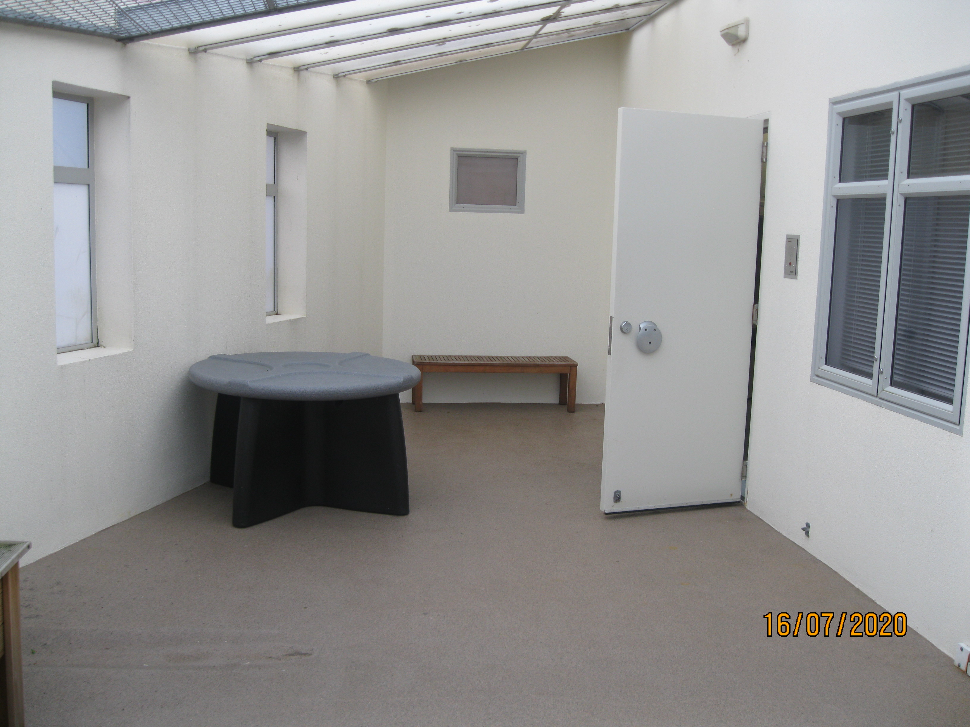
Figure 4: De-escalation room in Te Whare Watea |  | Figure 5: Courtyard for Te Whare Watea

Seclusion policies and events
The DHB provided Inspectors with its Seclusion Policy (dated 17 September 2015). The Seclusion Policy had a review date of 10 September 2020.
Data provided by the Service indicated that, in the six months from 1 January 2020 to 30 June 2020, there were six incidents of seclusion involving four clients.
In my previous report, data provided over six-month period (30 June 2015 – 29 January 2016) showed 42 seclusion events involving 11 clients.
I was pleased to see this significant reduction in the use of seclusion. This appeared to be reflective of the Unit’s proactive effort to eliminate the use of seclusion, led by the Charge Nurse Manager and supported by the wider team.
Inspectors observed a zero seclusion meeting on 15 July and found it to be robust, insightful and informative. The Unit kept – and shared amongst staff – thorough data on seclusion events, which included an analysis of seclusion by ethnicity, and the factors that drove the use of seclusion. The Unit had also developed a plan to reduce Māori seclusion rates, which included implicit bias training for staff and increasing whānau engagement.
The Unit fully maintained its seclusion register, as I recommended in my 2016 Report. Seclusion protocols were robust, with relevant staff notified of each event. Each client file my inspectors reviewed showed seclusion events were documented appropriately.
The total seclusion time for the six-month period (1 January 2020- 30 June 2020) was recorded as 68.24 hours. This was broken down as follows:
Table 1: Seclusion events 1 January 2020 – 30 June 2020
Month | Events | Client numbers | Hours | Average hours
January | 1 | 1 | 4.83 | 4.83
February | 0 | 0 | 0 | 0
March | 2 | 2 | 10.58 | 5.29
April | 0 | 0 | 0 | 0
May | 3 | 1 | 52.83 | 17.61
June | 0 | 0 | 0 | 0
Total: | 6 | 4 | 68.24 | 11.37

Restraint
Inspectors were provided with the DHB’s Restraint Minimisation & Safe Practice document (dated May 2020). The procedure had a review date of November 2023.
Inspectors were told that staff used restraint only as a last resort with clear justification. A review of files supported this claim.
Data provided by the Service showed that seven clients – six male and one female – were subject to 11 restraint events between 1 January and 30 June 2020. Two restraint events were recorded as personal restraint and nine were recorded as environmental restraint. This was a significant decrease in the use of restraint since my 2016 Report. At that time, the Unit had recorded 118 incidents of restraint involving 52 clients in a six-month period (1 July 2015 to 31 January 2016).
Inspectors were told the Unit documented all incidents of restraint on its restraint register and on clients’ files, and that the Charge Nurse Manager would follow-up restraint incidents with each staff member and client involved, and would notify whānau. My Inspectors saw evidence of this on client files and in the restraint register. These records were kept to a very high standard.
Table 2: Restraint data (exclusive of seclusion data) 1 January 2020 – 30 June 2020
 | January | February | March | April | May | June
Total restraint events | 0 | 3 | 3 | 0 | 2 | 3
Total clients restrained | 0 | 2 | 2 | 0 | 1 | 2
Personal restraint | 0 | 2 | 0 | 0 | 0 | 0
Environmental restraint | 0 | 1 | 3 | 0 | 2 | 3
Number of males restrained | 0 | 1 | 2 | 0 | 1 | 2
Number of females restrained | 0 | 1 | 0 | 0 | 0 | 0
Youngest person restrained (years) | N/A | 40 | 35 | N/A | 40 | 40
Oldest person restrained (years) | N/A | 57 | 39 | N/A | N/A | 54

Restraint training for staff
Multiple staff were not up-to-date with Safe Practice Effective Communication (SPEC) training. Inspectors were told that two staff were yet to complete SPEC training due to medical conditions; four staff were on leave during the training dates; and two staff members had their training cancelled due to the COVID-19 pandemic. Another six staff were physically unable to complete SPEC training. Inspectors were satisfied that these staff members were not permitted to become involved in restraint events.
While I understand the COVID-19 pandemic has caused disruption to the Unit – and to the Service generally – it is my expectation that all staff involved with restraints are up to date with SPEC training.

Electro-convulsive therapy
There were no clients undergoing Electro-convulsive therapy (ECT) on the Unit at the time of the inspection.

Sensory modulation
The Unit had two Sensory Modulation Rooms, one in the male area and another in the female area. Neither sensory modulation room was operational during the inspection.
A client was being accommodated in the sensory modulation room in the male area (discussed under ‘Seclusion’ above). The sensory modulation room in the female area was being used as a storage room and was not sufficiently equipped for sensory modulation purposes at the time of inspection. Staff informed my Inspectors of their intention to develop the sensory modulation room in the female area. I look forward to seeing progress in this area.
Each client received a sensory assessment as part of their induction process to the Unit by the Occupational Therapist (OT). This assessment was then transferred into each client’s wellness plan.
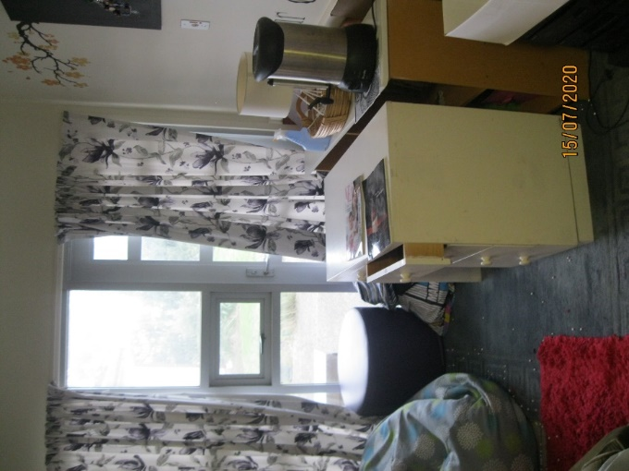
Figure 6: Female Sensory Modulation
Room, being used for storage
Unit staff told Inspectors that every staff member was trained to use the sensory modulation rooms.

Clients’ views on treatment
Clients told Inspectors they felt safe on the Unit, and that staff were approachable and respectful. Inspectors saw positive interactions between clients and staff.
Some clients raised concerns about ‘three day stand-down periods’, imposed if they were suspected of using drugs or were late returning from leave. These stand-down periods prevented clients from leaving the Unit to participate in their usual activities, such as canteen shopping or community outings.
Clients would be verbally informed of their placement on a stand-down period. However, the Unit had not clarified the policies and procedures surrounding stand-down periods with clients. Clients told inspectors they did not fully understand the stand-down process, and had raised concerns with the District Inspector (DI). Unit staff told Inspectors that stand-down periods were clinical decisions aimed at managing risk and were not intended to be punitive.
The Unit ran weekly community meetings, facilitated by the OT. The meetings were advertised across the Unit and were well attended by both clients and staff. Female clients would be escorted to the male area so that all clients could attend meetings together. The Unit provided Inspectors with one set of community meeting minutes. Issues raised in that meeting included a lack of fencing for the female outside area, limited hot water in showers, a lack of hot drinks, and the lack of sensory modulation rooms available to clients. The minutes indicated that staff were to raise these issues with unit management. I look forward to seeing the Unit’s response to client feedback.
The Consumer Engagement Advisor regularly visited the Unit, and gave senior management a written record of feedback they had received from clients.

Recommendations – treatment
I recommend that:
- Clients are never accommodated in hallways, sensory modulation rooms, or rooms without natural light or sufficient ventilation. This is an amended repeat recommendation.
- All relevant staff are up-to-date with their SPEC training.
- Both sensory modulation rooms are operational, advertised, and available to clients throughout the day.
- The Unit clarifies its policy and procedures for stand-down periods, and shares this information with clients.

Tāwhirimātea comments
The DHB accepted recommendations 1 to 4, noting that alternative living accommodation has been provided, all staff are scheduled to complete SPEC training by the end of 2021, sensory modulation rooms would be ready in April/May 2021, and the stand-down procedure is under review.

Protective measures

Complaints process
A copy of the DHB’s Consumer Complaints, Advocacy and Code of Rights policy (the Complaints Policy) (dated November 2016) was provided to Inspectors. The Complaints Policy was due for review on 7 November 2019.
The Unit displayed information about the complaints process to clients and visitors, as per my recommendation in my 2016 Report. Clients my Inspectors spoke with understood how to make a complaint along with the complaints process generally. However, there were no complaints forms available from which a complaint could be lodged. I encourage the Unit to ensure that complaints forms are available to clients and visitors at all times, independent of staff. I acknowledge that the Service publicises their complaints process on their website.
Staff told Inspectors that the Unit sent all complaints to the Quality and Risk Team, which the Team Leader then logged and reviewed.
The Unit received four complaints between 1 January and 30 June 2020. Two of these complaints related to staff treatment of clients, one related to property, and one was from whānau and related to visiting a client. Overall, the responses were timely, polite, individualised, and addressed the issues raised in detail.
District Inspector (DI) contact details and posters for the Health and Disability Commissioner’s Code of Health and Disability Services Consumers' Rights were displayed throughout the Unit. Information on the role and functions of the DI was also available on the Unit and in clients’ induction packs.
Inspectors observed that the DIs maintained a strong presence on the Unit, and knew of the issues within the Unit. Clients knew who the DIs were and how to contact them. Inspectors spoke with a client who made complaint to a DI, who had responded and followed up the complaint with the Unit. Inspectors were satisfied with this process and the DI’s response to the complaint.

Records
Inspectors were informed that on the first day of inspection all 29 clients were detained under the Mental Health (Compulsory Care and Treatment) Act 1992 (MHA). Inspectors reviewed a sample of files, all of which contained the necessary paperwork to detain and treat the clients.
Inspectors reviewed clients’ recovery plans, leave paperwork, clinical notes, and clinical review meeting minutes. Files were thorough and organised. Clients’ family and whānau contacts were comprehensive and clearly documented on file.
Client files contained up-to-date copies of their detaining paperwork. The Unit completed section 76 reviews (Certificate of Clinical Review of Conditions of Patient Subject to Compulsory Treatment Order) in a timely manner. I am pleased to note this improvement since my 2016 Report.
My Inspectors also reviewed clients’ files for evidence of completed consent to treatment forms for those under the MHA. While clients on the Unit are not there voluntarily, consent to treatment must be sought wherever possible. Where a client does not consent to treatment, this should be recorded on their file and in clinical notes. Unfortunately, not all files contained completed consent to treatment forms. I encourage the Unit to seek consent to treatment from clients wherever possible and, if this is not possible, to record where a client withholds their consent to treatment. I raised this issue in my 2016 Report.
The Unit ran fortnightly Forensic Client Issues meetings and three-monthly Multi-Disciplinary Team Meetings (referred to as Huihui). Clients were invited to attend their Huihui. The Unit had a robust feedback system for clients who declined the invitation to their Huihui, with each client’s care worker required to provide an account of the meeting. Inspectors attended Huihui, and saw an effective, client-centric, multi-disciplinary approach. Future responsibilities and delegations were clear to all attendees, and clients were updated of progress made before, during, and after each Huihui.
The Unit consistently operated at close to capacity (as seen in Table 3: Unit occupancy). Staff noted that some clients had been in the Unit for over three years due to lack of suitable alternative placements.
Table 3: Unit occupancy
 | January | February | March | April | May | June
Occupancy | 97.7% | 97.75% | 99.0% | 100.1% | 99.8% | 88.5%
Occupancy (Incl. leave) | 99.3% | 100.6% | 106.9% | 100.1% | 99.8% | 95.4%

Recommendations – protective measures
I recommend that:
- Complaint forms are available to clients, independent of staff.
- Clients’ consent to treatment forms are completed on admission and any other time consent is sought, and any refusal of consent is recorded in their files. This is an amended repeat recommendation.

Tāwhirimātea comments
The DHB accepted recommendations 5 and 6.
The DHB’s response included the following comment regarding recommendation 5:
Complaint forms are available to all clients on the Unit. All document holders around the Unit are checked and replenished with the complaint forms as required. Clients are also able to request forms from staff if they wish. Written complaints do not need to be made on a complaint form but can be submitted on any piece of paper. Clients are able to make a verbal complaint if they wish. Consultation with the Advocacy service and with the District Inspectors who visit regularly, is encouraged.
Ombudsman response:
I welcome the DHB’s response, as there were no complaints forms available for clients at the time of the inspection. I look forward to seeing complaint forms freely available in the Unit on future inspections.
In response to recommendation 6, the DHB advised regular auditing of consent forms would be completed by the Clinical Nurse Specialist or Key Worker, and a flag can now be added to clinical notes where necessary.

Material conditions

Accommodation and sanitary conditions
The Unit, which opened in 2000, had a mixed standard of cleanliness. Not all of the Unit’s carpets were clean, and furnishings were dirty and in need of repair or replacement. Many of the Unit’s bathrooms were in need of an upgrade. Renovation work was underway during the inspection, and all bathrooms in need of repair were scheduled for improvements. The Unit comprised two separate areas: the male area with 23 beds, and the female area with six beds. While most of the designated bedrooms had natural light and ventilation, none of the bedrooms had en-suite facilities. Clients were able to lock their bedroom doors, both from the inside and outside. Privacy curtains were not installed across observation windows on two of the bedrooms. Moreover, some bedrooms lacked sufficient storage facilities, with some clients storing their personal belongings in plastic tubs or filing cabinets. I urge the Unit to install suitable privacy blinds, along with appropriate storage facilities, to these rooms.
Inspectors were told that it was difficult for staff to interview clients in appropriate settings because some of the Unit’s original office rooms had been converted into bedrooms. Inspectors experienced this difficulty first hand, and had to conduct interviews in the lounge and activities areas.
The male and female area each had a dining area, toilets, a phone booth, a laundry room, linen storage and a kitchenette. Each area had its own lounge with a television, couches, and activities available to the clients. Clients could freely access these lounges. The male area had a reasonably sized games room, which I am pleased to see was open throughout the day, as I recommended in my 2016 Report.
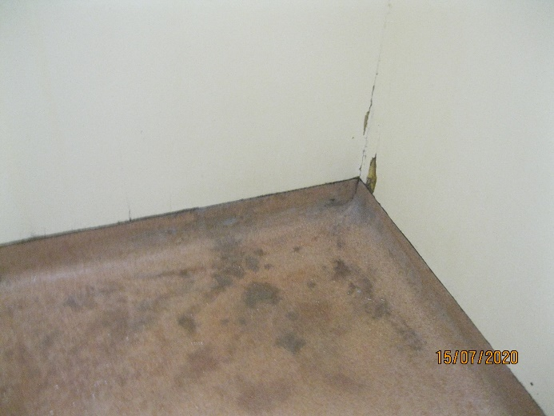 |  | 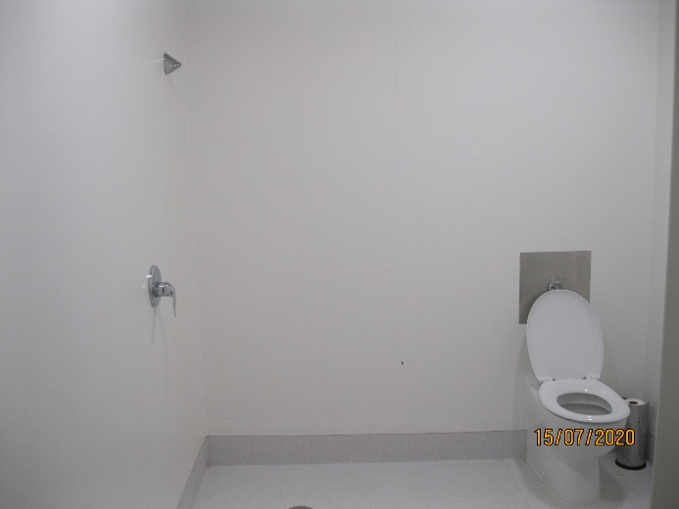
Figure 7: Bathroom floor (due for renovation) |  | Figure 8: Renovated bathroom

Outdoor areas
Both male and female areas had dedicated outdoor areas. I was pleased to note that the door to the male outdoor area was open throughout the day, as I recommended in my 2016 Report.
However, female clients without approved leave could not freely access fresh air. This was due to a lack of secure fencing around the female outdoor area. To allow female clients without leave access to outdoor areas and fresh air, staff had to escort the female clients to the male outdoor area. Clients and staff raised these concerns with my Inspectors. Inspectors were told this access was dependant on staff availability. While I acknowledge the importance of mitigating risk and ensuring clients’ safety, I am of the view that all clients should have access to fresh air and outside space independent of staff. Fencing the female outdoor area would allow this.
Staff told my Inspectors that they viewed the Unit as dated and no longer fit for purpose. Staff complained of a poor design, which made observing clients difficult. I acknowledge that the Unit was in the process of replacing its bathrooms and toilets. However, despite this renovation work, I consider the Unit design is dated and does not provide optimal opportunities for rehabilitation and promoting wellness.
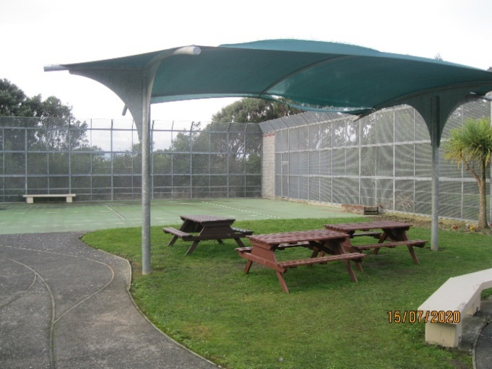
Figure 9: Male outdoor area

Food
Clients’ meals were transported from the main hospital kitchen and delivered to the Unit in heated trolleys. All meals were provided in each dining area (clients in Te Whare Watea could eat their meals in the lounge or in their rooms). Breakfast was delivered at around 8am, lunch at 1pm, and dinner around 5pm. During morning tea, afternoon tea, and supper, clients were provided with a range of snacks, including healthy options such as fruit and yoghurt, and hot drinks.
Clients were offered a choice of meals at the beginning of each month. However, clients told Inspectors that they often could not remember what they had ordered for the month’s meals because the Unit did not provide clients with a copy of their meal choices. I encourage the Unit to provide clients with a copy of their meal choices.
The dining area in the male area was locked outside of meal times. Clients were unable to access kitchen facilities to make their own hot drinks during the day. Staff advised Inspectors that hot drinks were available for clients at specified times during the day, however, upon a review of community meeting minutes, I note that clients have requested more opportunities to have hot drinks in addition to the morning and afternoon tea provided.
I acknowledge the view that there is a safety rationale behind this restriction. However, the current process disadvantaged all clients as it applied to everyone regardless of safety risk. I consider that free access to hot drinks should be facilitated based on individual risk and subject to regular review.

Recommendations – material conditions
I recommend that:
- The Unit erect fencing around the female outdoor area to enable clients to freely access the courtyard without staff supervision.
- Clients’ bedrooms have internal privacy blinds installed in the observation panel.
- Clients’ bedrooms have appropriate storage facilities where clients can store their belongings.
- Clients can freely access hot drinks, unless deemed unsafe based on individual risk assessment.

Tāwhirimātea comments
The DHB accepted recommendations 7 to 9, noting that a funding request for the fencing to progress was resubmitted in February 2021, privacy blinds or curtains will be installed in the observation panel of the two clients' bedrooms identified, and that bedrooms without appropriate storage facilities will have appropriate storage facilities installed or fitted.
The DHB rejected recommendation 10. The DHB’s response included the following comment regarding recommendation 10:
The safety risks associated with free access to hot drinks are well-recognised in secure environments. Tāwhirimātea is a minimum secure admission unit for the rehabilitation of clients with high and complex needs. It also provides extended care to a small group for whom rehabilitation is an unreasonable expectation and step-down care for those on a forensic rehabilitation pathway. It is a large facility, accommodating almost 30 clients. Given the complexity, varying acuity and high degree of need and care required for the majority of client group, the normative expectation in Tāwhirimātea is of hot drinks being available upon request. We consider this to be a necessary and proportionate response to maintain a safe environment. Staff are able to relax this (and do) when it is inappropriate to the care of an individual client and does not compromise the overall safety of the unit, by facilitating supervised access to hot drinks. Additional consideration is required of the risks to physical and mental health of unlimited access to hot drinks (caffeine/sugar). Hot drinks are routinely available with main meals, in addition to morning and afternoon tea and supper.
Ombudsman response:
I acknowledge the DHB’s safety concerns and the practical realities of what is needed to keep service users and staff safe. However, it is not clear to me why a hot drink made by a staff member is less likely to cause injury than one made by a client. The current policy on the Unit disadvantaged all clients as it applied to everyone irrespective of safety risk.
My Inspectors’ observations are that there is not a consistent approach to this issue across all facilities in the country. Providing clients the opportunity to make their own hot drinks also promotes independence and autonomy.
I therefore remain of the view that free access to hot drinks should be available for all clients unless deemed unsafe based on an individual risk assessment.

Activities and programmes

Outdoor exercise and leisure activities
Inspectors saw a wide range of activities were available to clients, both on and off the Unit.
Each client had a personalised timetable of meaningful activities to promote social inclusion and personal development. Each client’s programme was advertised on the inside of their bedroom door and included both group and 1:1 activities. Group activities were displayed throughout the Unit.
Inspectors’ review of Huihui and Care Plans showed that clients had appropriate access to leave. Clients told Inspectors they enjoyed being able to take leave, which included staying with and visiting whānau, van rides, and visiting the local shops. During the course of the inspection, a number of clients were on leave.
The Unit had a dedicated art room and provided board games, puzzles, books and other activities that were freely available on the Unit. Additionally, the Unit had a separate OT kitchen, where clients made meals on a set roster. Clients told Inspectors they enjoyed the opportunity to bake or make meals for the Unit.
Clients my Inspectors spoke with enjoyed the activities they were attending. However, both staff and clients told Inspectors that the Unit having only one van for 29 clients posed a barrier to facilitating regular community outings for clients.
There was a small activities room in the Unit and a larger activities centre directly outside the Unit where the Tangaroa Day Programme was facilitated. The Programme ran a late night session for Tāwhirimātea clients on a Wednesday night, which was well attended. A wide range of activities was on offer including computing, art and craft, cooking, gardening and car washing. There was a reasonably sized gymnasium which several clients regularly used. The day programme had also developed a new session whereby clients identified topics they would like to know more about, and presentations were subsequently arranged. In recent weeks, the Pharmacist had met with clients and facilitated a Question and Answer session. This had reportedly been well received. I encourage this good practice.
The Unit had one full-time equivalent (FTE) OT, one OT Manager and two OT Support workers. These roles were integral in facilitating programmes. My Inspectors were informed that the Unit was in the final stages of recruiting another FTE OT.
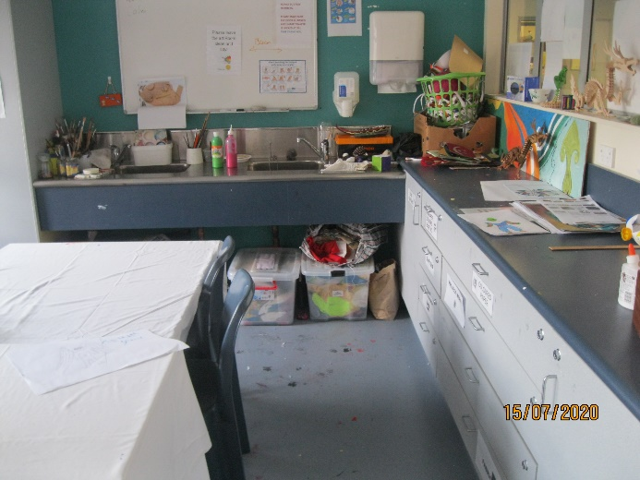
Figure 10: Activities room

Programmes
At the time of inspection, the Unit did not have a psychologist or alcohol and drug counsellor. Both clients and staff felt the absence of these professionals: for example, one-to-one psychological work was not readily available to clients. Staff were making efforts to minimise the impact of vacancies on clients, and the Service had undertaken extensive recruitment work.
Clients had an activity schedule and a treatment plan designed for their individual treatment needs. My Inspectors observed clients leaving the Unit to attend programmes provided by the Service. One client my Inspectors spoke with was particularly positive about the women’s programme.

Cultural and spiritual support
Cultural and spiritual support was readily available to clients on the Unit.
The Service employed two Spiritual Pastoral Therapists, who worked across the Service, and the Hospital Chaplaincy Team was also available to clients on request. A Sunday service and pastoral care were available to clients across the Service.
Clients in the Unit also had access to a broad range of cultural services such as Rūamoko Kaupapa Māori Service and Vaka o le Pasifika Service. Rūamoko, a Māori cultural centre, provided assessment, treatment, programmes and support to tāngata whai ora. Vaka o le Pasifika, a purpose-built facility for Pasifika, similarly provided cultural support to Pasifika clients.
The Service employed a Kuia and a Kaumātua, who had regular contact with both tāngata whai ora and staff to provide spiritual and cultural guidance and support. Inspectors were told that there was positive communication and support for the cultural team by senior management.
The Unit also employed a Kai Manaaki, who provided cultural support for clients. The Kai Manaaki worked with clients to identify their whakapapa and supported clients establish or re-establish connections with whānau, hapū, and iwi. The Unit had recently employed a new social worker who was working alongside the Kai Manaaki to facilitate whanau contact.
Additionally, the Kai Manaaki was tasked with ensuring te ao Māori was evident throughout the Unit through Rūamoko. Inspectors were told Rūamoko provided an environment that enabled the expression and exploration of te ao Māori by acknowledging, supporting and strengthening Māori Identity.
Clients my Inspectors spoke with enjoyed participating in cultural programmes and felt supported in exploring their identity.
I was pleased to observe that the Unit had good cultural provision and encourage the Service to continue utilising the knowledge of the cultural team to support tāngata whai ora and their whānau, reflecting the Service’s ‘Te Whare Tapa Wha’ model of care.

Recommendations – activities and programmes
I have no recommendations to make.

Communications

Access to visitors
The Unit had flexible visiting hours between 3pm and 7pm seven days a week, with alternative times available upon arrangement. The Unit had two visiting rooms equipped with tea- and coffee-making facilities and an outside visiting courtyard area.
Inspectors did not observe any visits during the inspection. However, clients generally understood the visitation process and how visits were organised. I was pleased to see that the Unit was utilising video conferences for families who were unable to visit the Unit.

Access to external communication
Both male and female areas had a telephone located in a booth in the main communal area of the Unit, which provided privacy for clients. During inspection, the telephone booth in the male area was unlocked throughout the day, which allowed for independent access to the telephone. However, the telephone booth in the female area was locked, and clients had to request access to the telephone. I am of the view that clients should have access to the telephone, independent of staff, unless deemed unsafe based on an individual risk assessment.
Unit staff told Inspectors that clients’ cell phones were only taken away if there was a clinically indicated need to do so. Inspectors observed clients in possession of their personal phones during the inspection.
Clients did not raise any concerns with Inspectors about the ability to send and receive mail. Inspectors were advised that mail could be sent and received daily.

Recommendations – communications
I recommend that:
- All clients have access to a telephone, independent of staff, unless deemed unsafe based on individual risk assessment.

Tāwhirimātea comments
The DHB partially accepted recommendation 11.
The DHB’s response included the following comment regarding recommendation 11:
A number of clients, unless deemed unsafe based on individual risk assessment, have access to their own personal phones or are able to independently utilise identified phones on the unit. The Unit's Clinical Governance Group will review the Unit's telephone procedure to ensure it meets the needs of the current population.
Ombudsman response:
I welcome the DHB’s response and look forward to seeing the result of the Unit’s Clinical Governance Group review in future.

Health care

Primary health care services
Inspectors observed a visit to the Unit from the House Officer, along with clients requesting medical care. There was evidence in clients’ files of regular health assessments and reviews. Several clients told my Inspectors of their positive relationship with their Registered Nurse (RN), Responsible Clinician, and Doctor. No concerns were raised with Inspectors regarding clients’ access to primary health care services.
Clients received a physical assessment on admission. A House Officer visited the Unit regularly, which included obtaining a medical history, taking routine blood tests, and addressing any physical health concerns. The Unit also employed a Pharmacist, who attended Huihui and other clinical governance groups.
A treatment room was available on the Unit for physical examination and stored medications, including controlled drugs. Inspectors observed that the room was tidy and well organised.
There were no documented medication errors between 1 January and 30 June 2020. Inspectors were told that the Unit’s two Nurse Educators had assessed all staff members who administered medication as competent to do so. The Clinical Nurse Specialist (CNS) had robust procedures in place to address medication errors when they were identified.

Recommendations – health care
I have no recommendations to make.

Staff

Staffing levels and staff retention
In my 2016 Report, I raised concerns that staff were not easily identifiable and recommended that staff wear clear identification at all times. During this inspection, my Inspectors observed that all Unit staff wore badges that displayed both their name and role. The Unit also prominently displayed up-to-date posters, which contained staff members’ photo, name and role.
Data provided by the Service showed a staff complement (excluding doctors) of 21 RNs; one Team Leader; one Clinical Shift Coordinator; one CNS; and 22 Health Care Assistants (HCAs).
Information provided to Inspectors indicated that the Unit had vacancies for four RNs, one OT, one Alcohol and Drug Counsellor, and one Psychologist. While I understand that the COVID-19 pandemic had created a challenge in filling vacancies at the Unit, staff shortages placed additional pressure on staff. Inspectors observed, for example, staff working double shifts to ensure coverage.
Nursing staff worked a three-shift roster, with a designated staffing level on each shift. The morning shift ran from 7am to 4pm with 11 staff; the evening shift ran from 2.30pm to 11pm with 11 staff; and the night shift ran from 10.45pm to 7.20am with four staff.
Data also showed that between 2017/18 and 2019/20 there was a significant decrease in nursing staff turnover, from 16.7 percent to 5.6 percent. The turnover for HCAs decreased from 17.6 percent in 2017/18 to 6.3 percent in 2018/19; however, it increased to 9.5 percent in 2019/20.
The majority of staff had worked on the Unit for over five years, with only one RN who had joined the Service within the last year. Inspectors were told that the Unit was seeking to recruit more graduate RNs, and that the Unit was mindful that many staff members would be soon reaching retirement age.
Having a diverse workforce, with an appropriate range of professional backgrounds, expertise and experience is essential for optimal quality of care for clients. I encourage the Unit to ensure its staff have an appropriate balance of skill mix and demographics.

Recommendations – staff
I have no recommendations to make.

Acknowledgements
I appreciate the full co-operation extended by the Unit and staff to the Inspectors during their inspection of the Unit. I also acknowledge the work involved in collating the information requested.
Peter Boshier
Chief Ombudsman
National Preventive Mechanism
- List of people who spoke with Inspectors
Table 4: List of people who spoke with Inspectors
Managers | Unit staff | Others
Team Leader (Unit Manager)  Acting Team Leader  Associate Charge Nurse Manager  Acting Team Leader  Clinical Nurse Specialist | Registered Nurses  Consultant Psychiatrist  Occupational Therapists  Social Workers  Health Care Assistants  House Officer  Registrar  Cleaner | Clients  Whānau  Māori Cultural Advisor  Chaplain  Consumer Advisor  Locality Coordination Service Coordinator  District Inspector

- Legislative framework
In 2007 the New Zealand Government ratified the United Nations Optional Protocol to the Convention against Torture and Other Cruel, Inhuman or Degrading Treatment or Punishment (OPCAT).
The objective of OPCAT is to establish a system of regular visits undertaken by an independent national body to places where people are deprived of their liberty, in order to prevent torture and other cruel, inhuman or degrading treatment or punishment.
The Crimes of Torture Act 1989 (COTA) was amended by the Crimes of Torture Amendment Act 2006 to enable New Zealand to meet its international obligations under OPCAT.

Places of detention – health and disability facilities
Section 16 of COTA defines a “place of detention” as:
“…any place in New Zealand where persons are or may be deprived of liberty, including, for example, detention or custody in…
(e) a secure facility as defined in section 9(2) of the Intellectual Disability (Compulsory Care and Rehabilitation) Act 2003…”
Ombudsmen are designated by the Minister of Justice as a National Preventive Mechanism (NPM) to inspect certain places of detention under OPCAT, including hospitals and the secure facilities identified above.
Under section 27 of COTA, an NPM’s functions include:
- to examine the conditions of detention applying to detainees and the treatment of detainees; and
- to make any recommendations it considers appropriate to the person in charge of a place of detention:
  - for improving the conditions of detention applying to detainees;
  - for improving the treatment of detainees; and
  - for preventing torture and other cruel, inhuman or degrading treatment or punishment in places of detention.

Carrying out the OPCAT function
Under COTA, Ombudsmen are entitled to:
- access all information regarding the number of detainees, the treatment of detainees and the conditions of detention;
- unrestricted access to any place of detention for which they are designated, and unrestricted access to any person in that place;
- interview any person, without witnesses, either personally or through an interpreter; and
- choose the places they want to visit and the people they want to interview.
Section 34 of COTA provides that when carrying out their OPCAT function, Ombudsmen can use their Ombudsmen Act (OA) powers to require the production of any information, documents, papers or things (even where there may be a statutory obligation of secrecy or non-disclosure) (sections 19(1), 19(3) and 19(4) OA. To facilitate his OPCAT role, the Chief Ombudsman has authorised inspectors to exercise these powers on his behalf.

More information
Find out more about the Chief Ombudsman’s OPCAT role, and read his reports online: ombudsman.parliament.nz/opcat

A person who uses mental health and addiction services. This term is often used interchangeably with consumer, patient, or tāngata whai ora.
When the term Inspectors is used, this refers to the inspection team comprising of two Inspectors.
See https://covid19.govt.nz/alert-system/covid-19-alert-system/ for more about New Zealand’s COVID-19 alert system.
UN Convention against Torture, Article 16(1): “Each State Party shall undertake to prevent in any territory under its jurisdiction other acts of cruel, inhuman or degrading treatment or punishment which do not amount to torture as defined in article I, when such acts are committed by or at the instigation of or with the consent or acquiescence of a public official or other person acting in an official capacity. In particular, the obligations contained in articles 10, 11, 12 and 13 shall apply with the substitution for references to torture of references to other forms of cruel, inhuman or degrading treatment or punishment.”
Recommendations from my 2016 report are on page 14.
Addressed in my Report on an unannounced inspection of Rangipapa Forensic Rehabilitation Unit, Rātonga-Rua-O-Porirua Campus, under the Crimes of Torture Act 1989, (2021) Wellington, and Report on an unannounced inspection of Pūrehurehu Unit, Rātonga-Rua-O-Porirua Campus, under the Crimes of Torture Act 1989, (2021) Wellington.
Data provided by the DAMHS shows occupancy across the Service has averaged over 103 percent in the six months from January to June 2020.
When a court orders a person be referred to the Service, that person must be accommodated regardless of capacity and waiting lists.
The units inspected at the same time were Rangipapa and Pūrehurehu.
For example, I have provided the Ministry of Health with my Report on an unannounced inspection of Haumietiketike Unit, Rātonga-Rua-O-Porirua Campus, under the Crimes of Torture Act 1989 (2021) and Final opinion of the Chief Ombudsman – Oversight: An investigation into the Ministry of Health’s stewardship of hospital-level secure services for people with an intellectual disability (2021).
See http://www.mhaids.health.nz/our-services/regional-forensic-and-rehabilitation-services/regional-rehabilitation-and-extended-care/ for more information.
http://www.mhaids.health.nz/our-services/regional-forensic-and-rehabilitation-services/central-regional-forensic-adult-inpatient-service/
I have used spelling and macrons as displayed in the Unit.
See https://covid19.govt.nz/alert-system/covid-19-alert-system/ for more about New Zealand’s COVID-19 alert system.
SPEC training was designed to support staff working within inpatient mental health units to reduce the incidence of restraints. SPEC training has a strong emphasis on prevention and therapeutic communication skills and strategies, alongside the provision of training in safe and pain-free personal restraint techniques. https://www.tepou.co.nz/initiatives/towards-restraint-free-mental-health-practice/149
My inspection methodology is informed by the Association for the Prevention of Torture’s Practical Guide to Monitoring Places of Detention (2004) Geneva, available at www.apt.ch.
For a complete list of people Inspectors spoke with, see Appendix 1.
Office of the Ombudsman Report on an Unannounced Visit to Tāwhirimātea Unit under the Crimes of Torture Act 1989, February 2016.
See, for example, Gerrit Zach and Moritz Birk “Cruel, Inhuman or Degrading Treatment or Punishment” in Nowak, Birk, Monina (eds) The United Nations Convention against Torture and its Optional Protocol: A Commentary (2nd ed, Oxford University Press, Oxford, 2019) 444.
Seclusion is defined as: ‘Where a person is placed alone in a room or area, at any time and for any duration, from which they cannot freely exit’. New Zealand Standards, Health and Disability Services (Restraint Minimisation and Safe Practice) Standards. Ministry of Health. 2008.
Clients in the de-escalation rooms did not require escorting.
Data as provided by the Service.
Personal restraint is when a service provider(s) uses their own body to limit a service user’s normal freedom of movement. New Zealand Standards. Health and Disability Services (Restraint Minimisation and Safe Practice) Standards. Ministry of Health. 2008.
The Service defines environmental restraint as ranging from a client’s environment being contained through to planned interventions that reduce a client’s level of social contact and/or environmental simulation.
Electroconvulsive therapy is used mainly in the treatment of severe depressive episodes. It involves the passage of an electric current across the head of a person to produce a convulsion. https://www.health.govt.nz/publication/electroconvulsive-therapy-ect
‘Sensory modulation uses a range of tools to help individuals get the right amount of sensory input. In mental health settings, sensory modulation can be used to assist distressed service users to regain a sense of calm’. Te Pou o te Whakaaro Nui (2011). Sensory modulation in inpatient mental health: A summary of the evidence. Auckland. Te Pou o Te Whakaaro Nui.
Also referred to as a ‘Period of Assessment’ by clients and staff.
Inspectors requested minutes for the period of 1 January to 30 June 2020.
See https://www.ccdhb.org.nz/contact-us/feedback-suggestions-complaints-and-compliments/ for more information.
A voluntary service user (sometimes called an 'informal patient') is someone who has been admitted as an inpatient to a psychiatric ward but is not detained under the MHA. This means that the service user has agreed to have treatment and has the right to suspend or stop that treatment. The service user has the right to leave the facility at any time.
Despite a compulsory treatment order, section 59 of MHA requires clinicians to make efforts to obtain clients’ consent to treatment wherever possible. See Guidelines to the Mental Health (Compulsory Assessment and Treatment) Act 1992. Ministry of Health. 2020.
This includes current inpatients who were on leave from the Unit.
See https://www.health.govt.nz/our-work/populations/maori-health/maori-health-models/maori-health-models-te-whare-tapa-wha for more.
12 RNs and 13 HCAs had worked on the Unit for over five years, whereas eight RNs and six HCAs had less than five years’ experience.

