OPCAT Report
Report on an unannounced inspection of Tumanako Mental Health Inpatient Unit, Whangarei Hospital, under the Crimes of Torture Act 1989
August 2020
Peter Boshier
Chief Ombudsman
National Preventive Mechanism

Report on an unannounced inspection of Tumanako Mental Health Inpatient Unit, Whangarei Hospital, under the Crimes of Torture Act 1989
ISBN: 978-0-473-53769-2 (PDF)
Published August 2020

Office of the Ombudsman | Wellington, New Zealand | www.ombudsman.parliament.nz
Contents
Executive summary 7
Background 7
Summary of findings 7
Recommendations 9
Feedback meeting 9
Facility facts 10
Tumanako Mental Health Inpatient Unit 10
Region 10
District Health Board 10
Operating capacity 10
Last inspection 10
The inspection 11
Inspection methodology 11
Inspection focus 12
Treatment 12
Protective measures 12
Material conditions 12
Activities and programmes 12
Communications 12
Health care 13
Staff 13
Evidence 13
Recommendations from previous report 13
Treatment 14
Torture or other cruel, inhuman or degrading treatment or punishment 14
Seclusion 14
Seclusion policies and events 15
Restraint 17
Restraint training for staff 18
Consent and leave arrangements for voluntary tāngata whai ora 19
Electro-convulsive therapy 19
Sensory modulation 19
Tāngata whai ora views on treatment 19
Recommendations – treatment 20
Tumanako comments 20
Protective measures 21
Complaints process 21
Records 22
Recommendations – protective measures 23
Tumanako comments 23
Material conditions 23
Accommodation and sanitary conditions 23
Whakaora 23
Pono 24
Pumau 24
Privacy and natural light 25
Laundry and linen 25
Activity areas 25
Food 26
Recommendations – material conditions 27
Tumanako comments 27
Activities and programmes 27
Outdoor exercise and leisure activities 27
Programmes 28
Recommendations – activities and programmes 29
Communications 29
Access to visitors 29
Access to external communication 29
Recommendations – communications 29
Tumanako comments 29
Health care 30
Primary health care services 30
Recommendations – health care 31
Tumanako comments 31
Staff 31
Staffing levels and staff retention 31
Recommendations – staff 32
Acknowledgements 32
Appendix 1. List of people who spoke with Inspectors 33
Appendix 2. Legislative framework 34

Tables
Table 1: Seclusion events 1 June 2019 – 30 November 2019 16
Table 2: Restraint data (exclusive of seclusion data) 1 June 2019 – 30 November 2019 17
Table 3: List of people who spoke with Inspectors 33

Figures
Figure 1: Seclusion room 15
Figure 2: Seclusion area courtyard 15
Figure 3: Bedroom 26
Figure 4: HDU lounge 26
Figure 5: Activities area vegetable gardens 28
Figure 6: The HDU’s Aroha courtyard 28

Executive summary

Background
In 2007, the Ombudsmen were designated one of the National Preventive Mechanisms (NPMs) under the Crimes of Torture Act 1989 (COTA), with responsibility for examining and monitoring the conditions and treatment of tāngata whai ora detained in secure units within New Zealand hospitals.
Between 9 December and 13 December 2019, Inspectors — whom I have authorised to carry out visits to places of detention under COTA on my behalf — made an unannounced inspection of Tumanako Mental Health Inpatient Unit (the Unit), which is located in the grounds of Whangarei Hospital Campus, Whangarei.

Summary of findings
My findings are:
- There was no evidence that any tāngata whai ora had been subject to torture or other cruel, inhuman or degrading treatment or punishment.
- Tāngata whai ora felt safe on the Unit.
- Tāngata whai ora described positive interactions with staff and felt respected by staff.
- The Whakaora training programme was having a positive impact on reducing the use of seclusion on the Unit.
- There had been a significant reduction in the use of restraint on the Unit.
- Files contained all the necessary legal paperwork to detain and treat clients on the Unit.
- District Inspectors’ contact details were well advertised on the Unit with a brief description of their role.
- The Unit was clean, tidy and well maintained.
- Activities areas were equipped and well utilised.
- The activities programme operated seven days a week with extended hours.
- Courtyards were accessible most of the time and there was good access to escorted leave.
- The Unit activities areas and courtyards were unlocked, and were only locked when this was clinically indicated based on individualised risk assessment.
- The role of the General Focus Nurse appeared to be a positive addition to the team.
- The diversity of Unit staff, in particular the number of Māori staff, is having a positive impact on the tāngata whai ora on the Unit.
- The initiative of the Mental Health Auxiliary Worker (MHAW) Team Leader role appeared to be having a positive impact on the functioning of the Unit, with MHAW fully integrated into the Multi-Disciplinary Team (MDT).
- Staff generally felt well supported.
The issues that needed addressing are:
- The window blinds in the seclusion rooms were not operational.
- Tāngata whai ora in seclusion were provided with a cardboard receptacle in which to urinate or defecate. Inspectors noted the receptacle was visible from the seclusion door window, which posed a serious risk to service users’ privacy and dignity.
- The intercoms in the seclusion rooms were not operational.
- Voluntary tāngata whai ora had leave restrictions.
- Tāngata whai ora were not invited to their MDT meetings.
- Fifty eight percent of staff were out of date with their Safe Practice Effective Communication Training.
- The complaints process and complaints forms were not available to tāngata whai ora on the Unit.
- Voluntary tāngata whai ora did not have consent documentation on file for admission to a locked ward.
- The High Dependency Unit (HDU) lounge area was being used as a thoroughfare for cleaning trolleys and other deliveries to the Unit.
- An interview room with no natural light, ventilation, or privacy, was being used as a bedroom in the HDU.
- Tāngata whai ora did not have access to a telephone independent of staff.
- Tāngata whai ora had no privacy when making telephone calls.
- The Unit had a high number of medication errors.

Recommendations
I recommend that:
- The window blinds in the seclusion rooms be made operational.
- The toilet in the seclusion area is accessible by tāngata whai ora in seclusion, unless deemed unsafe based on individual risk assessment. If a tāngata whai ora is not permitted access to the toilet, the reasons are recorded and regularly reviewed.
- The intercom in seclusion be made operational.
- Leave restrictions are not placed on voluntary tāngata whai ora.
- Tāngata whai ora admitted to the Unit on a voluntary basis consent to admission to a locked ward, and this is documented.
- Tāngata whai ora are invited to attend their multi-disciplinary team meeting, wherever possible, and be routinely informed of the outcome of their review.
- All relevant staff are up to date with their SPEC training. This is an amended repeat recommendation.
- The complaints process, including complaint forms, are well advertised and accessible to tāngata whai ora on the Unit and their whānau.
- The HDU is not used as a thoroughfare.
- The converted room in the HDU is not used as a bedroom. This is an amended repeat recommendation.
- Tāngata whai ora have access to a telephone, independent of staff, unless deemed unsafe based on individual risk assessment.
- Tāngata whai ora have privacy when making telephone calls.
- The DHB continues to actively monitor and work to reduce the level of medication errors.

Follow up inspections will be made at future dates to monitor implementation of my recommendations.

Feedback meeting
On completion of the inspection, my Inspectors met with representatives of the Unit’s leadership team, to outline their initial observations.

Facility facts

Tumanako Mental Health Inpatient Unit
Tumanako Mental Health Inpatient Unit (the Unit) is a 29 bed acute inpatient unit, providing assessment, treatment and stabilisation for tāngata whai ora experiencing acute mental health issues, who are unable to be cared for safely in a community environment.
Tāngata whai ora are admitted to Tumanako if they require inpatient care until their acute symptoms stablise, or for managing medication changes. Tāngata whai ora are admitted either voluntarily or under the Mental Health (Compulsory Assessment and Treatment) Act 1992 (MHA).
The Unit is located in the grounds of Whangarei Hospital Campus, Whangarei.

Region
Whangarei (Wellsford to Kaitaia)

District Health Board
Northland District Health Board

Operating capacity
- Whakaora (High Dependency Unit) – 8 beds (plus two seclusion rooms)
- Pono (Psychiatric Older People Services) – 5 beds
- Pumau (General Secure Wards) – 16 beds

Last inspection
Unannounced visit – May 2015
Announced inspection – April 2011

The inspection
Two Inspectors conducted the inspection of the Unit between 9 and 12 December 2019. On the first day of the inspection, there were 27 tāngata whai ora on the Unit, comprising eight females and 19 males.
The average length of stay for the preceding six months was 17 days for tāngata whai ora who were detained under the MHA and six days for tāngata whai ora who had voluntary status.

Inspection methodology
At the beginning of the inspection, Inspectors met with the Clinical Nurse Manager (CNM), before viewing the Unit.
Inspectors were provided with the following information during and after the inspection:
- a list of tāngata whai ora and the legislative reference under which they were being detained at the time of the inspection;
- the seclusion and restraint data from 1 June to 30 November 2019, and the seclusion and restraint policies;
- notes from any meetings or reports relating to restraint, seclusion minimisation, and adverse events;
- records of staff mandatory training, including Safe Practice Effective Communication training (SPEC);
- details of all adverse events between 1 June and 30 November 2019;
- complaints received between 1 June and 30 November 2019, a sample of responses and associated timeframes, and a copy of the complaints policy;
- copies of minutes of consumer and service user group meetings for the previous three months;
- a copy of the activities programme;
- information provided to tāngata whai ora and their whānau on admission;
- incident reports relating to medication errors between 1 June and 30 November 2019;
- staff sickness and retention data for the previous three years;
- staff vacancies at time of inspection (role and number), and data on staff (categorised by profession).

Inspection focus
The following areas were examined to determine whether there had been torture or other cruel, inhuman or degrading treatment or punishment, or any other issues impacting adversely on tāngata whai ora.

Treatment
- Torture or other cruel, inhuman or degrading treatment or punishment
- Seclusion
- Seclusion policies and events
- Restraint
- Restraint training for staff
- Consent and leave arrangements for voluntary tāngata whai ora
- Electro-convulsive therapy (ECT)
- Sensory modulation
- Tāngata whai ora views on treatment

Protective measures
- Complaints process
- Records

Material conditions
- Accommodation and sanitary conditions
- Food

Activities and programmes
- Outdoor exercise and leisure activities
- Programmes

Communications
- Access to visitors
- Access to external communications

Health care
- Primary health care services

Staff
- Staffing levels and staff retention

Evidence
In addition to the documentary evidence provided at the time of the inspection, Inspectors spoke with a number of managers, staff, and tāngata whai ora.
Inspectors also reviewed tāngata whai ora records, were provided additional documents upon request by the staff, and observed the facilities and conditions.

Recommendations from previous report
The Inspectors followed up on four recommendations made by my predecessor, following a visit to the Unit in 2015, which were:
  - Management and staff need to continue to work towards reducing both the seclusion hours, and the number of restraints within the Unit.
  - The converted room in the high care suite should not be used as a bedroom.
  - All staff should be up to date with their calming and restraint refresher.
  - The District Inspectors’ telephone numbers should be located next to the patients’ phone
The extent to which the DHB has implemented these prior recommendations is referred to in the relevant sections of this report.

Treatment

Torture or other cruel, inhuman or degrading treatment or punishment
There was no evidence that any tāngata whai ora had been subject to torture or other cruel, inhuman or degrading treatment or punishment.

Seclusion

Seclusion facilities
A seclusion area comprising a foyer, a small courtyard, a single toilet, shower, and two seclusion rooms, is located in Whakaora, the High Dependency Unit (HDU). Access to the seclusion area’s foyer was through a de-escalation lounge that could be opened or closed to one or both HDU wings.
The positioning of the de-escalation lounge provided a safe area outside the seclusion rooms to reintegrate tāngata whai ora onto the Unit after a seclusion event, or to prevent the need for seclusion.
Both seclusion rooms were stark, but clean and well maintained. Each seclusion room contained a mattress on the floor and a cardboard receptacle for tāngata whai ora to use as a toilet. There was no en-suite or toilet available in the seclusion rooms and no access to water. Staff provided water in disposable cups to tāngata whai ora in seclusion.
Inspectors noted that tāngata whai ora urinating or defecating into the cardboard receptacle would be visible from the seclusion door window. While observation of tāngata whai ora in seclusion is required, observation of tāngata whai ora urinating or defecating can, and should, be avoided unless absolutely clinically necessary based on individual risk assessment.
The ability to view tāngata whai ora in seclusion urinating or defecating poses a serious risk to their privacy and dignity. Any such viewing would likely amount to degrading treatment and a breach of Article 16 of the United Nations Convention against Torture and Other Cruel, Inhuman or Degrading Treatment or Punishment (‘Convention against Torture’).
A large window in each seclusion room provided natural light however the external windows’ built-in blinds were unable to be closed, in either room. There was no direct access to the outside from the seclusion rooms. However tāngata whai ora could access fresh air, with staff support, in the small courtyard adjoining the foyer located outside the seclusion rooms. The temperature in the seclusion rooms was controlled externally by staff.
An observation panel allowed staff in the foyer to observe the tāngata whai ora in the seclusion area. Tāngata whai ora had access to the time, day and date via a clock which was visible from the seclusion rooms. The intercom system to allow tāngata whai ora and staff to communicate was not operational in either seclusion room.
The courtyard was small, but well maintained and contained bean bags.
No tāngata whai ora were in seclusion at the time of inspection.
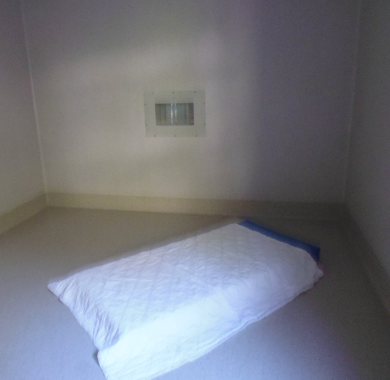 |  | 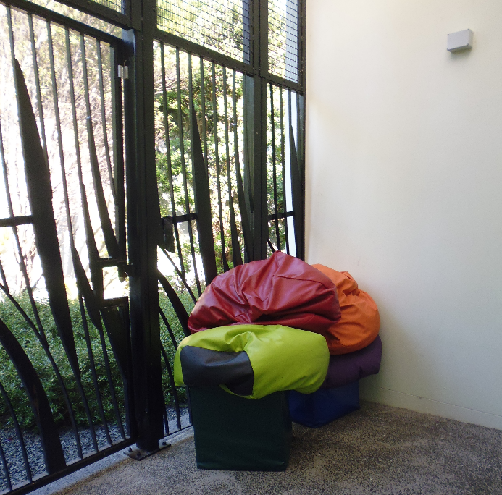
Figure 1: Seclusion room |  | Figure 2: Seclusion area courtyard

Seclusion policies and events
A copy of the Northland District Health Board’s (DHB) Tumanako Seclusion Policy and Procedure (dated September 2016) was provided to Inspectors. The procedure had a review date of June 2017 and was out of date.
The Unit demonstrated a strong commitment to reducing the use of seclusion. A multi-disciplinary working group met regularly to review seclusion data, identify areas of challenge, and agree actions to address these challenges.
The Whakaora training programme, initiated in July 2019, was in place to support and upskill staff working in the HDU to reduce the use of seclusion. The programme employed an additional senior Registered Nurse (RN) to work alongside, and mentor, less experienced staff who were working with tāngata whai ora requiring high levels of care. The feedback from staff was positive regarding the implementation of the training programme, and staff reported an increase in confidence when working in the HDU as a result.
An Inspector observed the monthly Seclusion Elimination Project Team Meeting, attended by several members of the Unit’s Multi-Disciplinary Team (MDT) and a number of senior managers external to the Unit. The discussion was comprehensive and topics included institutionalised racism, unconscious bias, and the potential contribution of these factors to the use of seclusion. Meetings were minuted with clear action points identified.
An Inspector reviewed files of tāngata whai ora who were inpatients at the time of inspection, and who had experienced a seclusion event during the course of their admission. Documentation showed that tāngata whai ora were routinely able to wear their own clothing while in seclusion. In circumstances in which tāngata whai ora were required to wear a safety garment, the rationale for this decision was clearly documented in the clinical file notes and seclusion documentation.
Data provided by the DHB indicated that, between 1 June and 30 November 2019, there were a total of 65 seclusion events involving 47 tāngata whai ora and a total seclusion time of 1988 hours. The number of seclusion events for this period was an increase from my predecessor’s 2015 inspection in which there were a total of 60 seclusion events involving 37 tāngata whai ora with a total seclusion time of 1322 hours.
Despite this increase between the 2015 and 2019 inspections, data provided by the DHB identified that the use of seclusion was steadily reducing between 1 June and 30 November 2019. Staff considered that the reduction was largely attributed to the implementation of the Whakaora training programme in July 2019, described at the Seclusion Elimination Project Team Meeting as a ‘deliberate shift in practice’. I commend the Unit’s commitment to reducing the use of seclusion.
Table 1: Seclusion events 1 June 2019 – 30 November 2019
Month | Events | Service user numbers | Hours | Average hours
June | 16 | 13 | 520 | 32.5
July | 12 | 6 | 457 | 38.0
August | 13 | 10 | 451 | 34.7
September | 11 | 8 | 292 | 26.6
October | 9 | 6 | 142 | 15.8
November | 4 | 4 | 126 | 31.6
Total: | 65 | 47 | 1988 | 179.2

Restraint
A copy of the DHB’s Procedure: Personal/Physical Restraint Mental Health and Addictions Services (dated January 2018) was provided to Inspectors. The procedure had a review date of January 2021.
Data supplied by the DHB showed there were 11 events of restraint involving seven tāngata whai ora between 1 June and 30 November 2019. All restraint events were recorded as ‘personal restraint’. This is a significant decrease from my predecessor’s 2015 inspection, in which there were 74 incidents of restraint involving 10 tāngata whai ora.
Table 2: Restraint data (exclusive of seclusion data) 1 June 2019 – 30 November 2019
 | June | July | August | September |  | October | November
Total restraint episodes | 2 | 3 | 2 |  | 3 | 0 | 1
Total tāngata whai ora restrained | 1 | 1 | 2 |  | 2 | 0 | 1
Personal restraint | 1 | 2 | 1 |  | 2 | 0 | 1
Mechanical/ physical | 0 | 0 | 0 |  | 0 | 0 | 0
Environmental (door locking) | 0 | 0 | 0 |  | 0 | 0 | 0
Police restraint | 0 | 0 | 0 |  | 0 | 0 | 0
Number of males restrained | 1 | 0 | 0 |  | 2 | 0 | 1
Number of females restrained | 0 | 1 | 1 |  | 0 | 0 | 0
Youngest person restrained |  |  | 21 |  | 24 | 0 | 29
Oldest person restrained | 32 | 40 | 39 |  | 88 | 0 | 29

My predecessor made the following recommendation, following the 2015 inspection:
Management and staff need to continue to work towards reducing both the seclusion hours, and the number of restraints within the units.
It is pleasing to note the significant reduction of the use of restraint on the Unit, as well as the Unit’s demonstrated commitment to reducing seclusion. The proactive approach taken by the Unit appears to be resulting in the desired outcome for tāngata whai ora.

Restraint training for staff
My predecessor made the following recommendation, following the 2015 inspection
All staff should be up to date with their calming and restraint refresher.
This is an amended repeat recommendation.
Information provided by the DHB showed that, at the time of inspection, 43 of the 74 Unit staff (58 percent) were out-of-date with their Safe Practice Effective Communication (SPEC) refresher training.
I am concerned by the lack of progress in this area as I consider that all relevant staff should be up-to-date with their SPEC training.

Consent and leave arrangements for voluntary tāngata whai ora
Inspectors reviewed the files of all tāngata whai ora on the Unit at the time of inspection. There was no clear documentation that the voluntary tāngata whai ora had consented to voluntary admission on a secure unit. Inspectors also noted that leave restrictions had been placed on voluntary tāngata whai ora, however there was no record of discussions about restricting leave having taken place.
I am concerned by the practice of leave restrictions being placed on voluntary tāngata whai ora. These tāngata whai ora are under no legal obligation to remain on the Unit and therefore do not have legal safeguards, such as access to the District Inspector (DI), to ensure their rights are not infringed.
Consent from voluntary tāngata whai ora admitted to a secure unit should be obtained and recorded on their file. Leave restrictions should not be placed on voluntary tāngata whai ora.

Electro-convulsive therapy
There were no tāngata whai ora undergoing Electro-convulsive therapy (ECT) on the Unit at the time of the inspection.

Sensory modulation
The Unit had a Sensory Modulation Room which was comfortable and well equipped. The massage chair was in need of repair.
I was pleased to note that the Sensory Modulation Room remained unlocked throughout most of the inspection and was accessible to tāngata whai ora throughout the day, affording tāngata whai ora a valuable level of autonomy. The Occupational Therapist (OT) would accompany tāngata whai ora for individualised sessions. The Sensory Modulation Room was well utilised, and also available to tāngata whai ora in the HDU at certain times of the day.

Tāngata whai ora views on treatment
Tāngata whai ora spoken with said they felt safe on the Unit, that staff were approachable and treated them with respect. Tāngata whai ora reported they had good access to visitors, with visits accommodated in private spaces on the Unit.
Tāngata whai ora spoken with were positive about the broad range of activities offered on the Unit, the extended hours of operation for the activities programme, the flexibility to adapt activities, and the availability of escorted leave.
Several tāngata whai ora said they did not feel involved in their care planning and did not know what their plan for discharge was. Tāngata whai ora told Inspectors they had difficulties accessing the telephone when they wanted to, due to the limited number of telephones. The Unit’s telephones were located in a busy, noisy area, and tāngata whai ora did not have privacy when using the telephone.
The tāngata whai ora my Inspectors spoke to did not know how to make a complaint. I discuss this issue in more detail in my section on Protective Measures.

Recommendations – treatment
I recommend that:
- The window blinds in the seclusion rooms be made operational.
- The toilet in the seclusion area is accessible by tāngata whai ora in seclusion, unless deemed unsafe based on individual risk assessment. If a tāngata whai ora is not permitted access to the toilet, the reasons are recorded and regularly reviewed.
- The intercom in seclusion be made operational.
- Leave restrictions are not placed on voluntary tāngata whai ora.
- Tāngata whai ora admitted to the Unit on a voluntary basis consent to admission to a locked ward, and this is documented.
- Tāngata whai ora are invited to attend their multi-disciplinary team meeting, wherever possible, and be routinely informed of the outcome of their review.
- All relevant staff are up to date with their SPEC training. This is an amended repeat recommendation.

Tumanako comments
The DHB accepted recommendations 1, 2, 3, 4, 5 and 7.
The DHB partially accepted recommendation 6.
Recommendation 1 response:
We are currently working with NDHB Facilities Service to have this work completed. We will ensure the window blinds are functional and fit for purpose when the installation of the new windows occurs.
Recommendation 2 response:
Will review the seclusion forms to ensure space for prompts are recorded.
Recommendation 3 response:
Completed.
Recommendation 4 response:
Process for informed, on-going consent to be developed.
Recommendation 5 response:
Process for informed, on-going consent to be developed.
Recommendation 6 response:
We accept and agree that whaiora should be involved in decision making in relation to their care. We make a commitment to review the current mechanisms for this input but do not commit to it being the weekly meeting known as MDT.
Recommendation 7 response:
2020 SPEC Calendar is available which includes bimonthly SPEC full and refresher courses.

Protective measures

Complaints process
A copy of the DHB’s Complaints Management Policy (dated October 2017) was provided to Inspectors. The procedure had a review date of October 2019 and was out of date.
Information on how to make a complaint was included in the Unit’s welcome brochure, however several tāngata whai ora said they had not received a copy of this. Inspectors noted that a number of brochures were held on tāngata whai ora’ files, rather than being given to them when they were admitted to the Unit. There was no information displayed on the Unit to inform tāngata whai ora or whānau how they could make a complaint.
The Unit received 12 complaints between 1 June and 30 November 2019. My Inspectors reviewed the documentation on all 12 complaints. The responses were courteous in tone, individualised, and addressed the complaints in detail. One complaint generated a Cultural Audit to assist the Unit to understand what tikanga and cultural gaps existed in the provision of care to a Māori tāngata whai ora. This demonstrated a willingness to be responsive to the needs of tāngata whai ora and whānau. Complaints were not always responded to within the DHB’s complaints management policy timeframes.
I was pleased to note that the Unit records receiving 18 compliments in this period, with many commenting on the care and empathy provided by the Unit team.
My predecessor made the following recommendation, following the 2015 inspection
The District Inspectors’ telephone numbers should be located next to the patients’ phone
District Inspectors’ (DI) contact details, along with a brief description of their role, were displayed on all wards. Inspectors observed the DI maintained a strong presence on the Unit. The DI reported having good access to tāngata whai ora. Tāngata whai ora spoken with generally knew who the DI was and what the role entailed.
The Health and Disability Commission Code of Rights was displayed on all wards.
Pumau - the general wards - had daily group tāngata whai ora meetings, facilitated by a Diversional Worker with input from other members of the Unit’s MDT. Inspectors attended one of the meetings, and reviewed the minutes of other meetings. These meetings were an opportunity for tāngata whai ora and staff to raise any issues or concerns, as well as identify progress being made. Information was shared between staff and tāngata whai ora and the daily activity plan discussed, with tāngata whai ora signing up to the activities they intended to attend. The meeting was observed to be respectful, inclusive and informative, and was well attended by tāngata whai ora.

Records
There were 27 tāngata whai ora on the Unit on the first day of the inspection. Twenty six tāngata whai ora were detained under the MHA and one had voluntary status.
The Unit holds MHA paperwork in both electronic and paper filing systems. Inspectors reviewed the clinical files of all tāngata whai ora who were on the Unit at the time of the inspection. All files contained the necessary paperwork to detain and treat the tāngata whai ora who were under the MHA. Case notes were thorough and well documented. Files were well organised and easy to navigate. Significant risks were easily identified, and were visible to staff on an electronic whiteboard inside the nurses’ station.
An Inspector observed a MDT meeting. The MDT meetings were attended by representatives of the wards’ staff, staff from the community mental health teams, and Needs Assessment Service Coordination services. Tāngata whai ora were not included in their MDT meeting and their key nurse was not always present at the meeting. Discussions were professional and constructive but the outcome of the MDT reviews was not always fed back to tāngata whai ora or whānau.
Inspectors also observed a ‘rapid round’ meeting. These meetings were a new initiative on the Unit where members of the Unit team met to share up-to-date immediate information about tāngata whai ora, including risks and immediate needs. The rapid round occurred once each shift. Feedback to my Inspectors about this initiative was positive with regards to the information sharing across the Unit team.
Information provided by the Unit showed there had been no serious adverse events (Severity Assessment Code 1 and 2) recorded between 1 June and 30 November 2019.

Recommendations – protective measures
I recommend that:
- The complaints process, including complaint forms, are well advertised and accessible to tāngata whai ora on the Unit and their whānau.

Tumanako comments
The DHB accepted recommendation 8.
Recommendation 8 response:
Completed and on-going.

Material conditions

Accommodation and sanitary conditions
The Unit comprised a total of 29 beds, divided into a number of ‘pod’ areas, with a flexible configuration allowing the option of expanding or reducing bed capacity in a particular area of the Unit.
All areas were clean, tidy and well ordered. All bedrooms were single occupancy and were of an adequate size. Tāngata whai ora accessed their bedrooms using a barcode on a wrist band. Bedrooms could be locked by tāngata whai ora from inside or outside. Staff were able to unlock the doors.

Whakaora
Whakaora, the High Dependency Unit (HDU), was divided into two pods (Aroha and Manaaki), each comprising four bedrooms. Two of the Manaaki bedrooms could be configured to be used as part of Pumau (general ward).
A garage area with laundry facilities was situated adjacent to the HDU’s seclusion area. Inspectors were informed that the garage area was used on occasion to admit tāngata whai ora directly into the HDU. My inspectors noted that laundry, rubbish, and recycling were stored in the garage. This practice was of particular concern for Māori, as entrance through the garage was not a culturally safe way to bring tāngata whai ora onto the Unit.
Aroha pod housed the HDU’s tāngata whai ora who needed the highest level of care. It had a living area with a kitchenette which opened to a secure, roofed courtyard area. The doors to the courtyard were open during the inspection. Inspectors noted that Aroha was used as a thoroughfare for cleaning trolleys and other deliveries into the Unit’s main ward area. This was not conducive to a safe and low stimulus environment.
Manaaki pod housed tāngata whai ora who required care in the HDU, but did not need to be on Aroha. Manaaki also had a living area with its own kitchenette and fenced courtyard area. The courtyard was accessible with staff supervision. During the inspection the courtyard was observed to be accessible most of the time.
An interview room in Whakaora had been converted into a bedroom which could be configured to be part of either Aroha or Manaaki. It was an internal room which opened into the Manaaki lounge and the corridor through to the nurses’ station and the Aroha de-escalation lounge. The room had no privacy, natural light, or external ventilation.
My predecessor made the following recommendation, following the 2015 inspection:
The converted room in the high care suite should not be used as a bedroom.
I am concerned to find that this room is still being used as a bedroom. This room is not fit for use as a bedroom.
A de-escalation lounge and the seclusion area was located between Aroha and Manaaki pods.

Pono
The Psychiatry of Older People Service (POPS) was based in Pono, which could accommodate five tāngata whai ora. One bedroom had an ensuite. Occupants of the other four bedrooms shared one shower and one toilet.
Pono was in its own wing with a small combined lounge and dining area, and its own fenced courtyard. Pono’s doors could be open or closed to the adjacent Pumau ward, depending on the needs of tāngata whai ora on both wards at the time. During the inspection, Pono was open to Pumau, and tāngata whai ora were able to freely access Pumau’s communal areas and courtyards.

Pumau
Pumau comprised of two pods, a nine-bed and a seven-bed pod, each with two showers and two toilets. The two pods were typically divided by gender. An additional two toilets were located in the ward’s communal area.

Privacy and natural light
All bedrooms on the Unit, with the exception of the converted interview room in the HDU, had an observation window in the door which contained integral blinds which could be opened and closed from outside the bedroom. The windows of the bedrooms on Pumau and Pomo opened, but not those in the HDU. There was sufficient natural light in all bedrooms other than the converted interview room in the HDU.

Laundry and linen
There was a well-stocked linen cupboard on each pod. The linen cupboards were locked and accessible with staff support.
Washing machines and driers were available on Pumau for use with staff support. There was a timetable for tāngata whai ora in each pod to use the laundry, and it was locked outside of these times. On the HDU there was a separate laundry area and staff laundered tāngata whai ora’s clothes.

Activity areas
A corridor adjacent to Pumau contained a computer room/library, activities room, sensory modulation room, Occupational therapy garden, gym and additional courtyard areas.
These areas were accessible to Pumau and Pono tāngata whai ora during most of the inspection, with decisions made to lock the areas based on regular risk assessment. The philosophy of the Unit was that these areas were unlocked unless there was a specific reason to lock them, and decisions to lock doors were reviewed throughout the shift. Inspectors rarely noted doors to be locked to these areas for more than 1-2 hours. Tāngata whai ora in the HDU had access to these areas at set times.
I am pleased that tāngata whai ora had good access to activities and activity areas, and that a restrictive approach was not taken.
Visits took place in a whānau room situated off the Unit’s entrance foyer, with an additional visitor room situated on Pumau. The HDU accommodated visits in a room in the HDU when appropriate.
An Occupational Therapy kitchen was also situated off the Unit’s entrance foyer and was accessible to tāngata whai ora with the supervision of staff.
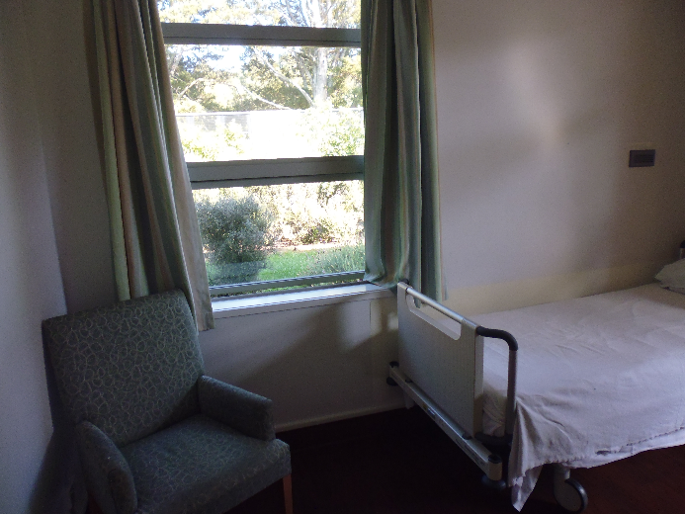 |  | 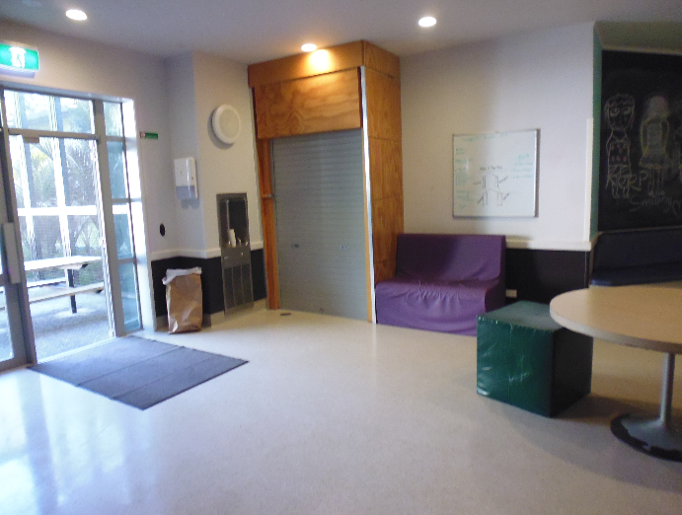
Figure 3: Bedroom |  | Figure 4: HDU lounge

Food
Breakfast was self-service in all parts of the Unit, with cereal and toast available. Staff were available to support tāngata whai ora who needed assistance. Diversional Workers cooked porridge in the OT kitchen and delivered this to each of the pods. On Sundays, Diversional Workers made a cooked breakfast which was available to all tāngata whai ora.
Lunch and dinner were prepared in the hospital kitchen, transported to the Unit on a trolley, and distributed to the pods by staff. Special dietary requirements were catered for. Tāngata whai ora selected their meals the day before from a menu. Inspectors observed a lunch meal, and the quality and quantity of the food appeared to be of a good standard. Tāngata whai ora spoken with by Inspectors felt that the food was of good quality and quantity, and they enjoyed the meals.
Tāngata whai ora on all pods could access drinking water at any time. In all areas other than Pono, hot drinks were independently accessible 24 hours a day. On Pono the hot water facilities were secured overnight for safety reasons, and accessible with staff support. Snacks were available on all pods at any time.

Recommendations – material conditions
I recommend that:
- The HDU is not used as a thoroughfare.
- The converted room in the HDU is not used as a bedroom. This is an amended repeat recommendation.

Tumanako comments
The DHB accepted recommendations 9 and 10.
Recommendation 9 response:
Submission for building works via the CAPEX process has been Completed.
Recommendation 10 response:
We only use it when we have no alternative space within Whakaora to accommodate acutely unwell whaiora when we don’t have the appropriate resources available to use. We use this as way of avoiding / minimising the risk of seclusion for whaiora as it allows us to swing this space to the most appropriate area, i.e. seclusion lounge (if requiring a low stimulus area) or out to either pod (Manaaki or Aroha).
Ombudsman response:
I acknowledge that the DHB uses this bedroom as a last resort. However I continue to consider that this room is not fit for use as a bedroom and should not be used as one.

Activities and programmes

Outdoor exercise and leisure activities
The Unit had a number of courtyard areas which were accessible to tāngata whai ora throughout most of the inspection. Courtyards were generally unlocked. Decisions to lock or unlock the courtyards were made at regular intervals throughout the day, dependent on tāngata whai ora risk assessment.
The courtyard areas in Pumau and Pono had various seating areas in well maintained gardens. There was a BBQ and a vegetable garden, accessible through the Pumau activities room. The HDU courtyards were concreted, and had minimal furniture which was fixed to the concrete.
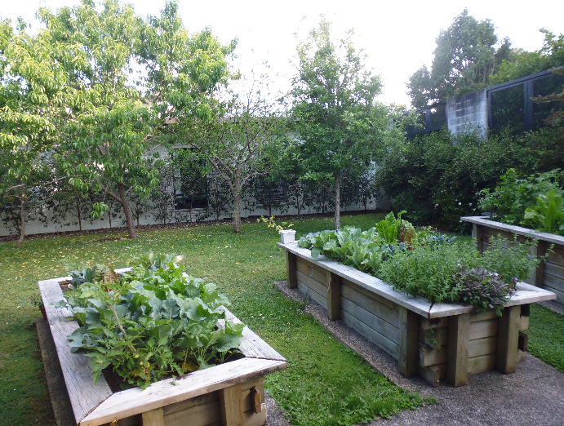 |  | 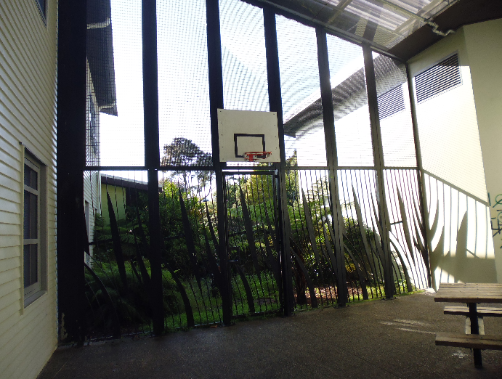
Figure 5: Activities area vegetable gardens |  | Figure 6: The HDU’s Aroha courtyard

Programmes
The Unit employed four Diversional Workers who worked extended hours and were rostered across seven days a week. The Diversional Workers and OT had a combined programme. The programme was displayed on the wards each day and discussed at the daily tāngata whai ora meeting. Tāngata whai ora identified what activities they would like to attend that day. Activities were targeted to the specific tāngata whai ora on the Unit and there was considerable flexibility in adapting the programme throughout the day to meet the needs of tāngata whai ora.
Diversional Workers supported tāngata whai ora to use the sensory room, computer room, library, activities room, gym and occupational therapy garden area. Time was set aside each day for tāngata whai ora in the HDU to access these areas, and Inspectors observed this in practice throughout the inspection. My Inspectors observed Diversional Workers and Mental Health Auxiliary Workers (MHAWs) taking tāngata whai ora on escorted walks at periodic intervals throughout the day, for example to purchase items at the local shops.
During the inspection, tāngata whai ora were observed actively engaging in the programmes being offered, using the gym, sensory room, computers, library, activity room and activity garden.
The extended hours and seven day a week provision of activities by the Diversional Workers appeared to be having a positive impact on the tāngata whai ora on the Unit, and the flexible and adaptable programme of activities was well received by tāngata whai ora.
However, Inspectors noted there were few activities offered suited to the needs of the tāngata whai ora on Pono. Inspectors were told that attempts were being made to recruit an OT specifically for this client group.

Recommendations – activities and programmes
I have no recommendations to make.

Communications

Access to visitors
The Unit visiting hours were 2pm to 8pm. Visits outside the designated times were at the discretion of staff.
Inspectors observed whānau visiting tāngata whai ora regularly during the course of the inspection and noted positive relationships between whānau and staff. Whānau were welcomed to the Unit and staff made efforts to facilitate the most appropriate room for the visit to occur.
There were a number of rooms which could be used for visits depending on the needs of the tāngata whai ora and visitors.
I have no concerns with tāngata whai ora access to visitors.

Access to external communication
Telephones were available on each ward for tāngata whai ora to use but these were corded phones, plugged inside the nurses’ stations. Tāngata whai ora using these phones were afforded no privacy, sitting just outside office doors in busy ward communal areas.
A number of tāngata whai ora had their cell phones, other than those in the HDU. Phone chargers were stored in the nurses’ station and were not allowed on the wards for safety reasons.
Tāngata whai ora were observed being supported by staff to send mail during the inspection.

Recommendations – communications
I recommend that:
- Tāngata whai ora have access to a telephone, independent of staff, unless deemed unsafe based on individual risk assessment.
- Tāngata whai ora have privacy when making telephone calls.

Tumanako comments
The DHB accepted recommendations 11 and 12.
Recommendation 11 response:
We have made enquiries regarding the installation of phone booths within the various pods of Tumanako.
Whaiora have unlimited access to their personal mobile phones in Pumau and Pono unless there is a clinical rationale that deem them unsafe to have such access. Personal mobile phones are restricted in Whakaora (Aroha and Manaaki pods) but depending on individual risk assessments, whaiora may have access to their personal mobile phones whilst utilising the activities area under staff supervision.
Recommendation 12 response:
We have made enquiries regarding the installation of phone booths within the various pods of Tumanako.
The room that was once an interview / quiet room for whaiora has since been converted to a bedroom to increase bed capacity within Tumanako, specifically in Whakaora. No alternative space is available to replace the interview / quiet room.

Health care

Primary health care services
Tāngata whai ora received a physical assessment by the House Officer on admission. Inspectors found evidence in tāngata whai ora clinical files of timely and comprehensive physical assessments on admission, and noted the House Officer was active on the Unit. A treatment room was available on the Unit for physical examinations. Medications were locked in a separate room. These rooms were tidy and well organised.
The Unit had a full time General Focus Nurse (GFN), a role which had been in existence for two years at the time of inspection. The GFN worked alongside the Unit’s House Officer to manage the physical health care needs of tāngata whai ora, including identifying and treating any issues on admission. The role provided a variety of services to tāngata whai ora, including metabolic monitoring, ECG, IV management, vaccinations, falls assessment and risk management, ECT coordination, and infection control education and management. I support the Unit’s clear commitment to the provision of physical health care to tāngata whai ora.
After hours medical cover was provided to the Unit by the on call hospital House Officer in the evenings and at weekends, ensuring that tāngata whai ora experiencing deteriorating physical health had timely assessment and treatment.
The Unit’s Pharmacist worked closely with medical staff.
The Unit had identified 22 medication errors between 1 June and 30 November 2019. Of the 22 errors 14 related to the administration of medication of which 12 were near misses with the other 2 events resulting in no harm, 3 were prescribing errors, which were detected prior to administration with no harm and 5 related to the storage of medications, also resulting in no harm.
I am concerned by the rate of medication errors on the Unit. As the Health and Disability Commissioner notes: ‘when medication errors do occur they have the potential to cause significant harm’. The Unit had conducted a review of medication errors between March and July 2019. While the DHB has advised that that since the review it has implemented a programme of continuous monitoring and implementation of improvement strategies, the number of medication errors was still of concern. That may reflect that part of the period during which the errors occurred was before the outcome of the review.

Recommendations – health care
I recommend that:
- The DHB continues to actively monitor and work to reduce the level of medication errors.

Tumanako comments
The DHB accepted recommendation 13.

Staff

Staffing levels and staff retention
At the time of inspection, the Unit had vacancies for 9.9 FTE RNs, 5.2 FTE MHAWs, 2.4 FTE OTs, and 1 Psychologist vacancy.
Nursing staff and MHAWs worked a three-shift roster, with a designated staffing level on each shift. The morning shift was from 7am to 4:05 pm with six RNs and four MHAWs, afternoon shift was from 3pm to 11.35 pm with six RNs and four MHAWs, and night shift was from 11pm to 7.35am with three RNs and four MHAWs.
Data provided by the Unit showed a turnover of 16.7 percent RNs and 24.3 percent MHAWs in the 2018/2019 calendar year. Inspectors noted that 28 percent of RNs and MHAWs had been with the Unit for less than one year. The Unit had taken steps to ensure that less experienced staff had additional support and training. The average sickness rate for all staff working on the Unit for the 2018/2019 period was 4.1 percent.
Inspectors noted that RNs, MHAWs, and Diversional Workers, wore uniforms and all Unit staff had identification badges making them easily identifiable to tāngata whai ora and visitors to the Unit.
The diversity of Unit staff, in particular the number of Māori staff, was highlighted to my Inspectors throughout the inspection as having a positive impact on the tāngata whai ora on the Unit.
The MHAW team had a strong presence on the Unit and were fully involved in the day-to-day running of the Unit, along with MDT meetings, handovers, rapid rounds, and the seclusion elimination working group. The creation of the MHAW team leader role appeared to have had a positive impact on the team’s professional development and the team’s integration with the MDT.

Recommendations – staff
I have no recommendations to make.

Acknowledgements
I appreciate the full co-operation extended by the Clinical Nurse Manager and staff to the Inspectors during their inspection of the Unit. I also acknowledge the work involved in collating the information requested.

Peter Boshier
Chief Ombudsman
National Preventive Mechanism
- List of people who spoke with Inspectors
Table 3: List of people who spoke with Inspectors
Managers | Unit staff | Others
Service Manager  Clinical Nurse Manager  Quality Manager | Associate Clinical Nurse Manager  Clinical Nurse Specialist  Registered Nurses  General Focus nurse  Clinical Nurse Educator  Clinical Head of Department  Consultant Psychiatrist  Occupational Therapist  Social Worker  Mental Health Auxiliary Workers  Diversional Worker  Pharmacist  House Officer  Administration/reception staff  Cleaner | Tāngata whai ora  District Inspector  Director of Area Mental Health Services  Consumer and Family Leader

- Legislative framework
In 2007 the New Zealand Government ratified the United Nations Optional Protocol to the Convention against Torture and Other Cruel, Inhuman or Degrading Treatment or Punishment (OPCAT).
The objective of OPCAT is to establish a system of regular visits undertaken by an independent national body to places where people are deprived of their liberty, in order to prevent torture and other cruel, inhuman or degrading treatment or punishment.
The Crimes of Torture Act 1989 (COTA) was amended by the Crimes of Torture Amendment Act 2006 to enable New Zealand to meet its international obligations under OPCAT.

Places of detention – health and disability facilities
Section 16 of COTA defines a “place of detention” as:
“…any place in New Zealand where persons are or may be deprived of liberty, including, for example, detention or custody in…
(d) a hospital
(e) a secure facility as defined in section 9(2) of the Intellectual Disability (Compulsory Care and Rehabilitation) Act 2003…”
Ombudsmen are designated by the Minister of Justice as a National Preventive Mechanism (NPM) to inspect certain places of detention under OPCAT, including hospitals and the secure facilities identified above.
Under section 27 of COTA, an NPM’s functions include:
- to examine the conditions of detention applying to detainees and the treatment of detainees; and
- to make any recommendations it considers appropriate to the person in charge of a place of detention:
  - for improving the conditions of detention applying to detainees;
  - for improving the treatment of detainees; and
  - for preventing torture and other cruel, inhuman or degrading treatment or punishment in places of detention.

Carrying out the OPCAT function
Under COTA, Ombudsmen are entitled to:
- access all information regarding the number of detainees, the treatment of detainees and the conditions of detention;
- unrestricted access to any place of detention for which they are designated, and unrestricted access to any person in that place;
- interview any person, without witnesses, either personally or through an interpreter; and
- choose the places they want to visit and the people they want to interview.
Section 34 of COTA provides that when carrying out their OPCAT function, Ombudsmen can use their Ombudsmen Act (OA) powers to require the production of any information, documents, papers or things (even where there may be a statutory obligation of secrecy or non-disclosure) (sections 19(1), 19(3) and 19(4) OA). To facilitate his OPCAT role, the Chief Ombudsman has authorised inspectors to exercise these powers on his behalf.

More information
Find out more about the Chief Ombudsman’s OPCAT role, and read his reports online: ombudsman.parliament.nz/opcat.

‘Tāngata whai ora’ is a person who uses mental health and addiction services. This term is often used interchangeably with ‘consumer’ or ‘service user’.
When the term ‘Inspectors’ is used, this refers to the inspection team comprising of two Senior Inspectors.
‘Whakaora’ is a training programme aimed at upskilling Tumanako HDU frontline staff to improve morale, reduce seclusion and support less experienced staff.
Tumanako Whānau Information Booklet, Northland DHB.
My inspection methodology is informed by the Association for the Prevention of Torture’s Practical Guide to Monitoring Places of Detention (2004) Geneva, available at www.apt.ch.
For a list of people spoken with by the Inspectors, see Appendix 1.
Office of the Ombudsman report on an unannounced visit to Tumanako Unit under the Crimes of Torture Act 1989, May 2015.
Seclusion is defined as: ‘Where a person is placed alone in a room or area, at any time and for any duration, from which they cannot freely exit’. New Zealand Standards. Health and Disability Services (Restraint Minimisation and Safe Practice) Standards. Ministry of Health. 2008.
UN Convention against Torture, Article 16(1): “Each State Party shall undertake to prevent in any territory under its jurisdiction other acts of cruel, inhuman or degrading treatment or punishment which do not amount to torture as defined in article I, when such acts are committed by or at the instigation of or with the consent or acquiescence of a public official or other person acting in an official capacity. In particular, the obligations contained in articles 10, 11, 12 and 13 shall apply with the substitution for references to torture of references to other forms of cruel, inhuman or degrading treatment or punishment.”
‘Whakaora’ is a training programme aimed at upskilling Tumanako HDU frontline staff to improve morale, reduce seclusion and support less experienced staff.
Data was supplied by the Unit in minutes and converted to hours for the purposes of this table.
Personal restraint is when a service provider(s) uses their own body to limit a service user’s normal freedom of movement. New Zealand Standards. Health and Disability Services (Restraint Minimisation and Safe Practice) Standards. Ministry of Health. 2008.
Data provided by the DHB.
Physical restraint is when a service provider(s) uses equipment, devices or furniture that limits the service user’s normal freedom of movement. New Zealand Standards. Health and Disability Services (Restraint Minimisation and Safe Practice) Standards. Ministry of Health. 2008.
Environmental restraint is where a service provider(s) intentionally restricts a tāngata whai ora’s normal access to their environment, for example where a tāngata whai ora’s normal access to their environment is intentionally restricted by locking devices on doors or by having their normal means of independent mobility (such as wheelchair) denied. Health and Disability Services (Restraint Minimisation and Safe Practice) Standards. Ministry of Health. 2008.
Calming and restraint training has now been replaced by Safe Practice Effective Communication Training
SPEC training was designed to support staff working within inpatient mental health wards to reduce the incidence of restraints. SPEC training has a strong emphasis on prevention and therapeutic communication skills and strategies, alongside the provision of training in safe, and pain free personal restraint techniques.
Electroconvulsive therapy is used mainly in the treatment of severe depressive episodes. It involves the passage of an electric current across the head of a person to produce a convulsion. https://www.health.govt.nz/publication/electroconvulsive-therapy-ect
A room in which sensory modulation is practised. ‘Sensory modulation uses a range of tools to help individuals get the right amount of sensory input. In mental health settings, sensory modulation can be used to assist distressed persons to regain a sense of calm’. Te Pou o te Whakaaro Nui (2011). Sensory modulation in inpatient mental health: A summary of the evidence. Auckland. Te Pou o te Whakaaro Nui.
Serious adverse events are an event that has resulted in, or has potential to result in, serious lasting disability or death, not related to the natural course of the consumer’s illness or underlying condition. Source: www.hqsc.govt.nz/assets/Reportable-Events/Publications/ National_Adverse_Events_Policy_2017/SAC_rating_and_triage_tool.
Diversional workers are mental health support workers with a focus on activity.
Mental health support staff, often called Mental Health Support Workers or Psychiatric Assistants.
The Health and Disability Commissioner. 2018. Complaints Closed by the Health and Disability Commissioner and Medication Errors: Analysis and Report 2009-2016.
Data provided by the DHB to 10 December 2019.

