A3.a

OPCAT Report
Final report on an unannounced inspection of Auckland Prison under the Crimes of Torture Act 1989
December 2020
Peter Boshier
Chief Ombudsman
National Preventive Mechanism

OPCAT Report: Report of an unannounced inspection of Auckland Prison under the Crimes of Torture Act 1989
ISBN: 978-0-473-55551-1 (PDF)
Published December 2020

Office of the Ombudsman | Wellington, New Zealand | www.ombudsman.parliament.nz
Contents
Foreword 1
Facility facts 4
Auckland Prison 4
Region 5
Operating capacity 5
Prison Director 6
Acting Regional Commissioner 6
Previous inspections 6
The Inspection 7
Methodology 7
Prisoner survey 7
Inspection criteria 7
Evaluation techniques 8
Criterion 1: Treatment 9
Assessment 9
Use of force 9
Directed Segregation 11
Suicide, self-harm and vulnerable prisoners 14
Safety (including voluntary segregation) 17
Staffing 19
Drugs 20
Gangs 20
Criterion 2: Reception into prison 24
Assessment 24
Receiving Office 24
Induction 25
Criterion 3: Decency, dignity and respect 28
Assessment 28
Accommodation 28
Clothing and bedding 30
Food and meal times 30
Prisoner canteen 31
Staff-prisoner relationships 31
Equality and diversity 32
Prisoners with disabilities 32
Transgender prisoners 33
Cultural provision 33
Criterion 4: Health and wellbeing 37
Assessment 37
Governance arrangements 37
Primary health care services 39
Dental services 41
Pharmacy provision 41
Mental health provision 42
Forensic service 43
Criterion 5: Protective measures 44
Assessment 44
Complaints 44
Categorisation of complaints 46
Searching, security and movements 46
Prisoner Forums 47
Kiosks, mail and phones 47
Misconducts 49
Remand prisoners 50
Criterion 6: Purposeful activity and transition to the community 53
Assessment 53
Time out of cell 53
Outdoor exercise 54
Chaplaincy 55
Library services 55
Legal visits 56
Visits 56
Training and employment 58
Education 60
Programmes 61
Case management 62
Case management for remand and long-serving prisoners 64
Reintegration Coordinator 65
Guided Release 65
Acknowledgments 67
Appendix 1. Department of Corrections’ comments on recommendations that were accepted 68
Appendix 2. Survey feedback: The Prison 89
Section 1: About you 89
Section 2: Respect and dignity 90
Section 3: Complaint process 91
Section 4: Safety 92
Section 5: Health 93
Section 6: Purposeful Activity 96
Appendix 3. Prison population demographics 99
Appendix 4. Legislative framework 102
Appendix 5. Glossary 104

Tables
Table 1: Short description of residential units 4
Table 2: Number of incidents per Unit 18
Table 5: Complaints by unit for 1 July – 31 December 2019 44
Table 6: Prisoner employment on Wednesday 29 January 2020 59

Figures
Figure 1: Assessment Unit cell 12
Figure 2: Assessment Unit cell damage 12
Figure 3: ISU cell 16
Figure 4: ISU day room 16
Figure 5: Receiving office 25
Figure 6: Property storage 25
Figure 7: Waste in external area outside Units 1–5 29
Figure 8: Empty cell – Unit 13 29
Figure 9: Standard cell – Unit 6 29
Figure 10: Disability cell – Unit 12 33
Figure 11: Disability cell – Unit 12 33
Figure 12: External yard – Units 1-5 54
Figure 13: External yard – Unit 6 54
Figure 14: Visits complex 57
Figure 15: Visits complex with children’s play area 57
Figure 16: Nursery 59
Figure 17: Industry workshop 59

Foreword
The following report has been prepared in my capacity as a National Preventive Mechanism (NPM) under the Crimes of Torture Act 1989 (COTA). My function under the COTA is to examine and make any recommendations that I consider appropriate to improve the treatment and conditions of detained persons in a number of places of detention, including prisons. This report examines the treatment and conditions of persons detained in Auckland Prison (the Prison).
I authorised my Inspectors to conduct an eight-day inspection of the Prison in late January and early February 2020, using defined criteria to assess the treatment prisoners were experiencing, and their living conditions. This inspection occurred prior to the full onset of the COVID-19 crisis and prior to any decision of the Department to lock down prisons other than for essential services.
The Prison is located in Paremoremo, northwest of Auckland City, and has capacity for 680 male prisoners with security classifications ranging from minimum to maximum. The Prison is New Zealand’s only maximum security facility and, at the time of inspection, approximately 14 percent of prisoners had a maximum security classification. The Prison had also recently started to hold remand prisoners due to muster pressures across the region — over 25 percent of prisoners were on remand at the time of inspection.
In July 2018, a new maximum security facility was opened at the site and the Auckland East maximum security division was decommissioned. The new facility was intended to help move from an operating model based on ‘containment’ of difficult prisoners to a modern, therapeutic facility. Given this intention, I was disappointed that the prison culture had not changed. In my view, the Department’s intention to shift from an operating model centred on ‘containment and management’ to one of ‘rehabilitation and reintegration’ is yet to be realised. I encourage the Prison Director and their staff to continue their efforts in this area.
While there were some good practices at the Prison, there were also some practices that required improvement and others that were of significant concern to me.
Processes for referring incidents of use of force to the Police, at prisoners’ request, were not robust. My Inspectors reviewed CCTV footage of an incident involving the unwarranted use of pepper spray on a prisoner. I consider this to be a breach amounting to cruel treatment under Article 16 of the Convention against Torture and Other Cruel, Inhuman or Degrading Treatment or Punishment. Furthermore, the associated incident report did not reflect what my Inspectors saw in the footage they reviewed. Staff had failed to accurately report the incident.
Generally, accommodation standards were good. All cells were single occupancy and were clean, bright and well-maintained in both the low and maximum security areas of the Prison. However, a lack of ventilation in the low and high security cells was an ongoing and unresolved issue at the time of inspection. The Prison did not actively provide cultural support, and there was no evidence of a coordinated approach or institutional commitment to cultural provision.
The provision of health services was reasonably good. My Inspectors observed respectful, positive and constructive interactions between health staff and patients. Issues relating to health-care confidentiality and privacy were identified during inspection. Custodial staff presence during consultations was disproportionate, and compromised the confidentiality of examinations.
There were a number of matters that were deeply concerning. This included my findings that there were prolonged lengths of stay occurring in the Assessment Unit, with some prisoners held in the unit for over a year, and some prisoners in maximum security were held on a regime of undocumented segregation.
At the time of inspection, staff shortages were having a significant impact on many aspects of custodial operation, impacting on day-to-day life for prisoners such as their ability to attend medical, case management and reintegration appointments. Staff shortages were a significant safety issue; vacancies coupled with significant levels of unplanned absences meant that both prisoner and staff safety could be compromised.
The majority of prisoners in Units 12 and 13 (maximum security) spent between 22–23 hours a day locked in their cells and were subject to a basic yard-to-cell regime. Interactions with custodial staff on these units were basic and transactional; this was in contrast to positive prisoner: staff relationships my Inspectors observed on some other units.
At the time of inspection, 35 percent of prisoner employment roles were vacant. Case management practice appeared to be task driven, with limited opportunities for engagement and meaningful interactions between Case Managers and prisoners. The increase of remand prisoners at the Prison had also created significant pressure for Case Managers who felt under resourced to meet the demand.
I was unable to gain an understanding of prisoners’ experience in the maximum security units, with the exception of the Assessment Unit. The majority of conversations with prisoners had to take place through locked doors, with my Inspectors trying to communicate through meal hatches. Survey responses from these units were few.
In conclusion, my report highlights some matters that require urgent attention. I look forward to seeing the results of that attention on our next inspection.
I wish to acknowledge and express my appreciation to the managers and staff of the Prison for the full co-operation they extended to my Inspectors. I also welcome the Department of Corrections’ response to my findings and recommendations, which I include in this report. Of the 37 recommendations made, the Department has accepted 33 and partially accepted four and reports work has been completed and/or commenced in relation to the recommendations. To accept or partially accept all of my recommendations reflects our mutual desire to strengthen protections against ill treatment and improve conditions of detention.

Peter Boshier
Chief Ombudsman
National Preventive Mechanism

Facility facts

Auckland Prison
Auckland Prison (the Prison) can accommodate 680 prisoners with security classifications ranging from minimum to maximum. The Prison historically held only sentenced prisoners, but in recent years has housed an increasing remand population. The Prison opened in 1969 and is operated by the Department of Corrections (the Department).
The Prison is located in Paremoremo, northwest of Auckland City, and is New Zealand’s only maximum security facility.
In 2018, Auckland East Division was decommissioned. A new maximum security facility was built under a Public Private Partnership (PPP). The new build was intended to help move from an operating model based on containment of difficult prisoners to a modern therapeutic facility that contributes to rehabilitative outcomes for prisoners, while continuing to protect the safety and security of staff and the public.
The Prison comprises three low security units (Units 6, 8 and 9) situated outside the main prison, five high security units (Units 1–5) and four maximum security units including the Assessment Unit (Units 10–13).
For the purpose of this report, units will be referred to by their number and not their security designation. This is due to prisoners of varying security classifications being accommodated in units that do not always reflect their classification.
Table 1: Short description of residential units
Unit | Name | Unit description | Capacity
Unit 1 | Te Aka | High Security Sentenced Unit also housing Low Security and Remand Convicted prisoners | 48
Unit 2 | Te Honongo | High Security Segregation Unit also housing Low Security and Remand Convicted prisoners | 48
Unit 3 | Te Takiwa | High Security Unit  Under renovation. Closed at time of inspection. | 48
Unit 4 | Te Whiringa | High Security Unit housing Remand Convicted prisoners | 48
Unit 5 | Iti Kahurangi | High Security Remand Unit also housing Low and High Security sentenced prisoners | 48
Unit 6 | Te Wairere | Low Security  Drug Treatment Unit | 60
Unit 8 | Te Piriti | Low Security  Sex Offender Treatment Unit | 60
Unit 9 | Te Mahinga | Reintegration Unit  Closed at time of inspection | 60
Unit 10 | Te Aranga Hou | Maximum Security  Assessment Unit | 30
Unit 11 | Kia Ma Kia Matara | Maximum Security  Special Needs Unit | 50
Unit 12 | Whai Ora | Maximum Security Unit also housing High, Low-Medium, Remand Accused and Remand Convicted Prisoners | 90
Unit 13 | Whiti Te Ra | Maximum Security Unit also housing, High, Low-Medium, Remand Accused and Remand Convicted Prisoners | 90
Total capacity: |  |  | 680

Region
The Prison is part of the Department of Corrections’ Northern Region.

Operating capacity
The facility can accommodate 680 prisoners in total. It consists of:
- 180 low security beds
- 240 high security beds
- 260 maximum security beds

Prison Director
David Pattinson (seconded)

Acting Regional Commissioner
Lynette Cave

Previous inspections
This was the first full OPCAT inspection of Auckland Prison.
A focus visit took place in 2010 with a subsequent follow-up visit taking place in 2011.
Inspections of segregation facilities occurred in 2012 and 2013.

The Inspection
Ombudsmen are designated as one of the National Preventive Mechanisms (NPMs) under the Crimes of Torture Act 1989 (COTA), with responsibility for examining the treatment of, and conditions applying to, detainees in New Zealand prisons.
From 28 January to 5 February 2020, a team of 11 Inspectors and Specialist Contractors (the Team) – whom I have authorised to carry out visits to places of detention under COTA on my behalf – made an unannounced eight-day inspection of the Prison.
The Team was informed that, on Tuesday 28 February, there were 518 prisoners in the Prison, so it was operating at approximately 76 percent capacity.

Methodology

Prisoner survey
On the first day of the inspection, the Team distributed a voluntary, confidential and anonymous survey to prisoners. The survey is designed to capture their experiences and perceptions of the Prison.
The Team spoke with prisoners individually and in groups to explain the purpose of the survey. The survey results are just one of several sources of evidence used and triangulated by Inspectors to help me form views about the Prison.
Four-hundred and eighty-two survey forms were distributed and 269 were returned (56 percent). A copy of the survey and a summary of responses is in Appendix 2.

Inspection criteria
I have developed six core inspection criteria (the criteria), each of which describes the standards of treatment and conditions in prison. These criteria are underpinned by a series of indicators that describe evidence Inspectors look for to determine whether the treatment and conditions are conducive to preventing torture, or cruel, inhuman or degrading treatment or punishment, or impact adversely on detainees. The list of indicators underpinning the criteria is not exhaustive, and does not preclude a prison demonstrating that the expectation has been met in other ways.
This was the tenth full inspection undertaken using my new inspection criteria. These criteria are being trialled and refined as necessary. On completion of the trial, I will publish the criteria on my website. I propose to update the criteria over time.
The following criteria were examined during the eight-day inspection:
Criteria 1: Treatment
Criteria 2: Reception into prison
Criteria 3: Decency, dignity and respect
Criteria 4: Health and wellbeing
Criteria 5: Protective measures
Criteria 6: Purposeful activity and transition to the community.

Evaluation techniques
My Inspectors gathered and assessed a range of information, resulting in the evidence-based findings presented in this report, using a variety of techniques including:
- obtaining information and documents from the Department of Corrections and the Prison;
- conducting a survey of prisoners;
- observing custodial staff and other specialist staff as they performed their duties within the Prison;
- interviewing prisoners, visitors and staff on a one-to-one basis;
- conducting focus groups with prisoners;
- observing the range of services delivered within the Prison at the point of delivery;
- inspecting a wide range of facilities impacting on both prisoners and staff;
- attending and observing relevant meetings, the results of which impact on both the management of the Prison and the future of the prisoners, such as case conferences;
- reviewing policies, procedures and performance reports produced both by the Prison and by the Department; and
- observing early morning, evening, and weekend routines.
Future follow-up inspections will be made as necessary to monitor the implementation of my recommendations.

Criterion 1: Treatment
Expected outcomes – treatment
The Prison has robust oversight measures and standards in place for preventing torture and other cruel, inhuman or degrading treatment or punishment. Such protection measures are subject to regular review by senior managers to ensure standards are consistently achieved.
The Prison takes all reasonable steps to ensure the safety of all prisoners. Prisoners live in a safe and well-ordered environment where positive behaviour is encouraged and rewarded. Unacceptable behaviour is dealt with in an objective, fair and consistent manner. There is regular and responsive consultation with prisoners about their safety.

Assessment

Use of force
The use of force in prisons is regulated by section 83 of the Corrections Act 2004 (the Act). Under section 83, physical force can only be used in prescribed circumstances and if reasonably necessary. The level of force used must be reasonable. Where force has been used, a registered health professional must examine the prisoner as soon as practicable.
There had been 55 instances of use of force for the six months from 1 July to 31 December 2019. Twenty-two of those incidents involved four prisoners. Three of those prisoners had mental health concerns and were being managed in the Special Needs Unit (SNU). My Inspectors spoke with a prisoner housed in the SNU, who had been subject to several use of force incidents, who informed Inspectors that he considered the use of force had been warranted and proportionate on each occasion.
Footage from the on-body cameras (OBC) was available for approximately 65 percent (35) of use of force incidents. On reviewing this footage my Inspectors found that staff did not always activate their OBC at the beginning of an incident, so that some recordings only showed the management of the prisoner following the event. Some recordings that required further review had not been saved.
Use of force paperwork was of a reasonable standard.
Use of force incidents were discussed at monthly ‘Safer Custody’ meetings. However, records showed that there was no direct follow up with staff when poor practice had been identified and remedial action was not taken.
Medtech records were reviewed for nine use of force incidents. Three incidents had no corresponding Medtech entries, despite documents noting the prisoner had been seen by a health professional following the use of force incident.
The Prison had established a database to record matters referred to the Police following a prisoner assault on staff or on another prisoner. However, this database did not extend to prisoner requested use of force investigations.
Of the 55 instances of use of force, over a quarter (14) involved the use of pepper spray.
My Inspectors reviewed CCTV footage of an incident involving the use of pepper spray on a prisoner who had activated his cell sprinkler. Footage showed the prisoner moving some of his personal belongings from his cell to the adjacent yard before setting off the sprinkler, and then standing in the yard waiting for staff response. Once the water supply to the sprinkler had been turned off, a group of officers entered the prisoner’s cell, stood at the entrance to his yard and ordered him to move to the back of the yard, get down on his knees and put his hands behind his back. Although footage showed that the prisoner immediately obeyed the order, he was nonetheless pepper sprayed whilst on his knees, with his hands fully visible behind his back.
I do not consider this a legitimate or necessary use of force and as such view it as a breach amounting to cruel treatment under Article 16 of the Convention against Torture and Other Cruel, Inhuman or Degrading Treatment or Punishment (‘Convention against Torture’).
Furthermore, the incident report (as well as a prisoner misconduct report) did not reflect what my Inspectors saw in the footage they reviewed. Staff had failed to accurately report the incident at the time of inspection, and the incident had not been reviewed by management, meaning that the incident could not be addressed in a timely manner. These issues were raised with the Deputy Prison Director at the time of inspection.
The majority of staff were up-to-date with their Control and Restraint training and only six percent of staff required training at the time of inspection.

Directed Segregation
The Prison had a new purpose-built Assessment Unit (the Unit) where prisoners subject to sections 58 to 60 of the Act (directed segregation) could be located. I am advised that this Unit is unique in New Zealand, consequently my Inspectors spent considerable time in the Unit.
My Inspectors also identified that some prisoners on Unit 13 were held in a regime of undocumented segregation; a number of prisoners were subject to a single unlock regime, meaning that they had no association with other prisoners. In effect, this was a segregation regime without the statutory safeguards.

Assessment Unit
The Assessment Unit contained 30 cells, each with their own small exercise yard, arranged in three separate wings. The Unit also contained two day rooms, three exercise yards, and a number of non-contact interview rooms. Exercise yards and one of the day rooms contained telephones for prisoners’ use. I was pleased to see some exercise equipment in the yards.
All cells were self-contained with a toilet, a hand basin (with drinking water), and a shower. Toilets had privacy screens. Cells also contained a TV/radio (behind Plexiglas), a desk, and a call bell. One cell had been adapted to meet the needs of disabled prisoners. Ventilation was good and access to both artificial and natural light was reasonable.
At the time of the inspection, five cells were not operational reportedly due to damage caused by prisoners. My Inspectors were told that there were long delays in getting cells repaired, meaning that a cell could remain out of service for months at a time.
Twenty-two cells were occupied at the time of the inspection. There were 16 prisoners on directed segregation, and six on directed protective custody. Two of the prisoners had been in the unit for over a year, three had been there for nine months, and nine for longer than three months.
I consider such long stays inappropriate. They also contravene Rule 43 of the United Nations Standard Minimum Rules for the Treatment of Prisoners (the ‘Nelson Mandela Rules’), which prohibits the use of prolonged solitary confinement, which is defined as periods in excess of 15 consecutive days.
Of the 22 prisoners residing in Unit 10 at the time of the inspection, 14 were handcuffed every time they left their cell. My Inspectors also reported that prisoner interviews had to be conducted behind glass, with many prisoners also handcuffed.
Prisoners were scanned with a security wand every time they were returned to their cells. Cells were regularly searched, either on a random basis or following intelligence reports. Contraband findings were few.
One of the prisoners in the Unit had his cell searched three times daily – twice by the Prison’s Site Emergency Response Team (SERT), and once by Unit staff. My Inspectors were told by staff that this was necessary as the prisoner has destroyed several cells. Such practices appeared to run contrary to principles of proportionality and necessity, as stipulated under Rule 50 of the Nelson Mandela Rules.
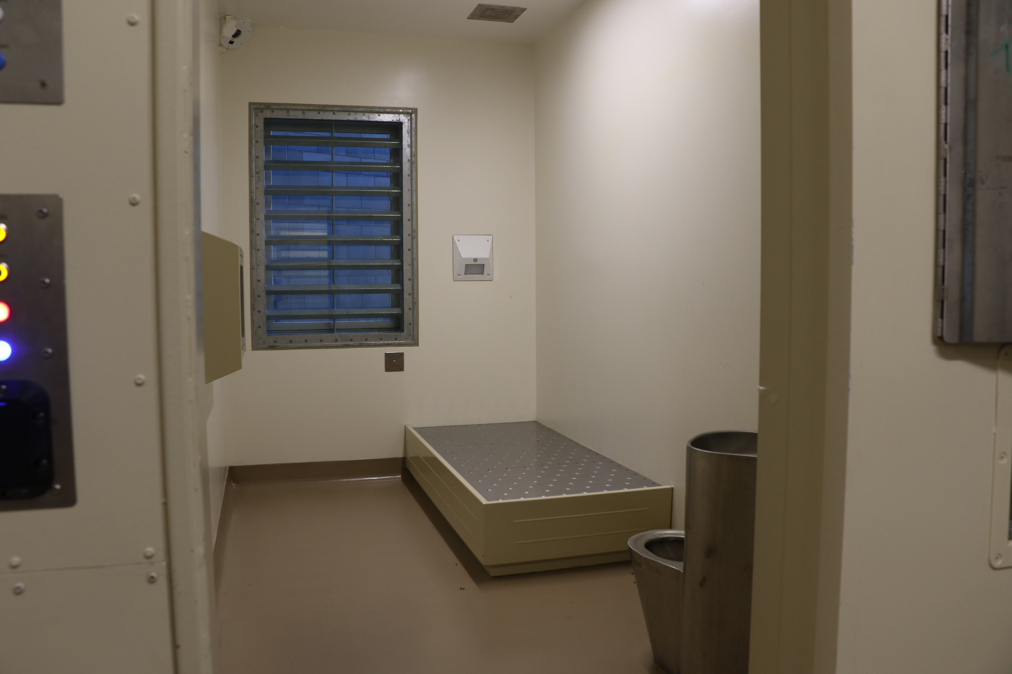 |  | 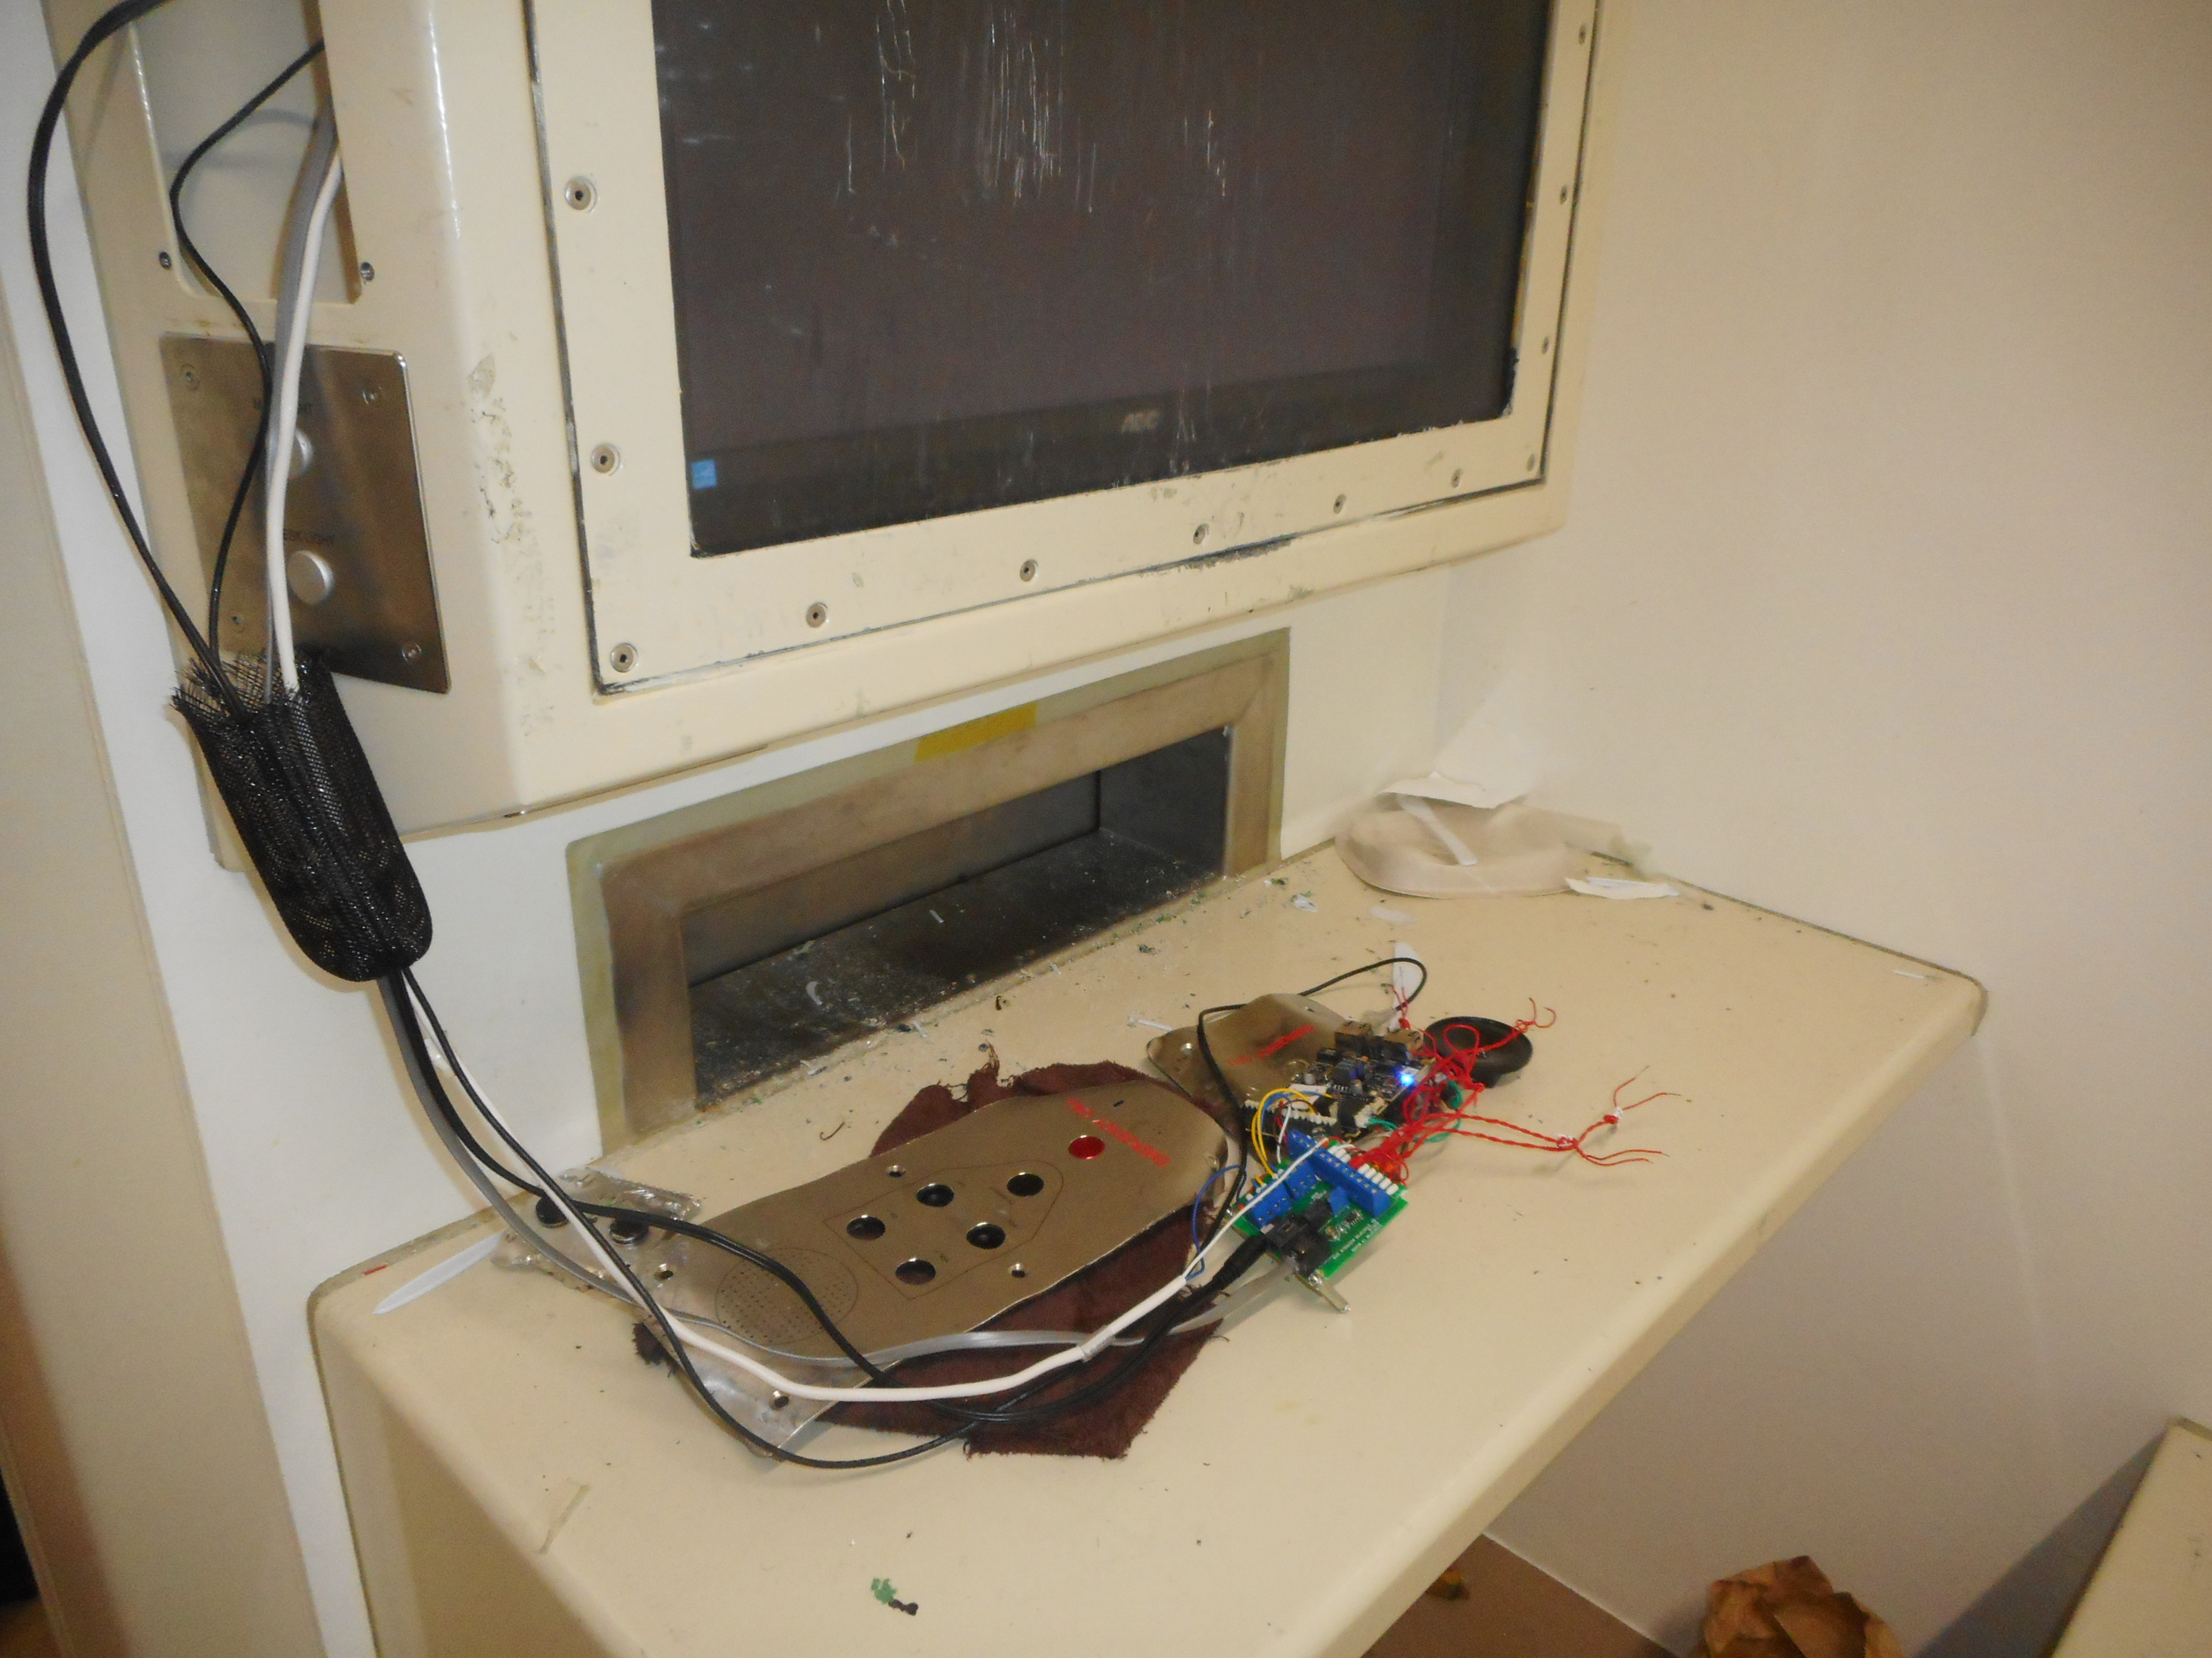
Figure 1: Assessment Unit cell |  | Figure 2: Assessment Unit cell damage

Access to phones
In principle, prisoners in the Assessment Unit could make unlimited telephone calls to approved numbers, including international numbers, at a cost of $2 per week. The amount of time they could spend on the phone, however, depended on their segregation status and management plan. All prisoners received their minimum entitlement of five minutes’ telephone time per week.
The Unit had four telephones for prisoners’ personal use. The minimal contact that prisoners in the Assessment Unit had with the outside world was further curtailed as phone calls could only be made when facilitated by staff, which only occurred during daytime hours. Such practices limited prisoners’ right to maintain meaningful contact with the outside world and are contrary to Rule 58 of The Mandela Rules.
The limited access to telephones was raised as a concern by all prisoners my Inspectors spoke with. Prisoners also expressed frustration at the need to call people during working hours and the inability to make calls on evenings or weekends. One prisoner commented in my survey, ‘they took away weekend phone calls. Everyone I know has a job - you can only call people during working hours – so I can’t speak to anybody.’ Another commented that he was unable to speak to his children as they were in school during the day.
Unit managers had requested portable telephones, which could be trolleyed to prisoners’ cells. While the request had been approved, at the time of the inspection, the Unit had been waiting for over two months to source the cable required.

Segregation paperwork
Between 1 July and 31 December 2019, there were 142 prisoners placed on directed segregation. Inspectors’ review of segregation paperwork within this period identified appropriate levels of approval.
Management plans were completed to the required standard and mostly on time.
Entries were mostly generic, such as, ‘the prisoner needs to maintain compliance with staff instruction’ or ‘needs to display compliance and appropriate behaviour towards staff’. Furthermore, entries lacked detail regarding pathways to prisoner progression out of the Unit and the setting of achievable goals for them to do so. Plans did not substantially change from the prisoner’s initial placement to later periods.

Regime and activities
Despite being considered an ‘Assessment Unit’, in practice, the focus appeared to be based on containment, with one Custodial Officer commenting ‘[they’ll] be here for life’.
Regime provisions for all prisoners were minimal and consisted mostly of one to two hours in the prisoner’s individual yard, and an hour in the unit’s exercise yard or day room. On occasion, two prisoners were able to ‘mix’ during yard time, however, the vast majority of prisoners in the unit exercised alone during the inspection. With the exception of one prisoner who was in charge of the laundry, prisoners had no access to employment. Prisoners in the unit expressed their frustration at having nothing to do, with one prisoner commenting in my survey, ‘I’m stuck in my cell 23 hours – that’s a lot of hours… perhaps if you gave us something to do people won’t harass you’.
Other regime activities included exercising with an Activity Officer during yard time, and limited access to education. At the time of the inspection, only four prisoners in the Unit were listed to attend education. Meetings with education tutors took place behind glass in the interview room. While the Unit had a Secure Online Learning Suite (SOL), my Inspectors were told that it was rarely used due to security concerns.
The Unit had no dedicated area for group activities, and other than emergency hospital visits or court appearances, prisoners spent all of their time within the Assessment Unit.
The security arrangements and impoverished regime meant that there were few avenues for prisoners to demonstrate good behaviour. A number of the prisoners my Inspectors spoke with felt they were being punished.
Staff clearly knew the prisoners in their charge, and staff: prisoner relationships appeared to be reasonably good. All the prisoners my Inspectors spoke with said that there was at least one staff member with whom they got along. However, interactions my Inspectors observed were mostly transactional. Staff in the Unit had informal debriefs to discuss each prisoner in the Unit, which took place three times daily. I consider this to be good practice.

Suicide, self-harm and vulnerable prisoners

Intervention and Support Project
The Prison was one of three pilot sites for the Department’s ‘Intervention and Support Project’ (ISP), which was taking place over a four-year period. The ISP model included a team of clinical specialists, employed at each of the three sites to assess and treat prisoners who are vulnerable to self-harm and suicide. The new model of care allowed for the possibility of prisoners being managed in their ‘home’ unit, if safe to do so, rather than being transferred to the Intervention Support Unit (ISU).
At the time of inspection, the ISP team at the Prison had a complement of seven staff, comprising a Clinical Manager, Clinical Psychologist, Clinical Nurse Specialist, Occupational Therapist, Social Worker, Cultural Support Worker and Administrator. The team were recruiting for a Psychologist and an additional Clinical Nurse Specialist role.
Referrals to the ISP team could be made by custodial staff, Case Managers, Psychologists and the Mason Clinic’s Regional Forensic Psychiatry Service (RFPS). Documentation provided by senior staff showed that, at the time of inspection, the ISP team had a caseload of 27 prisoners. Members of the ISP team provided assessment and, where appropriate, intervention to prisoners across the site. The Occupational Therapist supervised prisoners using the sensory room and sensory garden. There was no limit on the number of sessions a prisoner could have with a member of the ISP team.

Special Needs Unit
The Special Needs Unit (SNU) and the ISU were both located in Unit 11.
The SNU was a dedicated unit for prisoners who had complex and diverse needs, requiring a higher level of care and oversight, and prisoners who were deemed unable to serve their sentence safely elsewhere in the Prison. Custodial staff reported there were higher levels of incidents in the SNU, due to the behavioural challenges and complex needs of prisoners in the unit.
The SNU comprised 50 single cells, spread across three wings. All cells had natural light, and contained a shower and toilet. Cells were modern, air-conditioned and well maintained.
Each of the three wings had its own yard and a day room, containing an information kiosk and a telephone. Inspectors noted that not all kiosks were operational. Cardboard stools and tables had been removed from the day rooms, which meant prisoners were having to sit on the floor to play board games. Prisoners in the day room who needed to access the toilet had to be moved by custodial staff to the yard, which contained a toilet and a telephone. The toilet was located behind a partial screen, offering limited privacy.
At the time of inspection, the SNU housed prisoners of all security classifications as well as remand accused and remand convicted prisoners. Prisoners were also a mix of voluntary segregated and mainstream status. As a result, the SNU was operating a number of different regimes to prevent prisoners mixing. This impacted on the amount of time prisoners were unlocked.
There was a small workshop, which provided employment for up to 12 prisoners from Unit 11. A limited education programme was also available for some prisoners and Activity Officers worked with small groups of prisoners on a rotating schedule.

Intervention Support Unit
The ISU was a dedicated facility for prisoners deemed vulnerable or at risk, and those subject to segregation under section 60 of the Act (segregation for the purpose of medical oversight).
The ISU comprised 16 single cells and two dry cells, divided across two wings with the dry cells in an adjacent area.
ISU cells had natural light and were modern and well maintained. The ISU was air conditioned and had good ventilation, with large opening panels in the roof of the main corridor. All cells were equipped with a TV.
All areas of ISU cells, including the toilets, were subject to CCTV monitoring. CCTV footage was displayed in the staff area, meaning that it could be seen by anyone entering the staff base, presenting a significant privacy issue.
I reiterate my position from previous reports that the ability to observe prisoners undressing, showering or using the toilet, either directly or via CCTV, is a serious breach of privacy and dignity, amounting to degrading treatment under Article 16 of the Convention against Tortureand Other Cruel, Inhuman or Degrading Treatment or Punishment (‘Convention against Torture’).
Each wing had a separate yard and day room, which contained a kiosk, telephone and kitchenette for making hot or cold drinks. Staff had the ability to remotely disable the hot water if there was a safety concern. The ISU also had a sensory room and a sensory garden which were accessible to prisoners under the direct supervision of the ISP team. The sensory room was poorly equipped and the weighted bean bag had been removed. The sensory garden, however, was spacious, well maintained and well stocked with a variety of plants.
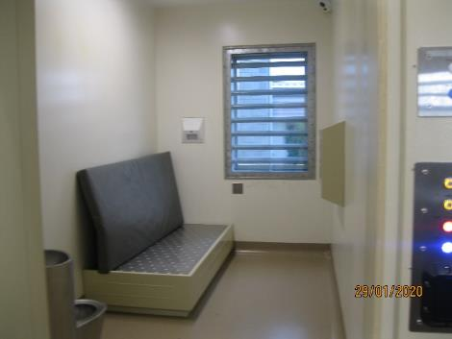 |  | 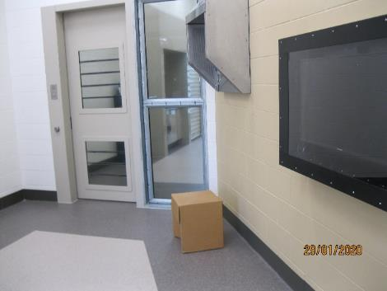
Figure 3: ISU cell |  | Figure 4: ISU day room
At the time of the inspection, my Inspectors did not observe either the sensory garden or sensory room being used.
While a number of therapeutic activities and facilities were available in the ISU, it was disappointing to note that access to these facilities was limited only to those engaged with the ISP team, and only under their direct supervision.
Prisoners in the ISU spent prolonged periods locked in their cells and received one hour yard time and one hour in the day room daily. They were not allowed to interact with each other unless they had the same security classification.
Inspectors observed evening meals being delivered to the ISU as early as 2:30pm.
On admission to the ISU, prisoners were initially placed on 15-minute observations and required to wear anti-rip gowns. As their risk status reduced, prisoners were placed on 30-minute observations and were able to wear standard prison clothing.
My Inspectors did not observe therapeutic engagement occurring between custodial staff and prisoners during the inspection. The Principal Corrections Officer (PCO) met regularly with prisoners in the ISU and appeared to have in-depth knowledge of their support needs; however, custodial staff spoken with did not appear to have a good knowledge of prisoners’ support needs. Staff were recruited to the ISU by submitting an expression of interest internally.
Between 1 July and 31 December 2019 there were 60 admissions to the ISU. The average length of time spent in the ISU was 16 days and the longest period was 437 consecutive days. One prisoner was transferred from the ISU to the RFPS during this period. Prisoners who had prolonged stays in the ISU were discussed at the weekly joint Department and RFPS High Risk Assessment Team (HRAT) meeting.
The High Risk Assessment Team met weekly to discuss the progress and ongoing management of prisoners on the forensic caseload. The meeting comprised the Assistant Health Centre Manager (AHCM), ISP team, a Forensic Psychologist and Registered Nurse, Social Workers, a Department Psychologist and custodial staff. Inspectors attended a meeting and noted discussion was collaborative, comprehensive, and patient-focussed.
At the time of inspection, there were three prisoners in the ISU. Inspectors reviewed the files of all prisoners and noted that management plans were generic, unsigned and without witness signatures.
Prisoners spoken with by Inspectors did not express any concerns about their treatment in the ISU.
I welcome the new ISP pilot. However, it is unsatisfactory that prisoners in the ISU are still being placed in isolation with limited opportunity for therapeutic activities and engagement.

Safety (including voluntary segregation)
There is an expectation that prisoners feel, and are safe from, bullying and victimisation, including verbal and racial abuse, threats of violence and assaults.
The Prison held monthly ‘Safer Custody’ Panel meetings. My Inspectors noted that these were well attended by a range of multi-disciplinary staff and meeting minutes demonstrated a comprehensive approach to managing safety issues. The Prison provided my Inspectors with data on violence-related incidents for a five-month period. Due to the limited data timeframe, my Inspectors were unable to determine if levels of violence in the Prison had increased, decreased or remained the same since the opening of the new facility.
My Inspectors undertook an analysis of incidents (by units) for a three-month period between 1 October 2019 and 31 December 2019. Four-hundred and twenty-two incidents were logged throughout this period. Nearly 70 percent of all incidents occurred in four units (Units 10 to 13). Violent incidents comprised approximately 16 percent of all incidents.
Table 2: Number of incidents per Unit
Unit | Number of incidents | Number of incidents as a percentage
Unit 1 | 29 | 6.87%
Unit 2 | 17 | 4.03%
Unit 3 | 10 | 2.37%
Unit 4 | 26 | 6.16%
Unit 5 | 3 | 0.71%
Unit 6 | 5 | 1.18%
Unit 8 | 5 | 1.18%
Unit 10 | 77 | 18.2%
Unit 11 | 95 | 22.51%
Unit 12 | 47 | 11.14%
Unit 13 | 74 | 17.54%
Other locations | 34 | 8.06%
Total: | 422 | 100%

Thirty-five percent of survey respondents (90) said they had been assaulted while in the Prison, while just over a quarter of those prisoners (24 prisoners) said they reported the incident.
Thirty-two survey respondents (thirteen percent) reported that they had been sexually assaulted while in the Prison. I expect the Prison to address this matter.
As at 29 January 2020, there were 320 voluntary segregated prisoners across the Prison (approximately 60 percent of the Prison population). Units 6 and 8 (120 beds) were dedicated for low security voluntary segregated prisoners, however, numbers across the site were high. Reasons given by prisoners for wanting voluntary segregation varied, but common themes were gang issues, bullying, stand-overs and a fear for personal safety.
Voluntary segregated prisoners were accommodated across seven of the Prison’s 10 units. Unit 13, a maximum security unit, held a particularly high number (64) of voluntary segregated prisoners. The Unit was running mixed regimes, whereby voluntary segregated prisoners were managed on separate regimes to mainstream prisoners.
Managers identified staff shortages as a significant safety issue. At the time of inspection, the Prison had 26 rostered vacancies. Managers explained that vacancies, coupled with significant levels of unplanned absences, meant that both prisoner and staff safety could be compromised.
Of particular concern was that the highest level of unplanned staff absences was in Units 10 and 12, which house the most challenging prisoners who require consistency and specialist expertise. I will address the significant issue of staffing pressures and the associated consequences in each section of my report, due to its visible impact during the inspection.

Staffing
At the time of inspection, staff shortages were having a significant impact on numerous aspects of custodial operation, impacting on day-to-day life for prisoners. On the first day of inspection, one unit was operating without the designated staff to prisoner ratio. Staff reported they were, on occasion, breaching unlock rules and relying on prisoner co-operation in these circumstances.
Information provided to Inspectors indicated that the Prison had 416 staff, inclusive of health professionals, Psychologists and Case Managers. Staff turnover for 2019 was 12.2 percent; an increase from 8.7 percent in 2018, and 6.7 percent in 2016. In 2019, the Prison had approximately 34 full-time equivalent (FTE) vacancies across the site.
Average staff sick leave in 2019 was approximately 10.6 days.
At the time of inspection, 36 staff members were not working or were unavailable to be rostered due to secondments, leave without pay, ACC or other sickness, parental or maternity leave (approximately 8.6 percent of staff).
Information provided by the Prison also detailed that 55 staff were either seconded to the Prison, seconded to another area within the Prison or in an acting position. During the course of the eight-day inspection, the Prison was managed by three different individuals in the Prison Director role.
Just over 30 percent of staff at the Prison had less than two years’ experience and almost 53 percent had less than five years’ experience.

Drugs
I consider a key driver of violence in prisons is the introduction and use of non-prescription drugs. The Prison had a well-designed drug testing facility and sample taking area, with three large holding cells. The facility had been developed as part of the new build. However, the Prison was struggling to meet national drug testing standards.
The Prison had two Drug Collection Officers (DCOs). DCOs were required to carry out approximately six tests per day to meet national targets but data showed that, on average, only three tests per day were carried out. DCOs were routinely reassigned to cover other roles as a result of staff shortages. Inspectors observed one DCO covering gatehouse duties. DCOs had also been allocated responsibility for parole board supervision. Staff reported that during 2019 there were in excess of 100 days where drug testing could not be conducted.
The Prison did not have a process for referring prisoners with Identified Drug User (IDU) status to any form of drug treatment, including brief intervention programmes.
Thirty-nine percent of survey respondents reported having a drug problem when they came to the Prison. Sixteen percent of respondents reported having a drug problem at the time of the survey.

Gangs
According to the figures provided by the Prison, 28 percent of the Prison population identified as gang members or affiliates. The Prison provided Inspectors with the Gang Strategy policy document (the Gang Strategy), and gang management was addressed at the Safer Custody meetings. The Gang Strategy identified key challenges for the Prison including, but not limited to: gang members’ use of violence and intimidation to control various ‘outcomes’; gang members negatively influencing those under the age of 25; the introduction of contraband; and a lack of cohesion when managing the activities of gang-affiliated prisoners.
Prison management reported that they managed gang-related risk by separating rival gangs. Staff reported that the recent increase in remand prisoners had impacted on the ability to accommodate gang members in the most appropriate units. My Inspectors reviewed the placement of prisoners in both Units 12 and 13 as at 3 February 2020 using the Integrated Offender Management System (IOMS) and found of the 80 prisoners in Unit 12 all were gang-affiliated. Prisoners in this unit were affiliated to 11 different gangs with approximately 52 percent affiliated to two gangs. Approximately 68 percent of prisoners in Unit 12 were affiliated to 11 different gangs. The complexity of gang dynamics in these units posed safety risks for both prisoners and staff.
Fourteen additional survey comments were made by prisoners in relation to gangs at the Prison. Two survey respondents commented:
Being jumped, constant threats to join gangs, I refused to join so I was beaten […]Because then my name would be marked all over prison as a SNITCH which would make things worse.
The staff do not take/pay enough attention to the Alerts of the prisoners. They just chuck you anywhere with anyone, even if you have alerts against you, or other prisoner.
I acknowledge the complexity of managing a high number of prisoners affiliated with various gangs. I note that, as part of the Prison’s Gang Management Strategy, a review of prisoner placement in Unit 12 is planned, and look forward to seeing its findings.

Recommendations – treatment
- I recommend that:
  - On-body cameras are always operational and turned on prior to use of force, and footage is saved as required.
  - Use of Force paperwork is comprehensive and accurate, including when pepper spray is deployed.
  - Use of Force incidents are subject to timely and comprehensive review to ensure records align with CCTV footage.
  - The Prison Director ensures robust processes are in place to ensure incidents of Use of Force are referred to the Police in a timely manner at prisoners’ request.
  - The Prison Director develops and implements a strategy to prevent sexual assaults on prisoners.
  - The practice of ‘single unlock regimes’ ceases.
  - Time prisoners spend in the Assessment Unit should be as short as possible, and subject to ongoing assessment and review. Paths for progression out of the Assessment Unit should be clear, specific and achievable.
  - Portable telephones be made available to prisoners in the Assessment Unit as needed, including in the evenings and at weekends.
  - Constructive and purposeful activities need to be increased for prisoners in the Assessment Unit and ISU.
  - Measures are taken to ensure the privacy of prisoners in the ISU when showering or using the toilet.
  - Prisoner-centric management plans be developed to assist prisoners while they are in the ISU and on their return to mainstream units. Paths for progression out of the ISU should be clear, specific and achievable.
  - The Prison Director ensures staffing levels are consistent with those prescribed by the Department.

The Department of Corrections accepted recommendations 1a, 1b, 1c, 1d, 1e, 1g, 1h, 1i, 1j, 1k and 1l.

Corrections partially accepted recommendation 1f and stated:
Your inspectors noted some prisoners were subject to single unlock regimes which meant the prisoners had no association with other prisoners. In effect, you consider this to be a segregation regime without the necessary statutory safeguards.
Auckland Prison considers the safety of Corrections’ staff and prisoners is paramount. Due to the environment of the prison’s maximum-security unit and the types of prisoners housed in this unit, the practice of single unlock regimes cannot cease for all prisoners as this raises concerns regarding the safety and security of both prisoners and staff at Auckland Prison. The single unlock regime is only used as a last resort action to ensure the safety of all in the prison.
Auckland Prison has ensured that staff are now completing the appropriate segregation paperwork to correspond with anyone on a ‘single unlock’ regime.
Examples where single unlock can occur include:
Directed Segregation pursuant to sections 58, 59 and/or 60 of the Corrections Act 2004. However, only when they have been assessed and approved as having their association with others denied (‘denied association’).
A prisoner who will voluntarily segregate and deny their own association because they greatly fear for their safety.
In either of these cases the Prisons Operating Manual (POM) section M.07 (Directed Segregation) and section M.01.05 (voluntary segregation) is adhered to in order to ensure an individual prisoner’s risk is assessed and mitigated. This can sometimes lead to prisoners appropriately being denied association for the safety of others or for their own safety.
Prisoners are able to complain both internally and externally should they not agree with their segregation, and the independent review of segregation orders through a Visiting Justice or the Senior Adviser to the Regional Commissioner acts as further safeguards.
Notwithstanding this, further work will be completed by the Custodial Systems Manager to further review the current status of prisoner unlock regimes across the entire site to ensure the necessary statutory assessments and approvals are in place. This review will be completed by 25 September 2020 with any next steps taking place at this time.
I am pleased the Department reports segregation assessments and approvals are now completed for all prisoners subject to ‘single unlock regimes’. It is imperative these safeguards are enacted when prisoners have limited or no association.

Criterion 2: Reception into prison
Expected outcomes – reception into prison
On arrival at Prison, prisoners are safe and treated with respect. Risks are identified and immediate needs met before prisoners move to their allocated units.
The Prison complies with administrative and procedural requirements of the law. There is a structured process to provide every prisoner with all necessary information about their rights, responsibilities and entitlements, the Prison’s expectations of them and the operating and administrative arrangements pertaining to their detention.

Assessment

Receiving Office
The Receiving Office (RO) was open Monday to Friday, from 6am to 8pm. An average of 43 prisoners arrived at the Prison each week and 13 prisoners were released or transferred. FIRST Security staff escorted prisoners transferred to Northland Region Corrections Facility; custodial staff undertook all other transfers.
My Inspectors observed the reception and transfer process for eight prisoners and identified it to be good. New arrivals were promptly disembarked from escort vehicles. Procedures for admission, transfer and release of prisoners took place in a well-designed, modern facility. There were 10 holding rooms in the RO, each with a screened toilet and TV. RO staff liaised effectively with other prisons to plan for new arrivals and transfers. RO processes were carried out efficiently and staff dealt with prisoners politely. Systems were in place to deal with the additional demands presented by an increasing remand population.
On arrival, all prisoners were strip searched in a discrete area off-camera before being issued with prison clothing and bedding. Strip searches were carried out with sensitivity and according to prescribed guidelines. Reception interviews commenced shortly after the prisoners’ arrival where custodial staff identified immediate needs. However, my Inspectors noted that between 1 July and 31 December 2019, only 92 percent of Immediate Needs Assessments were documented.
Results of my survey indicated that 107 prisoners (42 percent) reported having problems when they first arrived at the Prison.
Custodial staff and health services staff conducted initial reviews and at risk interviews with prisoners in private. However, Inspectors noted health services staff interviews lacked sufficient depth to detect safety concerns, such as risk of self-harm. Data provided by the Prison showed that between 1 July and 31 December 2019, only 88 percent of Reception Risk Assessments were documented.
Prisoners’ in-possession property was methodically recorded and issued at the time of reception. However, access to stored property was a source of frustration for 50 percent of survey respondents. There were 54 complaints relating to property for the period 1 July to 31 December 2019.
New arrivals were moved through the RO process quickly. My Inspectors followed three new arrivals and noted that they arrived in their unit within an hour of arrival to the Prison.
Initial phone calls, meals and access to toiletries were facilitated in the units.
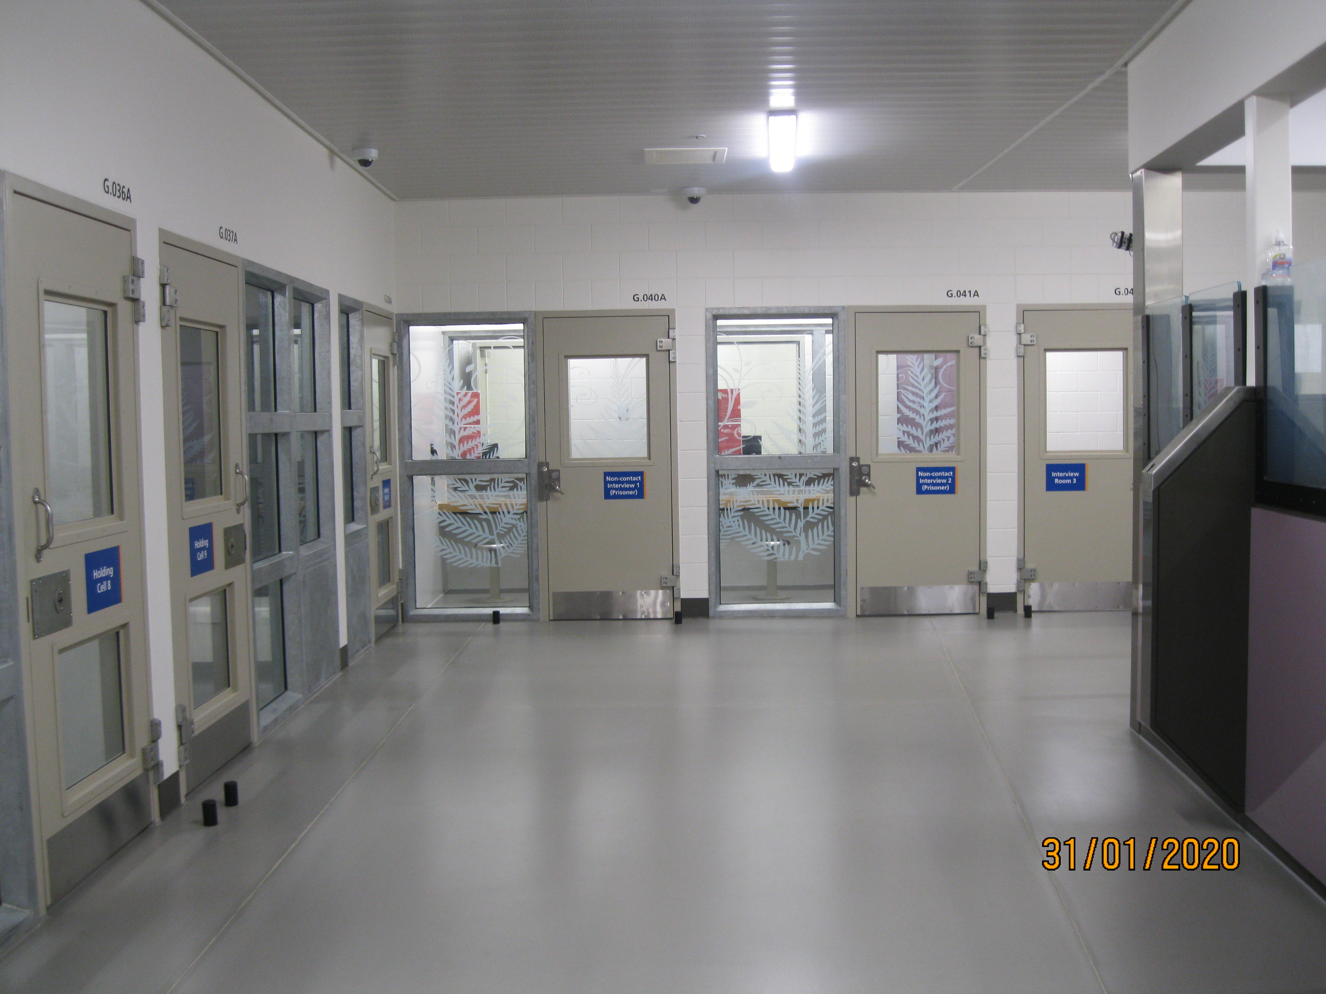 |  | 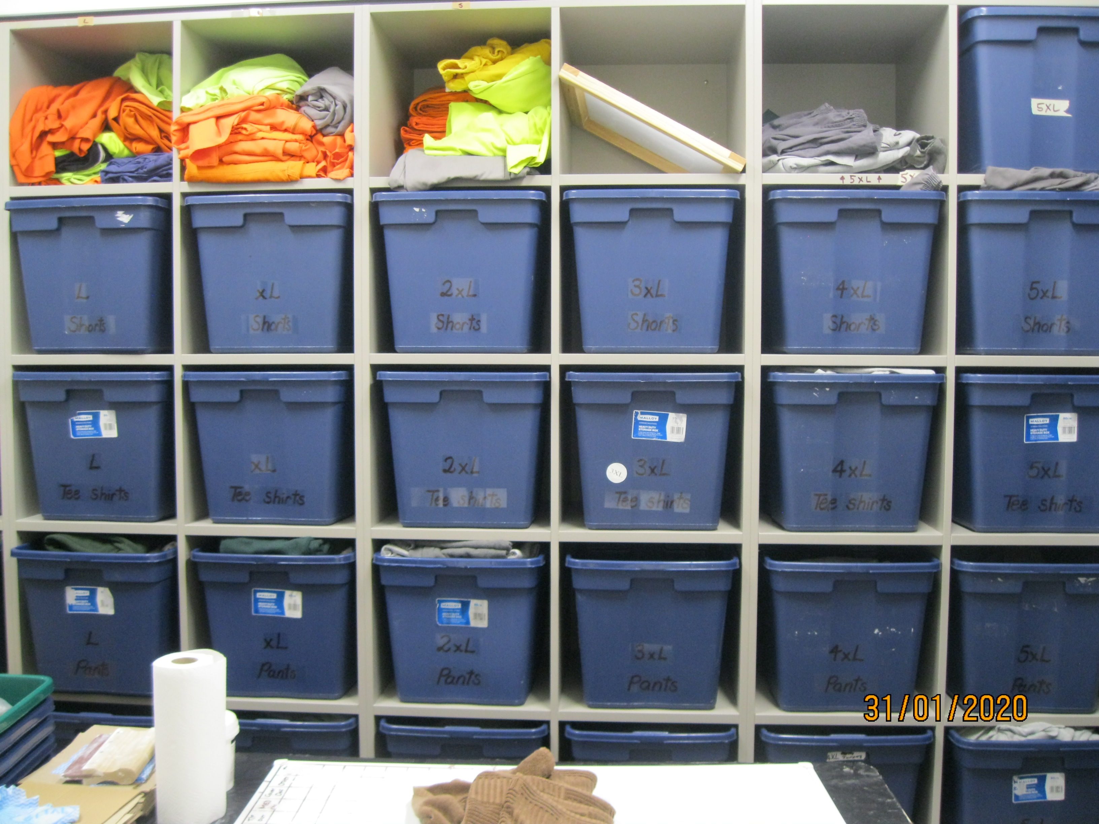
Figure 5: Receiving office |  | Figure 6: Property storage

Induction
There were no dedicated first night cells and so prisoners were allocated accommodation according to their security classification and bed availability. Inspectors observed the induction process for prisoners in Units 4, 8 and 13. Induction processes, which were largely mechanical in nature, varied. My Inspectors followed the progress of a prisoner who had transferred from another prison. He was aware of the reason for his transfer, was able to describe how he could contact his family and demonstrated a satisfactory level of understanding about unit routines. He confirmed that he had received his initial phone call and a leaflet about the unit.
My Inspectors noted that between 1 July and 31 December 2019, only 77 percent of Induction Interviews were completed within the required timeframe.
There were 168 foreign nationals in the Prison at the time of inspection. Induction arrangements for foreign nationals, speakers of other languages, and those with literacy issues were poor. The Prison was unable to provide translated versions of key information, such as the unit information/induction booklet. Some staff were aware of the Ezispeak translation service, while others still referred to it as Language Line.
According to the Department’s Custodial Standards of Practice, a prisoner should be assigned a Case Officer within three days from being transferred to a new unit. Between 1 July and 31 December 2019, only 74 percent of prisoners were assigned a Case Officer within timeframes. Sixty-four percent (167) of survey respondents reported that they did not meet with their Case Officer within their first week, and 82 percent (215) reported that they did not meet with their Case Officer at least weekly. It was not clear what action the Prison was taking to improve performance in this area.
The delay in Case Officer assignment made it difficult for foreign nationals, speakers of languages other than English, and those with literacy or communication difficulties to orientate themselves to the Prison. This caused difficulties with understanding unit rules as there was little information available for prisoners who did not speak English.
Arrangements for the reception, induction, and ongoing supervision of foreign nationals were insufficient, with an over-reliance on on-line translation services.
Recommendations – reception into prison
- I recommend that:
  - Prisoners have access to appropriate and timely reception, immediate needs and induction processes. This includes the allocation of a Case Officer within three days of arrival in a new unit.
  - Induction arrangements for foreign nationals, speakers of languages other than English, and those with literacy or communication difficulties are improved to ensure those prisoners are fully aware of the Prison’s procedures and how to access support.

The Department of Corrections accepted recommendations 2a and 2b.

Criterion 3: Decency, dignity and respect
Expected outcomes – decency, dignity and respect
The Prison employs fair processes while ensuring it meets the distinct needs of all prisoner groups irrespective of age, disability, gender and sexual orientation, race, religion and belief. A climate of mutual respect exists between staff and prisoners.
Prisoners live in a clean and decent environment which is in a good state of repair and fit for purpose. Each prisoner has a bed, bedding and clean suitable clothing, has good access to toilets and washing facilities, is provided with necessary toiletries and cleaning materials, and is properly fed. The Prison supplies the basic requirements of decent life to the prisoners.

Assessment

Accommodation
The Prison had two operational low security residential units (6 and 8), five high security residential units (1–5) and four maximum security residential units (10–13).
Generally, accommodation standards were good. All cells were single occupancy and were clean, bright and well-maintained in both the low and maximum security areas of the Prison.
All cells in Units 10–13 had in-cell integral sanitation and shower facilities. In both low and high security units showers were shared and located within the units. Some of the shower facilities in Units 1–5 had mould and ventilation issues. Some cells in Units 1-5 had limited natural light.
The Prison was implementing a painting and renovation programme for Units 1–5, including repainting the shower facilities. The programme involved decommissioning units while work was being completed. Two high security units had been redecorated and reoccupied. One unit was undergoing renovation during inspection, while two units were awaiting work.
Inspectors observed large amounts of rubbish and food waste in external open areas in close proximity to Units 1–5. Prisoners were reportedly throwing rubbish outside the windows of the dining room and recreation areas. The food waste attracted large numbers of ducks that defecated in the area.

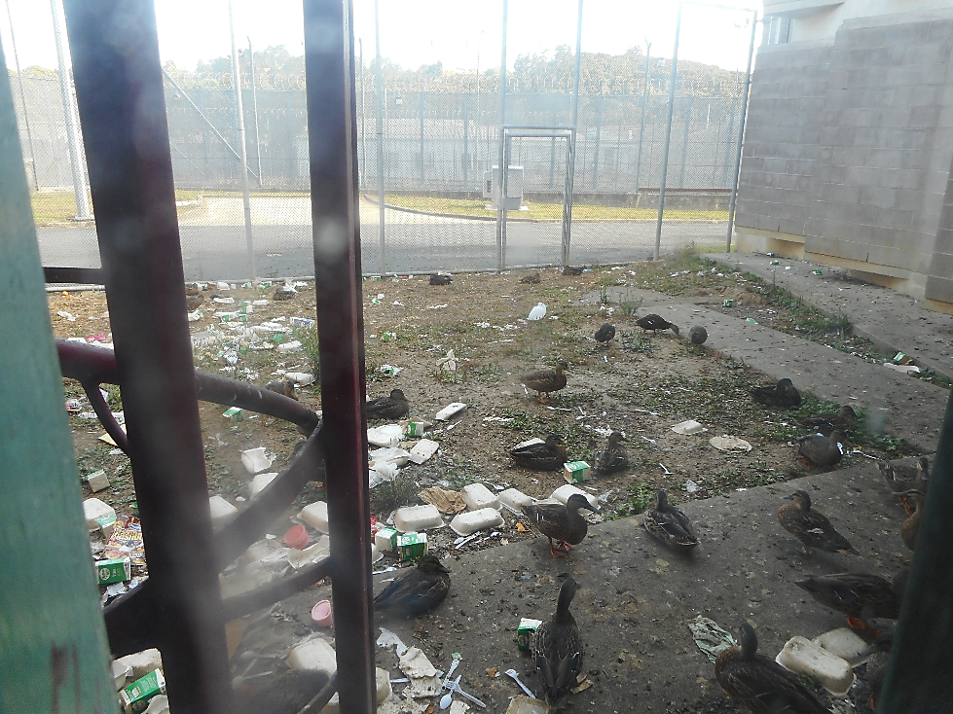
Figure 7: Waste in external area outside Units 1–5

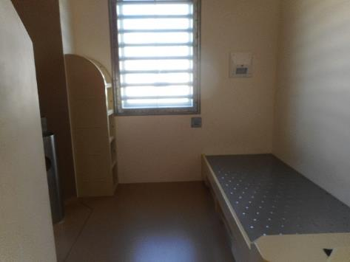 |  | 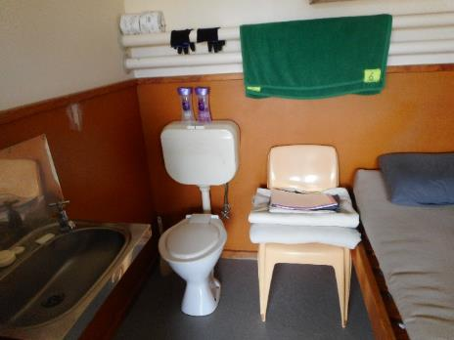
Figure 8: Empty cell – Unit 13 |  | Figure 9: Standard cell – Unit 6

A lack of ventilation in the low and high security cells was an ongoing and unresolved problem. Staff in Units 6 and 8 expressed concern at the high temperatures and the impact on prisoners attempting to complete programme homework in hot and stuffy locked cells. Cell temperatures measured during the inspection exceeded 30 degrees Celsius. The Prison did not have a robust heat management strategy in place.

Clothing and bedding
Clothing and bedding supplies in the low security units were plentiful and in generally good condition. Stock rooms in these units were well organised.
In contrast, clothing provision for prisoners in the high and maximum security units was limited. Sixty-six percent of survey respondents reported that they were offered enough clean and suitable clothing for the week. However, this figure reduced to 19 percent in Unit 12, and 46 percent in both Units 1 and 13.
Thirty-two percent of all survey respondents reported not regularly receiving clean sheets each week, with this figure rising to 82 percent in Unit 12.
The quality of mattresses and pillows in Units 1–5 was variable.

Food and meal times
Rule 22 of the Nelson Mandela Rules states ‘Every prisoner shall be provided by the prison administration at the usual hours with food of nutritional value adequate for health and strength, of wholesome quality and well prepared and served’.
Meal times across the Prison did not reflect usual meal times, an issue that is of concern to me across the prison estate. The Department has acknowledged that there are certain limitations to the current eight-hour shift structure in issuing meals to prisoners, conducting muster checks, and lock up times. The Department was in the process of reviewing prisoner meal times nationally, as part of its ‘Making Shifts Work’ project.
Inspectors noted that evening meals were delivered to the maximum and high security units around 2.45pm and issued to prisoners as early as 3.30pm. On one occasion, Inspectors observed the evening meal being served to prisoners at 2.30pm in Unit 11. Inspectors were informed that early distribution of meals allowed staff to leave the Unit to fill staffing shortages on Unit 12.
All prisoners in the maximum and high security units ate their meals in their cells. Prisoners in low security units could elect to eat their meals in communal dining areas.
A new national menu had recently been introduced and prisoners’ feedback to Inspectors regarding the quantity and quality of the food was generally positive. Twenty-nine percent of survey respondents described the quality of food as ‘good’ or ‘very good’, while 24 percent thought it was ‘bad’ or ‘very bad’. Forty-seven percent of respondents described the quality of the food as ‘average’.
The kitchen facilities were good, with generally high standards of cleanliness and hygiene. The Prison kitchen followed the national menu and provided a four-weekly menu. Prisoners requiring a special medical, cultural, or religious diet were catered for.

Prisoner canteen
Prisoners raised concerns to Inspectors regarding the high cost of items on the F.05 list (canteen list). Seventy-five percent of survey respondents said the F.05 did not sell the items and food supplies they needed.

Staff-prisoner relationships
My Inspectors observed generally relaxed and courteous relationships between staff and prisoners in Units 6 and 8. Staff in these units regularly interacted with prisoners and demonstrated a sound knowledge of prisoners in their charge.
In contrast, interactions observed between staff and prisoners in Units 10–13 were primarily transactional. Relationships were generally not well established. This was compounded by a lack of continuity in staff deployment in Units 12 and 13 and the limited time available to staff to carry out their range of duties. The absence of established relationships in the maximum security units undermined the quality of dynamic security and led to an over-reliance on the physical security arrangements of the facility.
One hundred and seventy-six survey respondents (69 percent) stated that there was a staff member they could turn to for help if they had a problem. Seventy-five percent of survey respondents reported that most staff treated them with respect. However, only 41 percent of survey respondents from Unit 12 stated there was a staff member they could turn to for help.
Additional comments in several prisoner surveys detailed accounts of bullying and intimidation by staff. These accounts appeared to centre on several of the same custodial staff.
Thirty-eight percent of survey respondents stated that they had been victimised by staff in the Prison, while approximately 20 percent stated they had been victimised by both staff and other prisoners. This figure was particularly pronounced in Units 5 and 12, where 62 percent and 56 percent of survey respondents reported being victimised by staff respectively.
Sixty-nine prisoner complaints relating to staff conduct and attitude had been lodged between 1 July and 31 December 2019.

Equality and diversity
The Prison did not have an Equality and Diversity strategy, however, I am aware the Department has drafted a national Inclusion and Diversity strategy. I look forward to this strategy being finalised and embedded in the Prison’s culture.
Staff advised my Inspectors that there were no literacy identification processes for prisoners who had difficulties with verbal or written communication. Staff noted that if a prisoner did require assistance, other prisoners would usually assist them. Custodial staff were unable to confirm which prisoners required additional support in this regard. One survey respondent commented, ‘they gave me a whole lot of paper and said all the info is in there but did not explain cause I can’t read’.

Prisoners with disabilities
Article 1 of the United Nations Convention on the Rights of Persons with Disabilities provides that people with disabilities includes those who have long-term physical, mental, intellectual or sensory impairments which in interaction with various barriers may hinder their full and effective participation in society on an equal basis with others.
Impairments can be physical, visual, hearing/speech centred, intellectual or mental. An impairment may be temporary, intermittent or ongoing. People may acquire impairment through an accident or illness, or may be born with an impairment.
The new facility was well designed so that prisoners with mobility needs, or other physical impairments, were provided with reasonable accommodation. Units in the new build had designated disability cells that were equipped with handrails and could accommodate a wheelchair. Prisoners could shower in a seated position in these cells.
In contrast, both the high and low security units were not suitable for prisoners with physical disabilities. All high security units were split-level, requiring prisoners to use stairs to enter and exit the units. There were no ramps to cells or shower facilities in the low security units, and no support handrails. Access to dining areas was also problematic. One frail prisoner, who used a walker for support, had recently fallen in a low security unit. Staff raised concerns about the absence of ramps and disability cells in their unit.
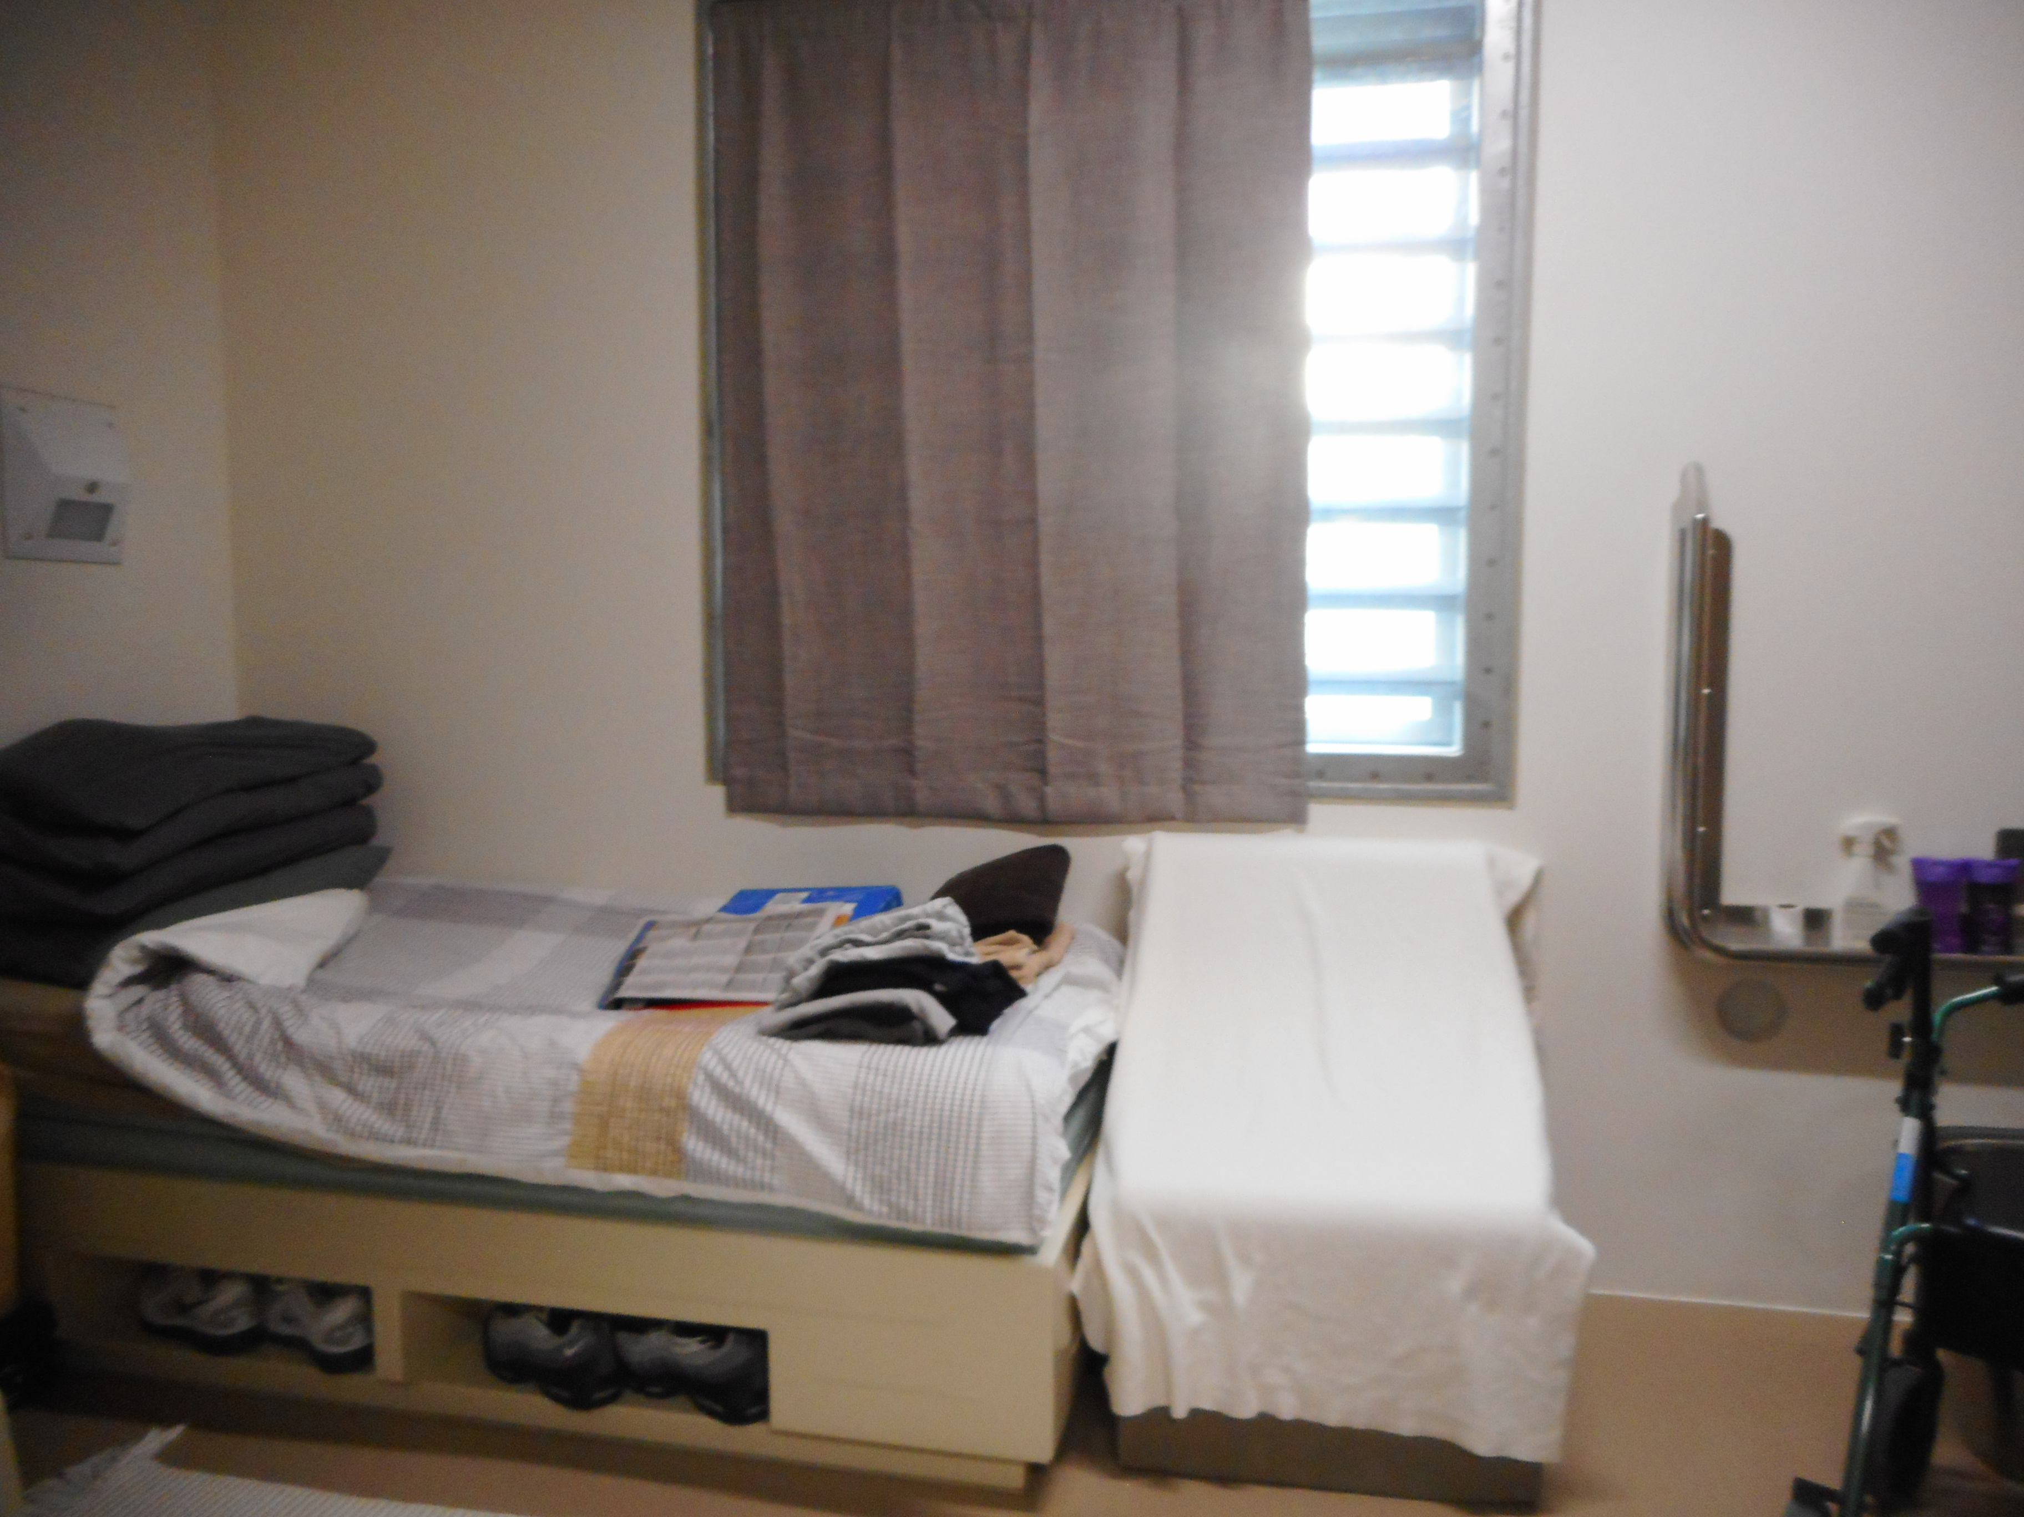 |  | 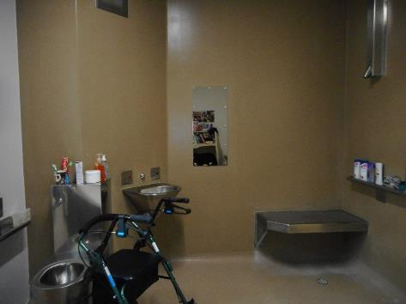
Figure 10: Disability cell – Unit 12 |  | Figure 11: Disability cell – Unit 12

Transgender prisoners
Health services at the Prison were making efforts to provide tailored services for transgender prisoners. However, concerns were raised with my Inspectors concerning the use of derogatory language and misgendering pronouns by some custodial staff. One survey respondent commented:
‘I have been called faggot, puffta, mofi, bitch, big cock, nothing but a man in a frock etc by staff. At least when it’s another inmate we are on the equal footing so I can give it back or fight. When its staff however there is an asymetrical distribution of power and I am therefore powerless.’
However, Inspectors also observed areas of good practice in terms of practical support for transgender prisoners by some Case Officers and Case Managers.
Transgender prisoners could order canteen items through the women’s prison paper-based order form.

Cultural provision
Information provided by the Prison indicated that, at the time of the inspection, 273 tāne identified as Māori (approximately 53 percent).
The Prison did not actively provide cultural support and there was no evidence of a coordinated approach or institutional commitment to cultural provision.
Approximately 70 percent of survey respondents said they could not access cultural services. Several staff members were making positive individual efforts and initial wānanga had been held to discuss Hōkai Rangi. Some prisoners were also teaching te reo Māori and tikanga Māori on the units and wanted to gain formal qualifications to continue teaching in these areas. However, there was not a clear process for these prisoners to access the support they needed to achieve this goal.
Information provided by the Prison indicated that there had been six visits from Kaiwhakamana in the six months prior to the inspection. Only one of the two Kaiwhakamana who had visited the Prison in the previous six months was still approved as a Kaiwhakamana at the time of the inspection. Staff told my Inspectors that the inaccessible and restrictive environment of the Prison contributed to the infrequency of visits from Kaiwhakamana.
My Inspectors spoke with prisoners, staff, service providers and mana whenua representatives about the implementation of the Department’s Hōkai Rangi strategy and the relationship between the Prison and mana whenua.
My Inspectors were informed that initial conversations about Hōkai Rangi had taken place, but that few practical steps had been taken to implement the strategy. Inspectors heard from prisoners, external providers, and staff that more resources for te reo Māori and tikanga Māori were required. Staff and providers also told Inspectors that there was a need for more Māori staff, particularly in senior positions at the Prison.
Mana whenua representatives told my Inspectors they would like to see more focus on reintegration, including bringing knowledgeable people into the Prison to, for example, teach meditation exercises to prisoners to uplift their wairua and reduce recidivism.
Descriptions of the Prison’s relationship with mana whenua varied. Some staff characterised the relationship as non-existent. Mana whenua and other staff were more positive about the relationship, highlighting mana whenua involvement in important formal occasions and representation from the Department at monthly Te Kaunihera Kaumatua hui.
I am pleased to hear that the Prison is considering how to implement Hōkai Rangi and that there are mechanisms in place for communication between the Prison and mana whenua. I consider, however, that the Prison needs to give greater priority to the implementation of Hōkai Rangi. I also expect the Prison to take steps to strengthen the relationship with mana whenua further. I will continue to monitor progress in these areas on future inspections.

Recommendations – decency, dignity and respect
- I recommend that:
  - Arrangements to improve ventilation in the high and low security units are identified, implemented and monitored to ensure appropriate temperatures are consistently achieved.
  - The serving of meals is standardised to normal hours. This would involve lunch being served any time between midday and 1.30pm and dinner to be served anytime between 5pm and 7pm.
  - Dynamic security training is provided for staff, particularly staff in Units 12 and 13.
  - The Prison ensures all transgender prisoners are treated with dignity and respect.
  - Sufficient, suitable accommodation should be provided for all prisoners with disabilities.
  - The Prison prioritise, implement and protect kaupapa Māori practices and programmes.
  - Prison management strengthens its partnership with iwi Māori, including by engaging kanohi ki te kanohi with mana whenua representatives on a regular basis.

The Department of Corrections accepted recommendations 3a, 3c, 3d, 3e, 3f and 3g.
Corrections partially accepted recommendation 3b and stated:
Corrections has acknowledged in past responses to your office there are certain limitations to the current eight-hour shift structure in issuing meals to prisoners, conducting muster checks and the lock up times. In addition, the current staffing levels per shift and shift patterns does not always allow the serving of meals at other times.
Corrections is working to provide foundational infrastructure to enable flexible work practices and a modern rehabilitation-focused prison system, supported by up-to-date and effective technology. This is an ongoing focus and we are not yet at a stage where we can confirm any changes to the current mealtimes in our prisons.

As your office is aware, Making Shifts Work has been an ongoing project that will influence the timing of prisoner meals. Making Shifts Work is a partnership project with the Department of Corrections, the Corrections Association of New Zealand and the Public Service Association to improve staff wellbeing, safety and operations in our prisons. As part of the project Corrections has established a standard of normalised meals, with no more than 14 hours between dinner and breakfast, seven days a week.
This will be enabled by longer shifts in residential units for our custodial staff. Manawatu Prison was the first site to adopt the change on 13 July 2020. Otago Corrections Facility implemented the change from 24 August 2020, followed by the remainder of our prisons in a structured roll-out over the next few years.
I expect the implementation of Making Shifts Work to ensure the serving of meals is standardised to normal hours for prisoners.

Criterion 4: Health and wellbeing
Expected outcomes: health and wellbeing
The Prison takes all necessary steps to ensure the wellbeing of all prisoners. Patients are cared for by services that assess and meet their health and substance use needs and promote continuity of care on release. Patients are treated with dignity, respect and compassion and their right to privacy is respected.

Assessment

Governance arrangements
The minimum standard for the health care of prisoners is set out under section 75 of the Act. Section 75 provides that a prisoner is entitled to receive reasonably necessary medical treatment, of a standard reasonably equivalent to the standard of healthcare available to the public.
Health services were provided by the Department with specialist contractor input, such as GP and dental provision.
There was no local health service strategic plan. Inspectors were informed that a process for identifying emerging trends in healthcare needs, such as an annual health needs analysis, was being developed.
The Prison also did not have a health services cultural strategy. The health service referred Inspectors to the Hōkai Rangi national strategy. However, my Inspectors found no evidence that Hōkai Rangi was being implemented in health services.
There was no co-ordinated approach to meeting the needs of disabled prisoners. Health services did not hold a definitive list of those with a disability. However, an indicative list of disabled prisoners, as identified by nursing staff, was provided to Inspectors. Twenty-three percent of survey respondents reported that they had a physical disability, 76 percent of whom reported that they did not feel supported with their disability needs.
Health services were delivered from different locations in the Prison. Nursing and GP clinics for Units 1–5 and specialist care, such as the dentist or radiography services, took place in Health Central Services. Satellite clinics operated in all other units of the Prison. All clinic rooms were clean and well equipped, and had handwashing facilities.
Health services at the Prison were managed by the Health Centre Manager (HCM). The HCM was supported by an Assistant Health Centre Manager (AHCM) and a Clinical Team Leader (CTL). There had been significant turnover in leadership of the health services over the previous two years, which had been disruptive for health services staff. My Inspectors noted that the current leadership provided a stable and positive environment for the health services team.
Quarterly clinical governance arrangements had recently been re-established. The Prison’s health service had Cornerstone accreditation.
The health services team included 15.4 FTE Registered Nurses (RN). The health services also included 1 FTE Enrolled Nurse (EN) and 1.8 FTE Assistant Support Officers (ASO). At the time of inspection, there were vacancies for 4.3 RN/EN FTE. Two RNs had been recruited and were due to start shortly after the inspection.
Health services were provided from 6am to 9pm. A rostered on-call RN provided after-hours health services, with an additional RN rostered if circumstances required it.
Emergencies were transported either to Auckland Hospital or North Shore Hospital. There was an emergency trolley in Health Central Services and emergency bags located in Units 6, 8 and 12. An emergency bag was being assembled for Unit 11 at the time of the inspection.
Inspectors noted that daily tamper checks on emergency bags were not being routinely carried out.
Health service staff told my Inspectors that the work was varied, and that they had support and autonomy in their roles. Formal clinical supervision was not in place. There were opportunities for professional development and several RNs had portfolio responsibilities in areas such as diabetes, hepatitis and infection control. However, health staff told Inspectors that they rarely had an opportunity to focus on their portfolio responsibilities because of workload pressures. All RNs had a current practising certificate.
Inspectors observed respectful, positive and constructive interactions between health staff and patients. My Inspectors also saw positive relationships between health services staff and other staff in the Prison. However, my Inspectors also observed occasions where tensions were evident between health services and custodial staff.
My Inspectors found MedTech records to be comprehensive. There was evidence of patients being referred to specialist contractors and to external appointments. However, Inspectors found examples where MedTech notes indicated that a referral had been made but no referral documentation was available.
The Prison did not have a separate health complaint process. While there was a specific health complaint form, and health services were responsible for responding to these complaints, health complaints were still recorded in IOMS.
Between 1 July and 31 December 2019, 44 complaints relating to health services were recorded in the general complaint system. The most common complaints related to delays in health service provision, though there were also several complaints about missed medication rounds and provision of incorrect medication. Almost half of all complaints recorded in IOMs included both the initial complaint and the response from the HCM or ACHM.
I consider that these processes failed to ensure the security of patients’ health-related information and breached patient confidentiality.
When prisoners were asked what they thought of the overall quality of the health service, 45 percent of survey respondents said it was ‘good’ while 38 percent said it was ‘bad’.

Primary health care services
On arrival at the Prison, all prisoners received a Reception Health Screen (RHS) by an RN, which included mental health and substance misuse. The RHS was conducted in a non-contact room with a Custodial Officer outside.
Inspectors observed the RHS of three prisoners. The RHS was not detailed and lacked structure, and consent forms were not explained in any detail. Inspectors found that while high-level notes of the assessment were entered in MedTech, the standard assessment and documentation tool for the RHS was rarely used.
My Inspectors checked the MedTech records for prisoners whose RHS they had observed to see whether an Initial Health Assessment (IHA) had been booked following the RHS. Inspectors also checked the records for a further three prisoners who had arrived at the Prison during a one-week period in the month prior to the inspection.
Only one of the six files reviewed contained an IHA completed in the Prison. The three arrivals whose RHS Inspectors had observed had all been booked for an RN or GP clinic, at which an IHA may have been planned. The remaining two records had an IHA on file, but these had been completed in another location prior to transfer into the Prison.
Access to healthcare was initiated by the prisoner completing a ‘Health Request Form’. The RNs collected the forms daily from locked boxes in the units and they were then triaged in Health Central Services.
At the time of inspection, there was a wait time of between seven and 23 days for a prisoner to secure a health appointment, depending on which unit the prisoner was accommodated in. Urgent cases could be seen more promptly. Thirty-five percent of survey respondents said that it was difficult to see the nurse, with 56 percent reporting that it was difficult to see the doctor.
The GPs provided clinics at the Prison from Monday to Friday. GP clinics were supported by a dedicated nurse. Inspectors observed that having dedicated nursing support for the GP was efficient and effective.
Where necessary, patients were referred to external health specialists. Health services were not able to provide data on the number of patients who attended consultations with external specialists, or on how many appointments were rescheduled or cancelled. Staff informed Inspectors that the most common issues with making appointments were availability of custodial staff to escort patients, or cancellation by the external providers.
The movement of prisoners to the clinics did not work well and caused significant disruption to timely consultations with health professionals. The primary cause of disruption was a shortage of custodial staff to escort patients to clinics. During the inspection, patients attended approximately 69 percent of RN clinic appointments across the Prison. In Units 12 and 13, attendance at RN clinics was only 59 percent. Attendance at GP clinics during the inspection was similar across the Prison (68 percent) and in Units 12 and 13 (56 percent).
I am concerned that patients in maximum and high security units had significantly longer wait times than in low security units and that their appointments were more frequently disrupted. While some variation is understandable, I consider the extent to which maximum and high security prisoners were disadvantaged to be unacceptable.
My Inspectors observed that custodial staff often remained with the patient for their examination. Custodial staff were in line of sight and often within hearing distance of the patient. In some cases, custodial staff were either seated or standing directly next to the patient. In one case, custodial staff were in full view of an intramuscular injection into a patient’s buttocks. My Inspectors also saw patients in Unit 10 remaining in handcuffs during their consultation.
I acknowledge that the Prison houses high and maximum security prisoners and that there is a safety rationale underlying the presence of custodial staff at clinics. However, the full confidentiality of medical examinations is required under the Nelson Mandela Rules. I consider that the extent of custodial staff presence during consultations was disproportionate and compromised the confidentiality of examinations.
The consultation rooms in Health Central Services and many of the satellite clinics had glass walls, meaning that anyone passing by could observe the appointment. While there were curtains for privacy, Inspectors noted that these were rarely used during the inspection. In some cases, Inspectors observed other patients and custodial staff not involved in escorting a patient standing in clear view of clinics. I consider the ability for people passing clinics to view consult rooms also compromised the confidentiality of examinations.
My Inspectors were told that, on occasion, a contracted health care provider had taken patient records home to complete tasks related to their treatment. There did not appear to be any formal arrangements in place for patient records to be securely transported outside the Prison. This issue was raised with health management at the time of inspection who acknowledged it was not appropriate and indicated that they would address this issue.
My Inspectors found little evidence of a planned, systematic approach to ongoing care for patients being released from the Prison. According to health services staff, patients would be provided with any necessary medication and a copy of their health records, and advised to seek out their community GP. Inspectors were informed that the Prison did not have a close relationship with local GPs to assist patients’ transition to the community.

Dental services
Dental services at the Prison were contracted to an external provider.
The dental room was located in Health Central Services. Dental equipment was maintained and serviced regularly and appropriate infection control processes were in place. A dentist and dental nurse attended the Prison for seven hours each Tuesday. Additional dental clinics could be held on a Wednesday or Thursday once a month.
Dental referrals were recorded in a physical logbook rather than on MedTech. Inspectors noted that this made it difficult for other staff to know in advance whether, or when, a patient had been booked for an appointment unless they checked back in Health Central Services. MedTech notes were uploaded by the dentist after the appointment had taken place.
At the time of inspection, the waiting list for a dentist appointment was approximately three weeks. Urgent cases were seen more promptly. However, difficulties around the movement of patients to clinics and an overlapping schedule with the radiographer meant that appointments could be delayed.
When asked how difficult it is to see the dentist, 59 percent of survey respondents said it was ‘difficult’, while 19 percent said it was ‘easy’.

Pharmacy provision
Medicines were provided to the Prison by an external pharmacy. Prescriptions were faxed to the pharmacy every weekday and delivered within 24 hours, or later the same day if necessary. Medications were stored in their original packaging and kept in each patient’s medication file in the relevant dispensary. Dispensaries in each clinic were well organised and secure.
At the time of inspection, 30 prisoners were on contracts to hold weekly ‘in-possession’ medications. Prisoners were prescribed controlled drugs, which were administered either in Health Central Services or in satellite clinics. Controlled drugs were stored appropriately.
Inspectors found weaknesses in the processes for checking the distribution of controlled drugs. Specifically, Inspectors observed that medication was not always countersigned by a second nurse at the time of dispensation. While a second nurse reviewed the medication chart afterwards, this was not a robust safeguard against medication errors.
Medication rounds occurred four times daily, with timing varying between different units. A medication administration process direction (the Direction), issued in 2017, was in place at the time of inspection. The Direction included requirements for patients to provide their name and date of birth to nursing staff, have lights on in their cell, and remove any covering from cell windows.
Inspectors observed medication rounds in two units and found that practice was inconsistent with the Direction. Prisoners were not always asked to identify themselves, including a prisoner an RN was not familiar with. When the medication was administered, staff did not ensure that tablets had been swallowed rather than secreted in the mouth. In some cases, it would not have been possible to ensure the tablets were swallowed as the cell window was obscured and the lighting was dim. There was also no privacy or confidentiality for patients when medications were administered through the cell hatch.
Inspectors found that over-the-counter medication (Panadol) log sheets were not consistently filled out and brought back to Health Central Services. Inspectors also observed nursing staff issuing Panadol directly during medication rounds without checking records for when a previous dose had been given. When Inspectors followed up the next day, there was no entry in the log book of the Panadol being issued. The lack of robust processes for issuing Panadol created a material risk of overdose.

Mental health provision
Mental health screening of prisoners was undertaken on arrival at the Prison, as part of the RHS. Referrals to the mental health services could be actioned at this point if required.
The Prison contracted Emerge Aotearoa (Emerge) to provide mental health services in the Prison. Prisoners with mild to moderate mental health conditions could also access a counsellor via the Time to Live (TTL) service.
Mental health providers were complimentary about health services staff. However, they also raised concerns with Inspectors about the impact of the custodial environment on prisoners’ mental health. For example, handcuffing of mental health patients during consultations, which were conducted in non-contact rooms, was identified as a concern. Inspectors also found MedTech records detailing professional concerns about restrictive practices.
When asked if they had any emotional wellbeing/mental health issues, 55 percent of survey respondents said they did. Seventy-three percent of these respondents reported that they did not feel supported with their emotional/mental health needs.

Forensic service
At the time of inspection, the forensic team carried a caseload of 48 prisoners. Those prisoners requiring a forensic bed were transferred to the Mason Clinic; two prisoners from the Prison were located in the Mason Clinic at the time of the inspection and two prisoners were waiting for a bed.
The forensic team routinely updated prisoner health records (MedTech) following consultations.
Members of the forensic team told Inspectors that they enjoyed positive and constructive relations with other health service staff at the Prison.
Recommendations – health and wellbeing
- I recommend that:
  - Health services lead a co-ordinated approach to meeting the needs of disabled patients.
  - There be a separate health complaint system to ensure patient confidentiality.
  - The Prison reduce the wait times for, and disruption to, medical appointments for maximum and high security prisoners.
  - Health services are supported by custodial staff to provide health services without compromising patient confidentiality and privacy.
  - Processes for administering medication be reviewed to comply with the Department’s Medicines Management Policy.
  - The current practice of recording the administration of Panadol is reviewed to ensure that any administration of Panadol is documented in patients’ treatment sheets.

The Department of Corrections accepted recommendations 4a, 4b, 4c, 4d, 4e, and 4f.

Criterion 5: Protective measures
Expected outcomes – protective measures
The Prison performs the duties both to protect the public by detaining prisoners in custody and to respect the individual circumstances of each prisoner by maintaining order effectively, with courtesy and humanity. Prisoners are encouraged to take responsibility for themselves, their environment and their future. Their rights to statutory protections and complaints processes are respected.
The Prison takes appropriate action in response to the findings and recommendations of monitoring, inspectorial, audit or judicial authorities that have reported on the performance of the Prison.

Assessment

Complaints
Under sections 152 and 153 of the Act, the Department’s complaints system must ensure that complaints are investigated in a fair, effective and timely manner. Information explaining the complaints investigation process, how prisoners obtain forms for requesting interviews or making formal complaints, and their right to request assistance from an Inspector of Corrections or an Ombudsman, must be prominently displayed in each prison unit. Also, under section 154, the opportunity to obtain assistance to make complaints, and assistance for persons who have difficulties with verbal or written communication, must be available.
Inspectors reviewed complaints made between 1 July and 31 December 2019 and identified that 632 complaints had been lodged (an average of 105 complaints per month). At the time of inspection, 18 complaints had been open for more than 14 days. Complaints by unit were broken down as follows:
Table 3: Complaints by unit for 1 July – 31 December 2019
Unit | Number of complaints
Unit 1 | 19
Unit 2 | 107
Unit 3 | 1 (not operational at time of inspection)
Unit 4 | 0
Unit 5 | 6
Unit 6 | 0
Unit 8 | 6
Unit 10 | 159
Unit 11 | 112
Unit 12 | 36
Unit 13 | 186
Total | 632

A number of prisoners in Unit 4 advised my Inspectors that they had requested PC01 complaint forms from staff but did not receive them. Forty-six percent of survey respondents from Unit 4 similarly commented that it was difficult to get a complaint form. I was therefore concerned to see that there was no record of any complaints being lodged by prisoners in that Unit during the reporting period.
Comments from survey respondents indicated that access to complaint forms was an issue across the Prison:
You do NOT ask for PC01 forms in this unit… you will be kicked out if you do!
You’re not allowed to ask or receive PC01 form.
I feel if I make a complaint I will be sent to the maximum security block.
The complaints process was not well advertised across the site. Units 12 and 13, in particular, lacked information on the complaints process. In addition, induction packs in Units 4, 12, and 13 did not provide information on the complaints process.
My Inspectors found that the Prison’s performance in managing complaints did not meet Custodial Standards of Practice. Between 1 July and December 2019, 216 complaints (34 percent) had not been responded to within the required timeframe. The required file notes in IOMS, detailing the issue raised and the Prison’s response to address the concern, were missing in a sample of files reviewed by my Inspectors. Where the Prison response was recorded, my Inspectors were also concerned about the quality and accuracy of responses. A number of responses lacked sufficient information to show if the complaint was adequately resolved.
Many prisoners did not have confidence in the complaints process, reporting that complaints were not dealt with fairly or in a timely manner, and that responses were superficial and lacked detail.
Eighty-three percent of survey respondents stated they did not have faith in the complaints process. Eighty-two percent reported they did not feel complaints were managed promptly, while 83 percent did not feel they were dealt with fairly.
Some survey respondents commented:
The complaint system doesn't work. People with learning disabilities can't fill out forms and [there’s] no evidence that it’s been resolved because you don't get anything back in writing.
Just bullshit fake window dressing answers if you do put a complaint in, if they actually give the inmate a form or type it up. Inmates have no faith in the complaints system plus staff make out like its narking or you’re weak if you make a complaint or seek petty retribution.

Categorisation of complaints
Data provided by the Prison indicated that the majority of complaints lodged between 1 July and 31 December 2019 were categorised as ‘other’ (95 complaints), followed by ‘communications’ (82 complaints), ‘staff conduct and attitude’ (69 complaints), and ‘prisoner requests’ (63 complaints).
On review of all 95 ‘other’ complaints, it was identified that some of these complaints should have been recorded in existing categories. The improper categorisation of complaints does not allow for accurate and meaningful analysis by the Prison.
In February 2019, the Department undertook an independent review of the complaints system. I look forward to seeing meaningful progress in this area.

Searching, security and movements
My Inspectors observed poor practice in relation to the searching, supervision and escorting of prisoners. During the inspection, staff were observed escorting and searching prisoners in a manner that did not comply with Custodial Standards of Practice; the standard of rubdown searches varied and were generally insufficient to detect contraband, and walk-through scanners were not always used when prisoners were entering and exiting units.
Senior custodial staff reported that cell searching was completed to a high standard across the site; however, the Prison did not use a daily search matrix to ensure that cells and ancillary areas were regularly searched. Inspectors identified numerous occasions where cell searches in Units 12 and 13 were either not conducted, the same cells were repeatedly searched, or unoccupied cells were searched. Staff attributed this occurrence to resource issues.
The new prison gatehouse used biometric entry for security purposes. All staff and visitors were required to pass through one sealed biometric pod in order to access the Prison. Inspectors observed that the process was time-consuming and delayed staff entry into the Prison. As a result, the biometric pod was often overridden, which undermined the purpose of the security function.
The Prison operated a Site Emergency Response Team (SERT) that were active on site. The SERT PCO provided information to Inspectors that indicated targeted searches were conducted regularly. SERT also managed all movements and escorts for maximum security prisoners, inclusive of all hospital and out of region movements.
At the time of inspection, the Prison had one operational drug detection dog, with a second dog due to come into service. Communication between SERT and the dog handler occurred on a daily basis and staff described strong working relationships. However, it was noted that having access to only one drug detection dog for 18 months had impacted on the effectiveness of the service and detection of contraband.
Staff shortages had also impacted on the ability to utilise the drug detection dogs and other approved searching activities. Prison entry searching protocols were often compromised as a result of staff shortages.

Prisoner Forums
There was no established prisoner forum on site, such as focus groups or surveys, for prisoners to express or share their views of the Prison.

Kiosks, mail and phones
Sections 76 and 77 of the Act provide that a prisoner may send and receive as much mail as the prisoner wishes, and that every prisoner is entitled to make at least one outgoing telephone call, of up to five minutes, per week.

Kiosk
Several information kiosks across the Prison were not operational at the time of inspection. Both staff and prisoners reported that kiosks had to be reset frequently by staff.
The Prison had received a directive from the Deputy Regional Commissioner (dated 12 February 2019) advising that all prisoners must be encouraged to use the kiosks for ordering their weekly canteen. Kiosks in Units 10–13 were located in the day rooms; management had made a decision to stop maximum security prisoners’ access to day rooms in an attempt to reduce vandalism and prisoners creating weapons, consequently preventing access to kiosks.

Mail
The Prison Operations Manual specifies that mail should normally be distributed each working day.
The Prison had dedicated staff for processing prisoners’ mail, including emails. Volumes of mail and email correspondence were high. Inspectors observed the processing system, which was robust and efficient.

Prisoners of National Interest mail
The Prison was complying with a new mail process put in place by the Department. Prisoners of National Interest (PNI) had their incoming mail and email, as well as outgoing mail, reviewed by the National Mail Team (NMT). PNI mail was sent to Wellington every two days for review, before being returned to the Prison following approval. Inspectors were advised that this review process could take up to three weeks.
At the time of inspection, 62 prisoners were subject to this process. Staff reported that prisoners were not aware that their mail was being reviewed by the NMT. Inspectors reviewed the Department’s National Mail Monitoring Guidance which states that ‘prisoners must not be notified their mail has been subject to this process’.
It is my view that prisoners should be informed that both their incoming and outgoing mail and emails are subject to delay as a result of the PNI process.

Telephone
Inspectors reviewed the phone approval process and associated number logging system; administrative staff reported some delays in telephone request forms being sent to them from the units to action. Most request forms were sent to administration on Friday resulting in processing delays over the weekends. Inspectors noted that prisoner telephone number request forms did not detail when the request was made, and there was no provision on the form for custodial staff to indicate when they had attempted to approve telephone numbers.
Access to telephones was generally good in Units 1–5 with schedules in place to assist with equitable access in the units. Inspectors observed prisoners regularly using the telephones in these units. Units 10 –13 had one phone in each yard and day room; prisoners’ access to the day rooms was limited. Not all units had the global phone numbers on display. Phone locations and an absence of privacy screens did not afford prisoners any level of privacy when conducting calls. Prisoners could only make telephone calls during daytime unlock hours. This impeded some prisoners in maintaining regular contact with their children who were attending school (see page 11).
All units provided the opportunity for compassionate calls, which were recorded in a logbook.
Prisoners could make unlimited telephone calls during unlock periods (including international calls) for $2 each week. I consider access to telephones is essential for prisoners to maintain contact with whānau and to access advice helplines. I welcome the introduction of the unlimited $2 telephone call option for prisoners.

Misconducts
Inspectors observed a number of misconduct hearings during the inspection. Misconducts were heard in the unit where the prisoner was housed. Inspectors observed one adjudication conducted at a prisoner’s cell door. Inspectors were informed this would occur if custodial staff were concerned by a prisoner’s behaviour. One prisoner attended his misconduct hearing in an anti-rip gown. The prisoner appeared to be embarrassed and uncomfortable.
Misconducts my Inspectors observed were conducted fairly and structured to facilitate the prisoner’s understanding of the process. Punishments were appropriate and proportionate. Prisoners were made aware they could appeal the outcome of an adjudication to an independent Visiting Justice.
A review of the Prison’s internal recording system post-inspection indicated that between
1 July and 31 December 2019, there were 537 misconduct charges. The most common charge (98) was for a ‘prisoner having an article in their possession without the approval of a Corrections Officer’, followed by (72) ‘assaults any person’ and (69) ‘behaves in a threatening manner’.
Three hundred and sixteen of the 537 misconducts were heard, while 122 charges were withdrawn. Of the 122 withdrawn charges, 68 were withdrawn due to being outside of timeframes, 16 due to Custodial Officer’s evidence or insufficient evidence, and 10 were due to the prisoner’s release prior to the charge being heard. The remaining 28 were withdrawn for other reasons.
Custodial staff reported that there had been an increase in the number of adjudicators in September 2019 from three to seven to assist the Prison in meeting timeframes for hearing charges. A further review of the Prison’s internal recording system post-inspection demonstrated that the majority of charges after September 2019 were now being heard within the designated timeframes.
The Prison undertook analysis of misconducts to identify trends and locations. This information was discussed at the Safer Custody Panel monthly meeting.

Remand prisoners
Remand accused prisoners are generally required to be separated from remand convicted and sentenced prisoners. This separation is mandated in Corrections Regulations (Regulation 186), and is also a requirement under Rule 11 of the Nelson Mandela Rules. This is a protective measure to ensure that those who have not been found guilty of an offence are protected from those who have. Remand prisoners are not formally classified, and by default are managed as high security prisoners, which limits opportunities to participate in activities.
On the first day of inspection, Auckland Prison housed 157 remand prisoners, located across eight units. A recent increase in the remand population created pressure across the Prison.
Not all custodial staff understood the Remand Management Tool (which has been trialled by the Department since 2015). Staff in one unit were unable to tell Inspectors if the remand management tool was used and custodial staff in other units said they relied on the transferring prison to have completed the assessment prior to transfer.
The Prison supported Mount Eden Corrections Facility by accepting transfers of some of their high risk remand prisoners. During the inspection, seven remand accused prisoners who were described as fitting a maximum security profile had been transferred to the Prison. However, some remand accused prisoners were inappropriately housed in maximum security accommodation; my Inspectors identified a Level 2 (low) remand prisoner was housed in a maximum security setting. Custodial staff advised that remedial action would be taken.
To ensure prisoner safety and separation of categories, a number of different regimes operated; staff managed the different regimes effectively but recognised that limited periods of unlock were a consequence.
In 2013, the United Nations Subcommittee for the Prevention of Torture visited several New Zealand prisons and stated that limited time out of cells, and the limited range and provision of constructive activities, were issues for remand prisoners that should be addressed.
Provision of activities and employment for remand convicted prisoners was dependent on their placement within the Prison. Access to short courses and education activities for remand prisoners in Units 10–13 was particularly limited. This was due to courses, classes and activities being cancelled regularly due to lack of available rooms, escort staff shortages and a competitive booking system. My Inspectors were advised by staff that although there were purpose-built programme rooms in Units 12 and 13, they were not used due to staff shortages. My Inspectors did not observe these programme rooms being used during the inspection.
Remand prisoners said there was nothing for them to do and little or no opportunity to use their time constructively. The following quotes are from my prisoner survey:
As a remand convicted prisoner I have been absolutely astounded at what little opportunity to educate myself or even begin any form of rehabilitation.
[We’re] being forbidden to use the library because this unit is not allowed to access library.
Recommendations - protective measures
- I recommend that:
  - Compliance with standards for complaints handling should be improved, including ensuring that complaint forms are made available to all prisoners, support for prisoners who have difficulties with verbal or written communication is provided, and that descriptions of the complaints process are accessible across all Units.
  - The Prison establish and implement a daily search matrix.
  - Remand prisoners are provided with more opportunities to engage in constructive activities on a daily basis.

The Department of Corrections accepted recommendations 5a and 5b.
Corrections partially accepted recommendation 5c and stated:
Importantly, Auckland Prison predominantly consists of sentenced prisoners, and has a specialist maximum security function. If remand prisoners are assessed as requiring a maximum-security environment, Auckland Prison accommodate these individuals; however, it is acknowledged, given Auckland Prison’s environment, there can be difficulties in these individuals accessing activities at the same frequency as they may be able to access activities in other prisons.
It is pleasing to note that since January 2020, Auckland prison has run the following activities with remand prisoners:
Vocational training in Health and Safety;
Ongoing Intensive Numeracy and Literacy classes
Ongoing Art Studio Workshops
Life 101 life skills programme
Parenting Programmes
Tikanga programme
Brainwave
Storytime
Pasifika Identity Programme
Auckland Prison successfully gained a representative from Prisoners Aid Rehabilitation Societies (PARS), who is based on site to assess the reintegrative needs of individuals on remand based on a referral from their Case Manager. This initiative was launched in June 2020.
Over 25 percent of prisoners were on remand at the time of my inspection; a significant proportion were not subject to maximum security placement. I am pleased to hear of developments to assess the reintegrative needs of individuals on remand and the provision of constructive activities.

Criterion 6: Purposeful activity and transition to the community
Expected outcomes – purposeful activity and transition to the community
All prisoners are encouraged to use their time in prison constructively and this is facilitated by the Prison. The Prison supports positive family and community relationships.
Prisoners’ sentences are managed appropriately to prepare them for their safe return to their community at the earliest opportunity. The Prison provides a broad range of activities, opportunities and services based on the profile of needs of the prisoner population. There are sufficient, suitable education, skills, and work and programme places to meet the needs of the population. Prisoners are consulted in planning the activities offered.
Prisoners have the opportunity to participate in recreational, sporting, religious and cultural activities.

Assessment

Time out of cell
Inspectors undertook a full muster check across the Prison to determine how many prisoners were undertaking purposeful activity, including education, work or programmes. At the time of the muster check, 35 percent of prisoners were unlocked in their respective units or exercising in the yards. Twenty percent of prisoners were engaged in some form of constructive activity outside of their unit, and the remaining 45 percent were locked in their cells.
During the inspection, the majority of prisoners in Units 12 and 13 spent between 22–23 hours locked in their cells. Prisoners in these units were subject to a basic yard-to-cell regime.
On one occasion during the inspection, prisoners in Unit 12 did not receive their minimum entitlement of one hour’s access to fresh air. Access to fresh air was limited to 30 minutes as a result of staff shortages.
Units 12 and 13 were also operating a ‘rolling unlock’ on occasion due to staff shortages. There was no formal register detailing any restricted regimes to provide a safeguard against unintended extended lock. Inspectors noted that prisoners could be locked continuously for over 26 hours.
Twenty percent of survey respondents indicated that they spent between two and four hours out of the cell daily. Twenty-four percent reported spending six or more hours out of their cell, with the majority of these respondents being housed in Units 6 and 8.
All prisoners were locked in their cells at approximately 4.30pm for the night, regardless of their security classification.

Outdoor exercise
Rule 23 of the Nelson Mandela Rules states every prisoner who is not employed in outdoor work shall have at least one hour of suitable exercise in the open air daily if weather permits. Sections 69(1)(a) and 70(1) of the Act entitle prisoners (other than those engaged in outdoor work) to a minimum of one hour of physical exercise per day, in the open air if the weather permits.
Access to fresh air was unlimited during the hours of unlock for prisoners in Units 6 and 8. Eighty percent of all survey respondents reported getting at least one hour’s fresh air daily.
Prisoners in Units 1–5 had access to small yards (for up to 12 prisoners) as well as a large exercise compound. Units 12 and 13 each had two yards which were equipped with basic exercise equipment. Yards had shelter and seating.
The Prison employed several Activity Officers who provided structured physical activities on a group and individual basis.
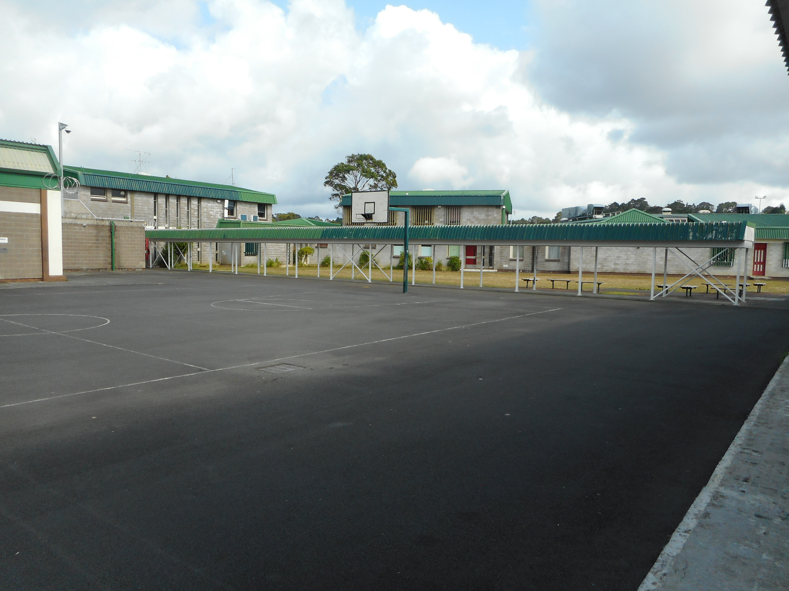 |  | 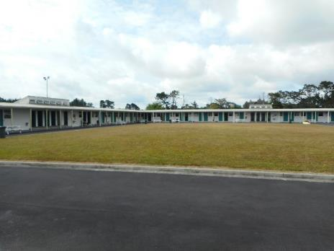
Figure 12: External yard – Units 1-5 |  | Figure 13: External yard – Unit 6

Chaplaincy
The Prison employed one FTE Chaplain and two Assistant Chaplains, supported by a group of volunteers. Services included spiritual guidance, Bible studies, Sunday service and pastoral care. Between 1 July and 31 December 2019, there were 345 recorded visits from the Prison Chaplaincy Service to provide religious or spiritual services to prisoners. Sunday services were held either at the Prison Chapel or in the units, facilitated by the Assistant Chaplains and volunteers. Prisoners in Units 12 and 13, however, were unable to attend these services due to their security classification.
The Chaplaincy team noted that access to prisoners was difficult due to early locks, site restrictions, and lack of interview spaces and escort staff. The Prison Chaplaincy Service was not well advertised in the units and prisoners had to request an appointment with the Chaplain through staff referral, which were often cancelled due to competing priorities.
Fifty-five percent of survey respondents stated they could access religious services. Only 27 percent of survey respondents in Unit 13 stated they were able to access religious services, while no survey respondents in Units 10 or 12 reported having access to religious services.

Library services
The Prison employed a 0.8 FTE Librarian and had a vacancy for one FTE Librarian. The library had a minimal selection of books for prisoners and there were no prisoners employed in the library at the time of inspection. Books were generally donated from public libraries and there was a limited range of publications available to prisoners; particularly books in Easy Read format, Te Reo Māori or foreign language books, or educational resources such as dictionaries.
Access by the Librarian to prisoners, primarily due to staff shortage and site restrictions, had significant impacts on the availability of books to prisoners. Inspectors were advised, by prisoners and staff, that the Librarian had not delivered books to Units 12 and 13 for approximately six months, while some prisoners in Units 1–5 hadn’t seen the Librarian for approximately two months.
As there was no request or catalogue system available to prisoners, they were only able to select from a limited range of books when the Librarian visited the units. On occasion, Case Managers would send library requests on prisoners’ behalf.
In contrast, Units 6 and 8 both had a dedicated library area which prisoners could freely access during periods of unlock. Prisoners worked in these areas and did a good job cataloguing and managing resources. Books were donated by local charities and organisations.
Thirty-eight percent of survey respondents reported they never used the library, with this figure rising to 100 percent in Unit 4 and 82 percent in Unit 12. Only 19 percent of all survey respondents (50 prisoners) were able to access the library more than once a week, with the majority of those respondents housed in Units 6 and 8.
While I am pleased to see that prisoners in Units 6 and 8 have good library provision, I am aware that this is not the case for most prisoners, in contravention of Rule 64 of the Nelson Mandela Rules.

Legal visits
The Prison had two dedicated legal visits booths. These booths were designed to allow lawyers and prisoners to pass legal paperwork. Staff reported that two booths was not sufficient for the amount of prisoners that required non-contact legal visits.
Legal visits could also take place in dedicated rooms in Units 11, 12 and 13, but access to these rooms was dependent on the prisoner’s security classification and staff availability.
My Inspectors observed that maximum security prisoners were handcuffed during non-contact interviews with their legal counsel. Counsel with whom Inspectors spoke expressed concern about this practice.
I share the concern regarding the handcuffing of prisoners during legal consultations. The Nelson Mandela Rules require that instruments of restraint are to be imposed only when no lesser form of control would be effective and only for the time period required to manage the risks posed by unrestricted movement. The Act and Corrections Regulations 2005 reflect these requirements.
Maximum security prisoners could only receive visits in non-contact booths. The practice was imposed for all maximum security prisoners irrespective of individual risks posed.
I consider that the application of handcuffs during legal interviews disproportionately impacted on the dignity of affected prisoners.

Visits
Visits at the Prison took place each weekend from 8.30am until 4pm. The Prison had a dedicated visitors centre. Visitors were processed through the centre which had a small children’s play area and a small café facility.
Prisoners housed in low security units received visits in a large meeting area in their respective units. These areas were clean, bright, spacious and suitable for visits.
Visits for prisoners in high and maximum security units took place in the dedicated visits centre.
The main area within the visits complex could accommodate 25 prisoners and their visitors. The maximum number of visitors who could visit a prisoner at any one time was three adults and three children. On one side of the visits area was a small children’s play area as well as a courtyard area. A partition ran through the high security visits hall; this created two separate spaces so child protection prisoner (CPP) visits could run simultaneously with general visits. My Inspectors had some concerns regarding this approach. Prisoners who had CPP status could be easily identified by visitors walking through the separate area to access toilets. Children wanting to use toilet facilities during visits were also required to walk through the separate area.
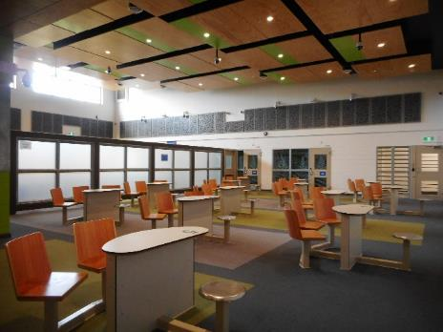 |  | 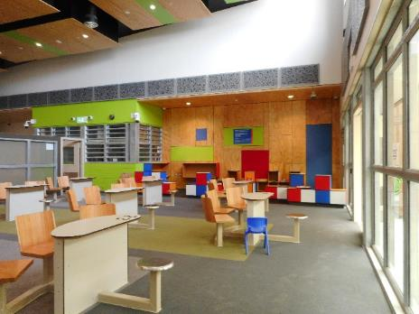
Figure 14: Visits complex |  | Figure 15: Visits complex with children’s play area
Staff reported that children who had been approved to visit a CPP undertook visits in the separate area with other CPPs present. Staff raised concerns about the appropriateness of this arrangement.
Inspectors observed a two-hour visit session which occurred on a hot day; water was not readily available to visitors or prisoners.
The visits complex contained 18 non-contact booths to facilitate maximum security and IDU prisoner visits. Non-contact booths typically only have sufficient space for one visitor, therefore this practice placed a restriction on all maximum security prisoners’ access to group whānau contact.
The visits complex contained two Audio Visual Link (AVL) facilities which enabled prisoners from out of region to maintain quality family contact. However, this area was underutilised. Two whānau rooms for special visits, including whānau hui, were also located in the visits complex. Staff reported that hui were often cancelled due to staff shortages.
Inspectors spoke with visitors who reported that visits staff were friendly and helpful. A first-time visitor with a small child reported that the visiting process had been far easier and less stressful than imagined.
Fifty-one percent of all survey respondents stated that visits started on time. Only 23 percent of survey respondents stated that they had one or more visits per week from family and friends.
In line with regulations, prisoners were not routinely strip-searched before or after visits. Prisoners were required to wear Prison issue overalls. Overalls were bright orange, zipped and secured at the back of the neck.

Training and employment
The Prison had 141 employment roles available to prisoners, however, not all positions were filled at the time of inspection. Prisoners could be employed on site in the industry workshops, café, kitchen, laundry, internal grounds, horticulture, or employed in their units. The Prison also had a number of commercial partnerships with companies to support employment in prison industries. External employment was also available for those prisoners with the necessary security clearance.
While there were a range of employment and vocational opportunities available in the Prison, the number of vacancies was high.
Thirteen prisoners were employed to work outside the Prison – ie, ‘outside the wire’ (OTW) with a further 32 OTW positions unfilled at the time of inspection. The number of OTW vacancies was due, in part, to lack of eligible prisoners – prisoners could only be employed from Units 6 and 8, where rehabilitation programmes were prioritised. The closure of Unit 9, a 60-bed reintegration unit, further limited the number of eligible prisoners available for employment.
The Prison had recently approved one prisoner for Release to Work (RTW). While this number was low, it was evident that senior management were supportive of increasing the number of opportunities for RTW.
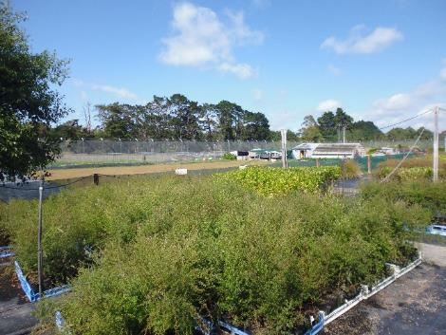 |  | 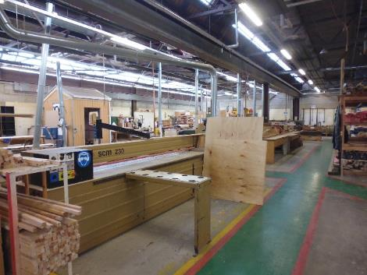
Figure 16: Nursery |  | Figure 17: Industry workshop

Inspectors assessed the number of prisoners in training, or employment, on Wednesday 29 January 2020. At the time of inspection, 35 percent of employment roles were vacant. The table below details areas of training and numbers of attendees.
Table 4: Prisoner employment on Wednesday 29 January 2020
Work area | Workplace capacity | Number on day of assessment | Prison’s comments
Kitchen | 30 | 20 | Not enough prisoners to cover kitchen duties.
Café | 3 | 2
Canteen | 2 | 2
Laundry | 5 (per shift) | 8 (2 shifts) | Not enough work.
Internal grounds | 30 | 3 | Workers employed from Unit 9, which is not in operation at present.
Nursery (Unit 8) | 20 | 20
Horticulture hub | 10 | 6 | Workers employed from Unit 9, which is not in operation at present.
E-Cycling | 10 | 9
Joinery – portacom | 5 | 4
Joinery | 10 | 10
Light engineering | 20 | 5 | Not enough work/interest/and prisoners.
Light Assembly (Unit 11) | 15 | 10
Apiculture | 15 | 14
Total | 141 | 91

Vocational training was delivered by a number of providers. Between 1 July and 31 December 2019, there were 52 graduations in accredited courses such as traffic control, forklift, first aid and site safety. Prisoners could also achieve unit standards in employment areas such as the kitchen and nursery.
Prisoners employed in industry workshops told my Inspectors that they enjoyed the training and employment opportunities available to them and were highly motivated and keen to learn. Inspectors observed positive and respectful interactions between prisoners and Instructors. Prisoners were producing quality work while developing a range of practical skills and knowledge.
I am pleased prisoners employed in industry workshops were engaged in meaningful and constructive activity, gaining valuable employment and social skills for their release.

Education
The Prison had four FTE Education Tutors and a volunteer network (facilitated by the Volunteer Coordinator) to provide educational support to prisoners.
The Prison’s Education Department offered a number of classes, ranging from basic literacy and numeracy tuition to formal qualifications such as Level 4 Certificate in Small Business. Examples of other classes included visual arts, apiculture, financial literacy, te reo Māori, and basic computer skills.
Tutors completed literacy and numeracy assessments for all prisoners within two weeks of their reception into the Prison and were notified of new arrivals through the Scheduler. Prisoners assessed as below Level 3 were offered an Intensive Literacy and Numeracy (ILN) course, while prisoners assessed as Level 3 were eligible to access secure online learning in the Prison’s computer suite. Individual tutors were provided to prisoners with literacy difficulties.
Between 1 July and 31 December 2019, 20 literacy assessments and 18 numeracy assessments were completed across the Prison. Forty-five prisoners had participated in an ILN course between 1 July and 31 December 2019, yet only five had completed the course. Senior staff advised that the reasons for low completion rates or ‘early exits’ on courses were due to unit or site transfers, behavioural reasons or prisoners not engaging.
Self-directed learning (SDL) was available to those prisoners with the necessary entry level, and serving a sentence of 12 months or more. SDL was facilitated through Te Kura and Open Polytechnic. Between 1 July and 31 December 2019, 16 prisoners had enrolled in SDL and one had completed a SDL course.
While there were a large number of educational courses available and sufficient resources in the Prison’s Education Department, it was identified that a lack of available rooms, escort staff shortages and a competitive booking system were presenting significant barriers regarding access to prisoners. Prisoners, particularly in Units 12 and 13, were afforded limited opportunities for engagement and educational activities.
Inspectors reviewed data provided by the Prison for the period 1 July to 31 December 2019, and noted that 42,483 ‘learning’ hours had been recorded across the site. This equated to an average 0.6 hours per day, per prisoner (including remand prisoners) in educational activities. Units 12 and 13 equated to an average 0.3 hours and 0.5 hours per day, per prisoner respectively.
Fourteen percent of all survey respondents reported they had access to education, with the majority of those respondents housed in Units 6 and 8. No survey respondents in Units 10 or 12 reported that they had access to education, with this figure at 10 percent and eight percent in Units 2 and 4 respectively.

Programmes
Data provided by the Prison showed that between 1 July and 31 December 2019, 260 prisoners participated in programmes to assist their rehabilitation and address offending behaviour.
The Prison provided a range of programmes including the Medium Intensity Rehabilitation Programme (MIRP), Short Motivational Programme (SMP), Short Rehabilitation Programme (SRP) as well as Maintenance. Other short courses included Parenting programmes, Head Start, Journey through Changes, and Gambling programmes.
Unit 6 ran a Drug Treatment Programme (DTP), with a focus on reducing and managing participants’ alcohol and drug use (AOD) and addressing the links between AOD use and their offending, as well as impacts on whānau.
Unit 8 operated as a Special Treatment Unit, which provided the Child Sex Offender Treatment Programme (CSOTP) and Short Intervention Programme (SIP).
When prisoners were not participating in these programmes, they were engaging in other activities including extracurricular studies, employment, recreational and educational activities. As in other Industry, Training, and Learning (ITL) spaces, a source of frustration for programme facilitators was regarding the limited access to prisoners. High and maximum security prisoners in Units 12 and 13 required higher staffing ratios and engagement could only be facilitated either in small groups in purpose-built programme rooms or individually through non-contact booths. As a result, there were minimal opportunities for rehabilitation and programmes for prisoners in Units 12 and 13 due to staffing pressures. Throughout the inspection, Inspectors did not observe the programme rooms in Units 12 or 13 being used.
Inspectors reviewed data provided by the Prison for the period 1 July to 31 December 2019, and noted that 55,572 ‘rehabilitation and reintegration’ hours had been recorded across the site. This equated to an average 0.8 hours per day per prisoner (including remand prisoners) in activities. Units 12 and 13 both equated to an average 0.05 hours per day, per prisoner.
One survey respondent commented, ‘there are insufficient rehabilitation programs for foreign national prisoners’.
Fifteen percent of all survey respondents reported they had access to programmes, with the majority of those respondents housed in Units 6 and 8. Only seven percent of survey respondents in Unit 12 and three percent in Unit 13 stated they had access to programmes.

Case management
The Case Management team comprised two Principal Case Managers (PCMs), 18 Case Managers (CMs), one Parole Board Liaison and one Scheduler. At the time of inspection there were two FTE CM vacancies. A number of staff were also on secondment or in acting roles.
Most CMs were new to their roles and some still in training, with only a small number of staff with over three years’ experience in the role. Induction and training processes for CMs had reportedly improved and CMs my Inspectors spoke with felt supported by the leadership team. Case Managers held an average caseload of around 30 to 40 prisoners.
Inspectors observed that current case management practice appeared to be task driven, with limited opportunities for engagement and meaningful interactions between CMs and prisoners. Case Managers my Inspectors spoke with expressed frustration as significant workload pressure meant that time spent with prisoners was often restricted. Case Managers did not routinely attend Right Track meetings in the units.
Between 1 July and 31 December 2019, initial contact meetings were trending at 92.5 percent, initial offender plans were at 95.8 percent, and planned contact at 90 percent. Timeframes for providing the New Zealand Parole Board with board reports was trending at 90.9 percent completion and the Six Pillars of reintegration release planning was trending at 85 percent.
The Case Management team identified that release planning was an area for improvement, due to difficulty finding accommodation and meeting reintegration needs such as OTW, Guided Release (GR) and engaging whānau and community support. However, CMs noted that there had been a recent increase in senior management support and approvals for GR, whānau hui, OTW and RTW opportunities. The implementation of the Creating Positive Pathways (CPP) initiative, which launched in August 2018, was established to support accommodation needs and had successfully placed three prisoners at the time of inspection.
Among the concerns raised by the Case Management team was the difficulty accessing prisoners, particularly in Units 12 and 13, due to a lack of available staff escorts and dedicated interview spaces. Inspectors reviewed a sample of case notes and observed throughout the inspection that multiple planned contacts with prisoners were cancelled due to custodial staffing shortages.
During the inspection, Inspectors also observed Parole Board hearing delays, Work and Income New Zealand (WINZ) appointment cancellations and other external provider appointments cancelled as a result of staffing shortages.
One survey respondent commented, ‘we need more reintegration options for people going home within one year or so. E.g. self-care, release to work, wrap around services’.
I have concerns that custodial staffing shortages and competition for interview spaces are having a detrimental impact on the reintegration and rehabilitation of prisoners, in contravention of Rule 4 of the Nelson Mandela Rules:
…Prison administrations and other competent authorities should offer education, vocational training and work, as well as other forms of assistance that are appropriate and available, including those of a remedial, moral, spiritual, social and health- and sports-based nature. All such programmes, activities and services should be delivered in line with the individual treatment needs of prisoners.

Case management for remand and long-serving prisoners
The increase of remand prisoners at the Prison had also created significant pressure for CMs, who felt under-resourced to meet the demand. Case Managers held approximately 10 remand prisoners on their caseload. After completing core functions such as initial needs assessments, CMs would then ‘unallocate’ remand prisoners from their caseload. Inspectors also observed instances where long-serving prisoners had been ‘unallocated’. Consequently, ‘unallocated’ prisoners were not being provided with end to end case management and had no direct point of contact for case management needs. Inspectors spoke with a number of ‘unallocated’ prisoners who raised frustration and confusion regarding access to CM support.
One survey respondent commented:
I have been unallocated a case manager for the reason my sentence is too long and they have a shortage of staff. So many plans I want to put into place have to be put on hold until I can see someone (whenever that may be). My case officer has no answers for any questions I have so I just give up asking.
Staff reported that ‘unallocated’ prisoners could either send a request via the kiosk (to a generic inbox) or through custodial staff. Inspectors were told that this approach was intended to alleviate workload pressure for CMs, however, it did not provide adequate safeguards for prisoners. This approach appears to be at odds with best practice case management, which supports an end to end framework.

Reintegration Coordinator
The Reintegration Coordinator (RC), based in Unit 8, was responsible for facilitating the transition for prisoners in the Special Treatment Unit to the community or their maintenance phase while residing in the unit. Following a strong multi-disciplinary team approach, the RC engaged with the therapy team, custodial staff, case management and external contacts, such as whānau and relevant agencies, to provide reintegrative support to prisoners.
The RC also facilitated GR and whānau hui for prisoners in Unit 8. It appeared that there was confusion amongst some case management staff regarding the RC’s role, as some CMs were sending all referrals to the RC, creating an overlap in work.

Guided Release
The Prison had one dedicated Guided Release (GR) CM who supported prisoners (serving over two years) with reintegrative needs in their transition back to the community. The GR CM was responsible for all GR applications from Unit 6, while the RC managed applications for Unit 8.
Prisoners had to be minimum security and within six months of the parole eligibility date (PED), or low security prisoners with a release date from the Parole Board. Reintegration activities included visiting release accommodation, opening a bank account and sitting their driving test. Inspectors observed a number of reintegration activities taking place during the course of the inspection.
Between 1 July and 31 December 2019, 55 applications for reintegration activities were raised at the Internal Advisory Panel meeting – only three applications were declined and one was deferred. Thirty of the approved applications were for GR.
I am pleased to see this recent increase in senior management support for reintegration activities in the Prison and I look forward to seeing the resulting benefits on future inspections.

Recommendations – purposeful activity and transition to the community
- I recommend that:
  - Prisoners’ access to the Chaplaincy service is improved.
  - Prisoners’ access to library services is improved.
  - Water is accessible to prisoners and their whānau during visits.
  - The Prison fill employment vacancies across the site and increase support and provision for employment and vocational training to prisoners.
  - Prisoners are able to access, in a timely manner, the range of educational and reintegration activities available in the Prison.
  - High and maximum security prisoners in Units 12 and 13 have access to educational and rehabilitation activities.
  - The practice of case management staff ‘unallocating’ prisoners from their caseload cease.

The Department of Corrections accepted recommendations 6a, 6b, 6c, 6d, 6e and 6f.
Corrections partially accepted recommendation 6g and stated:
Auckland Prison currently has the capacity to allocate all prisoners to a case manager; however, due to movements in and out of prison, new or recently returning prisoners may be unallocated for a period of time while they are waiting to be allocated to a new case manager. New or recently returning prisoners are allocated within 10 days of their arrival to Auckland Prison.
Corrections are currently working on a strategy to support the allocation of all prisoners to a case manager. As such, the addition of 20 new FTE case managers has been granted which will be distributed as a resource to assist the prisons requiring the most support. This will also help support best practice which is for all allocated prisoners to remain with the same case manager until they are released from prison or another movement purpose including transfer to another prison.
I am pleased the Department has allocated additional resource to case management and that a strategy is being developed to support the allocation of all prisoners to a case manager, including for remand and long-serving prisoners. I look forward to seeing the progress on future inspections.

Acknowledgments
I appreciate the full co-operation extended by the managers and staff to my Inspectors during their visit to the Prison. I also acknowledge the work involved in collating the information sought by the Inspectors.

- Department of Corrections’ comments on recommendations that were accepted

Recommendations – treatment
- I recommend that:
  - On-body cameras are always operational and turned on prior to use of force and footage is saved as required.
  - Use of Force paperwork is comprehensive and accurate, including when pepper spray is deployed.
  - Use of Force incidents are subject to timely and comprehensive review to ensure records align with CCTV footage.
  - The Prison Director ensures robust processes are in place to ensure incidents of Use of Force are referred to the Police in a timely manner at prisoners’ request.
  - The Prison Director develops and implements a strategy to prevent sexual assaults on prisoners.
  - The practice of ‘single unlock regimes’ ceases.
  - Time prisoners spend in the Assessment Unit should be as short as possible, and subject to ongoing assessment and review. Paths for progression out of the Assessment Unit should be clear, specific and achievable.
  - Portable telephones be made available to prisoners in the Assessment Unit as needed, including in the evenings and at weekends.
  - Constructive and purposeful activities need to be increased for prisoners in the Assessment Unit and ISU.
  - Measures are taken to ensure the privacy of prisoners in the ISU when showering or using the toilet.
  - Prisoner-centric management plans be developed to assist prisoners while they are in the ISU and on their return to mainstream units. Paths for progression out of the ISU should be clear, specific and achievable.
  - The Prison Director ensures staffing levels are consistent with those prescribed by the Department.

The Department of Corrections accepted recommendation 1a and commented as follows:
Auckland Prison took action following your inspectors’ findings. As a result, on-body cameras are checked daily and immediate remedial action is taken if the cameras are found to be not in working order. Additionally, staff are reminded by the Central Control Operators each time there is an incident, to ensure cameras are activated when required. Camera footage is saved via the S.08 process by the SERT (Site Emergency Response Team) team when required. Staff are educated on the appropriate use of on-body cameras, for use of force in Tactical Options Training. This training is provided on an ongoing basis and is used to reinforce staff understanding around tactical options. Given we have taken immediate remedial action, and we are satisfied by the ongoing provision of Tactical Options Training, we consider this recommendation is complete.
The Department of Corrections accepted recommendation 1b and commented as follows:
Auckland Prison acknowledge the importance of comprehensive, accurate use of force paperwork. Since your inspection, Auckland Prison have allocated two staff members who have been tasked with managing and overseeing use of force paperwork to ensure that all paperwork is comprehensive, accurate and completed to an acceptable standard. This will include reviewing the use of pepper spray.
Ongoing training and coaching have been provided to staff since your inspection and will continue to be given to all relevant individuals as required. Information will also be provided to all relevant staff to advise that any deployment of Individual Carry Pepper Spray (ICP) requires immediate reporting, as per any other use of force event.
The delivery of this will be ongoing, as consistent and continued messaging is key to its success. This will be delivered by way of Unit Toolbox meetings, Friday lockdown training and communications from the Tactical Options Team through organised coaching sessions.
The Department of Corrections accepted recommendation 1c and commented as follows:
Following your inspection, the Custodial Systems Manager (CSM) has been tasked with overseeing all ‘use of force’ reviews to ensure they are completed to an acceptable standard and within a timely manner. This will be standard practice moving forward at Auckland Prion with the requirement that CCTV footage be saved for each incident. Any shortfalls in paperwork identified by the CSM will result in feedback and reminders to staff around quality.
Your report identified that no direct follow up was taken following poor practice following an incident involving use of force. I wish to advise you this particular incident as outlined in your report was recorded, reported to management, and a routine review into the ‘use of force’ incident occurred. Whilst all ‘use of force’ incidents are reviewed, Auckland Prison acknowledges the timeliness of these reviews could be better.
In addition to the actions taken by Auckland Prison, Corrections’ National Office based Mental Health team has set up monthly clinical supervision to support custodial staff.
In addition to increasing the provision of staff supervision, Mental Health 101 training has been rolled out to approximately half of the staff at Auckland Prison. Other mental health and trauma informed training has also been made available and promoted across the site, with approximately 80 percent of staff taking up this opportunity.
The Department of Corrections accepted recommendation 1d and commented as follows:
The Prison Director has assigned the SERT Principal Corrections Officer (PCO) to oversee and manage all prisoner requests regarding use of force incidents to ensure that where indicated, incidents are reported to NZ Police in a timely manner. This senior oversight will provide assurance that incidents are being referred to NZ Police as required.
In addition, Corrections has recently implemented a new system for recording ‘Allegations Against Staff’ made by prisoners. This includes when they have made an allegation about the conduct of a ‘use of force’. It is expected that information about uses of force which have been referred to Police is recorded in this database. The database also helps local managers have a strong oversight of the status of any investigation of an allegation.
The system is currently active and allows for notifications to be sent to the Prison Director once an entry has been made. Due to the system being unable to create automatic reminders, the Prison Director has initiated a fortnightly check which will be conducted by the Senior Advisor to the Prison Director, to ensure appropriate timeliness with the Policy.
The Department of Corrections accepted recommendation 1e and commented as follows:
Importantly, Auckland Prison is able to accommodate all prisoners in their own cell, without the need for a cellmate. This alone reduces the risk of sexual assault.
Any risks identified through the completion of Corrections’ ‘Structured Dynamic Assessment Case-management’ (SDAC) system regarding sexual assault, will be communicated to custodial staff via Case Management to ensure appropriate risks are identified and appropriate action is taken. This includes the loading of alerts onto an individual’s file.
Case Management have been briefed by Principal Case Managers regarding what criteria they are looking for and how to escalate any occurrence. Custodial staff are also communicated with to ensure they are aware of any potential risks. Additionally, staff will be advised of the process though email communication, Unit Toolbox meetings, site briefings, and supported by custodial practice leads.
Auckland Prison has also developed an anonymous prisoner survey in conjunction with Psychological Services, specifically for prisoners at Auckland Prison. This survey has been developed and implemented to provide each prisoner the opportunity to voice any concerns or incidents they may have, in a safe and confidential way. The feedback and results from the anonymous prisoner survey will be discussed by the Senior Leadership Team with a focus on identifying any specific themes or matters that require attention, including sexual assaults on prisoners.
The Department of Corrections accepted recommendation 1g and commented as follows:
Since your inspection, Auckland Prison has designed a progression plan to aid prisoner unit placement and progression. While this plan is still in its early stages of implementation, the daily Multi-Disciplinary Team (MDT) meetings include discussions on new prisoner arrivals into the Assessment Unit to ascertain when progression can take place for individuals.
In addition to the MDT daily meetings, an amended ‘high risk prisoner’ meeting has been implemented at Auckland Prison to further discuss those on directed segregation (including those in Unit 10) and to discuss each prisoner’s suitability of any continued segregation. This meeting is chaired by the Deputy Prison Director of Auckland Prison and held twice a week. Both the Health Centre Manager and the Clinical Manager of the Intervention and Support Practice team attend these meetings.
This amended meeting allows for a more structured agenda, preparation and quick identification of those prisoners on a segregation direction (whether in the assessment unit or not). It also allows for identification of agreed approaches, interventions and behavioural observations with which to make a more informed recommendation of the prisoners next progressive/regressive step.
The Department of Corrections accepted recommendation 1h and commented as follows:
While this is an area of ongoing development at Auckland Prison, staff are willing to facilitate weekend calls as an alternative option for prisoners. This will be considered at prisoners’ request and will be facilitated within current constraints operating at site at the time of the request.
I wish to note due to Auckland Prison’s unique phone system, specialist phones have been ordered to ensure compatibility with the system. An order for the phones was placed in March 2020, and contractors have completed appropriate measurements for the building of the ‘phone trollies’ to transport the phones upon their arrival into Auckland Prison. A timeframe for delivery of the phones from the USA cannot be ascertained due to COVID-19.
The Department of Corrections accepted recommendation 1i and commented as follows:
Since your inspection, Auckland Prison has increased whānau contact in Unit 10 by providing prisoners the opportunity for AVL visits. This initiative has been targeted to prisoners who are not from the Auckland region.
Unit 10 has daily engagement with the Activities Officers who have expertise in physical activities and an Education Officer within the unit, who provides prisoners with guidance and assistance where required.
In addition, staff are involved in establishing learning pathways for new arrival prisoners and the longer-term residents within Unit 10. Daily meetings with the MDT also occur to discuss new arrivals in this unit, including what can and/or should be implemented to alleviate prisoner boredom and assist prisoners with tailored pathways to move on from Unit 10.
The use of the ISU sensory garden is contingent on the presence of custodial staff. The decision to use the garden is preceded by a discussion between the Intervention and Support Project (ISP) team and custodial staff to ensure any risks can be appropriately managed. Since January 2020 the ISP team has increased in size which will help to increase the use of the sensory garden.
In January 2020, the sensory room was in the process of being relocated. The equipment from this room has now been relocated and is used by the therapists throughout the unit as ‘mobile kits’ so the use of the equipment can be more widely available to individuals.
The Department of Corrections accepted recommendation 1j and commented as follows:
As always, Corrections acknowledges balancing the dignity and privacy of prisoners in Intervention and Support Units (ISUs) with the preservation of life presents a unique challenge.
In early 2019, we provided your office with the completed paper for consultation. You provided your feedback in late 2019 which relevant teams at Corrections have been considering. There have been active considerations of the current regulatory prohibition on privacy screening in some cells and, as a result, there may be some changes to current procedures regarding the use of cameras which will work to further improve privacy for prisoners; we are not yet in a position to provide concrete timeframes for these next steps.
Auckland Prison has advised that when the showers are in use, there are no cameras operating, which allows prisoners privacy. Prisoners in the ISU are unable to be seen by anyone, including staff, when they are in the showers. There is a discretionary wall which allows for prisoners to maintain their dignity while showering. Staff do, though, stand out front of the showers to maintain supervision. This is a necessary task given the complex and at-risk individuals who reside in this unit.
The Department of Corrections accepted recommendation 1k and commented as follows:
Since your inspection, Auckland Prison has implemented new ‘care plans’ for prisoners while in the ISU. Care Plans do not replace the Management Plans. Care Plans include more detailed input from the ISU mental health and custodial teams to identify where assistance may be required with cultural support, health needs and interventions. Care plans originated as part of the Intervention and Support Project and provide a more holistic approach to the prisoner’s management during their stay, as well as ongoing support following an ISU exit.
The Department of Corrections accepted recommendation 1l and commented as follows:
Auckland Prison’s staffing levels are currently higher than at the time of your inspection. There is a proposal to have Auckland Prison staffing levels at 105 percent to avoid staff shortages on any given day. Auckland Prison staffing levels are currently sitting at 100 percent.
Due to identified challenges related to COVID-19, Auckland Prison has adopted a new approach towards recruitment. The new approach includes recruiting against our retention rate (staff turn-over).
In the event of reduced staffing levels at Auckland Prison, the Staff Safety Plan is actioned. This includes an analysis of resources available. Additionally, a pro-active approach is taken by the Principal Corrections Officers and the Senior Leadership Team to manage absences in the workplace by forecasting rosters and providing staff disposition sheets in advance to facilitate the provision of further resource to manage staff absences.
Following any unplanned absences ‘on the day’ at Auckland Prison, the Duty Principal Corrections Officer will liaise with the Senior Leadership Team to analyse the impacts of any given absence to allow for any affected position to be resolved and allow for the appropriate staff to prisoner ratio. Consultation is also carried out with the affected staff to discuss how to mitigate the absence safely.

Recommendations – reception into prison
- I recommend that:
  - Prisoners have access to appropriate and timely reception, immediate needs and induction processes. This includes the allocation of a Case Officer within three days of arrival in a new unit.
  - Induction arrangements for foreign nationals, speakers of languages other than English, and those with literacy or communication difficulties are improved to ensure those prisoners are fully aware of the Prison’s procedures and how to access support.

The Department of Corrections accepted recommendation 2a and commented as follows:
Auckland Prison has advised that a consistent increase in available staff has resulted in an improvement in the timely induction of prisoners.
Notwithstanding this, Auckland Prison sees merit in this recommendation and has confirmed it will review the induction process (including immediate needs and other reception processes). This review will create an outline that will follow the style of induction processes in Unit 12 which will then be implemented throughout all units within Auckland Prison.
This review is currently underway and is being conducted by the Residential Managers to ensure a consistent approach in line with the good practice identified in Unit 12. This review should be completed by 2 October 2020. Implementation will take place shortly thereafter.
Auckland Prison acknowledges the important role of a Case Officer and of the importance of a prisoner being allocated to a Case Officer within the three-day timeframe. An increase in available staff as well as a proactive approach in managing staff absences in the workplace has made a positive impact in this area.
Additionally, as of 1 July 2020, the First Line of Defence (FLOD) assurance tool has been revamped. This provides assurance that all compliance type actions have either been completed or have clear rationale as to why the actions have not been completed. While the FLOD tool does not specifically cover the assigning of a Case Officer, Auckland Prison is looking to include this aspect into the induction section of the FLOD tool.
The Department of Corrections accepted recommendation 2b and commented as follows:
Staff at Corrections can declare whether they speak any other languages, and if so, this information is loaded in their profile in Corrections’ system. If Auckland Prison has available staff for the required language needed, they will be asked to support the new arrival. Auckland Prison also relies on ‘Ezispeak’ as it is an easily accessible option available to support prisoners and staff.
As your office is aware, Corrections has been working with Translation Services at the Department of Internal Affairs with the view to have key documents relating to the reception and induction process of prisoners (including at risk assessments) translated into other languages. Initially, it is envisaged that we will trial translated material in several languages at a couple of prison sites to test that we have covered all the necessary information and have conveyed the information in a user-friendly way to the intended audience. Unfortunately, we are not yet able to propose an expected timeframe for completion of this work although in recent months we have extended the scope of this work with the provision of information in Te Reo Māori and NZ Sign Language.
Once implemented, this resource will have similar value to Ezispeak in assisting staff in their duties and people in Corrections’ care.
In addition, staff provide further assistance to any prisoner with a literacy or communication difficulty, to enable them to fully understand the prison’s procedures and how to access support if needed.

Recommendations – decency, dignity and respect
- I recommend that:
  - Arrangements to improve ventilation in the high and low security units are identified, implemented and monitored to ensure appropriate temperatures are consistently achieved.
  - The serving of meals is standardised to normal hours. This would involve lunch being served any time between midday and 1.30pm and dinner to be served anytime between 5pm and 7pm.
  - Dynamic security training is provided for staff, particularly staff in Units 12 and 13.
  - The Prison ensures all transgender prisoners are treated with dignity and respect.
  - Sufficient, suitable accommodation should be provided for all prisoners with disabilities.
  - The Prison prioritise, implement and protect kaupapa Māori practices and programmes.
  - Prison management strengthens its partnership with iwi Māori, including by engaging kanohi ki te kanohi with mana whenua representatives on a regular basis.

The Department of Corrections accepted recommendation 3a and commented as follows:
Your inspectors noted that a lack of ventilation in the low and high security cells was an ongoing, unresolved problem and that Auckland Prison did not have a robust heat management strategy in place.
Since your inspection, Auckland Prison’s ventilation systems in Units 1-5 have been refurbished as part of Auckland Prisons ‘Refurbishment Project’. As a result, there has been a significant improvement to the ventilation and temperature control, which is performing in line with the NZ standards; AS/NZS 3666.2.2011 and AS/NZS 3666.4. Units 6, 8 and 9 have received electric fans at the prison’s expense. In addition, a heat management plan (Managing Site Temperature) has been implemented which focuses on these units. Please find attached as Appendix Three, a copy of the operational plan created for managing the temperature at Auckland Prison.
Additionally, contractors have been assigned to complete daily temperature checks and report back to the Operations Manager who will identify any particular areas of concerns that may require remedial action.
The Department of Corrections accepted recommendation 3c and commented as follows:
Auckland Prison has an allocated time period once a week for the upskilling and further training of staff. Guidance is also provided to staff working with prisoners, as well as a range of tools and strategies that can be used when working with prisoners. A debrief meeting is also held on a weekly basis where discussion and education is had around security and tactical options. Areas for improvement are also discussed in order to provide an opportunity for reflective practice.
Whilst Corrections does not have a policy or set process specifically for ‘dynamic security’, it is applied through custodial training and is also incorporated into ‘Cue Sensitivity’, which is key to pro-active management.
Furthermore, Auckland Prison’s new operating model is closely aligned with Hōkai Rangi with a focus on healthy and positive staff-prisoner relationships. It is envisaged staff will have the skills through education, training, leadership and support to proactively and positively engage with prisoners in constructive and purposeful conversations.
To support this effort, Ara Poutama Values Workshops are currently being rolled out across Auckland Prison. All staff members are required to complete a first workshop and then three-monthly check ins. This is an initial component of a broader plan to educate, train, lead and support our staff to positively interact with prisoners.
The Department of Corrections accepted recommendation 3d and commented as follows:
Auckland Prison acknowledges the importance of treating transgender prisoners with dignity and respect. This work sits within a wider culture of acceptance and celebration of diversity.
As you will be aware, the I.10 Management of transgender and intersex prisoners’ policy was implemented 5 March 2018. A training package was developed and made available to support the policy implementation. A subsequent review has identified facets of the policy and procedure that could be enhanced to better support transgender prisoners and staff managing them.
The Northern Region Senior Advisor Inclusion and Diversity role exists to support staff who manage prisoners in Corrections’ care who identify as non-binary or transgender, as well as to provide support to prisoners in custody.
The training for staff includes reflective and interactive sessions designed to inform and gently challenge staff’s unconscious bias, a brief history on the Rainbow Communities and the laws protecting these communities, minority stress and the difference between biological sex and gender identity. Additionally, practical issues such as; safety risk, implementing the transgender policy, operational issues and the use of pronouns and terminology are covered in a safe and supportive environment.
This training also aligns well with the values of Hōkai Rangi and treating those in our care with dignity and respect in a healing and humanising way. The intention of the staff training is to have a better understanding of what it means to be LGBTTQI+ and how Corrections can better work with those in our care.
The Department of Corrections accepted recommendation 3e and commented as follows:
Auckland Prison is currently able to accommodate Maximum and Low/Medium to Minimum security prisoners with disabilities in the new build as well as in Units 6, 8 and 9.
It is acknowledged High Security Units 1-5 do not currently have full ability to accommodate prisoners with disabilities due to these units being on split levels which require the use of stairs.
As such, the use of the wider prison network is sometimes required to ensure all prisoners with disabilities have sufficient and suitable accommodation.
Whilst we acknowledge there are constraints associated with the physical layout of High Security Units 1-5, we consider we are supporting prisoners with disabilities in other ways.
We employ the services of external contractors to ensure disability needs are met, from prosthetic needs to supporting visual and hearing defects, to support for larger scale disability needs such as wheelchair/prosthetic limb needs.
Nationally, a Senior Adviser Disabilities position has been appointed into the Health Quality and Practice team. We are also in the process of identifying the requirements for a Disability Action Plan to inform health and custodial practice. More details regarding our support for prisoners with disabilities can be found in our response to recommendation 4a.
The Department of Corrections accepted recommendation 3f and commented as follows:
Auckland Prison currently has an established Māori network for staff which involves a Tikanga group led by prisoners. The Senior Leadership Team are dedicated to this Māori network, although it is acknowledged more can be done to implement, prioritise and protect Kaupapa Māori practices and programmes.
I am pleased to advise you that since your inspection, recruitment for a Cultural Advisor position at Auckland Prison has been approved. Recruitment for this role will be underway soon and it is envisioned this individual will work closely with Auckland Prison and regional services to improve cultural support on site. Additionally, the ISP team at Auckland Prison has a Cultural Support Worker which has been in place since January 2019.
Whilst implemented prior to your inspection, Auckland Prison want to draw your attention to the following two programmes already offered on site:
‘Dynamics of Whanaungatanga’ (DoW);
The kaupapa or goal of DoW is to address, enhance and restore the Tapu (Wellbeing) of tangata (people) so that they have the Mana (power and authority) to achieve their goals in life. The programme can also be delivered to staff to assist in reinforcing the concepts and values of DoW to further support participants implementing these strategies. This has been facilitated once already and it is expected that this will be delivered again in the upcoming financial year.
‘Tikanga’
Tikanga is a motivational programme to support individuals to engage in further interventions that is based on four kaupapa; manaakitanga, whanaungatanga, rangatiratanga, and wairuatanga. This programme is delivered four times per year.
Auckland Prison aims to reintroduce daily activities including karakia to open and close meetings so that staff and Auckland Prison as a whole, can build on, and protect these practices.
Corrections also acknowledges that Kaiwhakamana and Fautua Pasefika are specified visitors that have approved access to visit prison sites to promote the wellness and wellbeing of people in our care, particularly Māori and Pasifika. Kaiwhakamana and Fautua Pasefika volunteer their time and expertise because they care deeply for the wellbeing and outlook of their people.
From now until 30 October 2020, Corrections will be engaging with Kaiwhakamana, Fautua Pasefika, our Māori and Pasifika partners, Prison Directors and others to understand their aspirations going forward. Following this, Corrections will look at options to refresh current policies to better support the underlying principles of Hōkai Rangi.
The Department of Corrections accepted recommendation 3g and commented as follows:
In addition to the Māori and Pasifika partners Kaiwhakamana and Fautua Pasefika noted above, Auckland Prison has previously engaged in Māori Advisory Board Meetings with mana whenua to strengthen the partnership with iwi Māori. Auckland Prison is refocusing efforts on strengthening this relationship. Subsequently, a meeting is scheduled for 6 October 2020.
Our Departmental strategy Hōkai Rangi, has been in place for a year now. Hōkai Rangi represents a new strategic direction for our organisation, one that builds on the good practice already occurring. This includes strengthening our relationships with mana whenua at each prison site and working with mana whenua to define what meaningful partnership looks like locally and confirm the mutual outcomes that we each seek to achieve for and with the people in our care and management. Corrections is currently planning Hōkai Rangi implementation across our entire organisation, developing measures for what performance in these areas looks like, and establishing shared governance with Māori.

Recommendations – health and wellbeing
- I recommend that:
  - Health services lead a co-ordinated approach to meeting the needs of disabled patients.
  - There be a separate health complaint system to ensure patient confidentiality.
  - The Prison reduce the wait times for, and disruption to, medical appointments for maximum and high security prisoners.
  - Health services are supported by custodial staff to provide health services without compromising patient confidentiality and privacy.
  - Processes for administering medication be reviewed to comply with the Department’s Medicines Management Policy.
  - The current practice of recording the administration of Panadol is reviewed to ensure that any administration of Panadol is documented in patients’ treatment sheets.

The Department of Corrections accepted recommendation 4a and commented as follows:
Health Services are mindful of all Health and Disability sector needs amongst our patient demographic. We employ the services of external contractors to ensure disability needs are met, from prosthetic needs to supporting visual and hearing defects, to support for larger scale disability needs such as wheelchair/prosthetic limb needs.
We tailor our approach to meet the needs of the Disability Services Consumer, as defined by the Health and Disability Commissioner, and work to maintain individuals’ ability to function independently, and maintain our support for as long as is needed.
Health Services (including Administration Support Officers) is also mindful of small changes that can be made to promote the autonomy and independence of the disability consumer, by ensuring small things that can promote reduction of pain, ease/aid mobility, and generally increase quality of life are prioritised. Health Services helps all patients in need with financial aid to purchase glasses, hearing aids, dentures, etc. COVID-19 provided an opportunity to review the information available to people in care and present it in an ‘easy to read’ format that uses images as well as words to convey messages.
Nationally, a Senior Adviser Disabilities position has been appointed into the Health Quality and Practice team. We are in the process of identifying the requirements for a Disability Action Plan to inform health and custody practice. We aim to have a draft outline of this plan completed in early 2021.
A joint working group between ACC and Corrections has been established to support continuity of care and ensure the needs of people with a disability are met. The group is initially focusing on those with an intellectual disability and will move into the traumatic brain injury space once the initial work is completed to strengthen the relationship between Corrections and ACC.
In addition, a cross sector group has met recently to gather feedback on services available, gaps in service provision, and opportunities to improve the journey of a person with disabilities through Corrections. Work is also underway to review all health specific information with a view to making it suitable for varying levels of health literacy.
The Department of Corrections accepted recommendation 4b and commented as follows:
Alongside Corrections PC.01 complaints process, prisoners are able to request to see any Health Services staff member for any health service-related issues, and this will be attended to by the Assistant Health Centre Manager (or Health Centre Manager) if specifically needed. Outcome notes will be documented in MedTech; however, it is important to note that custodial staff will not be made aware of any health details or information relating to any prisoners. This ensures confidentiality of health information is maintained.
Patients are able to access a confidential process for submitting health complaints. Health complaint forms are available, and these can be handed to any Health Services staff member or lodged in the box where health request forms are placed. This ensures Health Services are the only staff accessing these complaints.
The Health Centre Manager is responsible for ensuring patients are aware of this process, through continuous reminders. However, it is not uncommon for a patient to put a complaint on the bottom of a Health Request Form which is then managed in a way which ensures patient privacy is maintained.
In August 2020 the Patient Complaint policy was reviewed by the Health Senior Leadership Team, and it was agreed the policy needed to simplify the complaints process and ensure the resultant health process supports patient privacy. The policy has been released as an interim policy so improvements can be made to the process during a trial phase.
A working group is to be established to review the interim policy, strengthen the health complaints process and remove all reference to the PC.O1 process. This will require a practice change for both custodial and health staff and ensuring that prisoners utilise the health complaints process. A finalised Patient Complaints policy is expected by 31 March 2020. This will include ensuring the policy reflects the intent of Hōkai Rangi and mechanisms for electronically collecting, recording and tracking health complaints.
In conjunction with the release of this interim policy, communication with prisoners will be undertaken to encourage the use of the health complaints process. This will also be communicated to Health Services staff at all prisons to ensure they understand the process and know how to support people in our care with complaints about the health service.
The Department of Corrections accepted recommendation 4c and commented as follows:
If for any reason, health clinics cannot be held, this is escalated to the Health Centre Manager while custodial constraint issues are escalated to senior prison management.
Auckland Prison runs extra dental clinics if and when required and calls in mobile/emergency x-ray services to augment the normal imaging processes if needed (normally expedited by emergency), and is working more closely with the District Health Board (DHB) to promote Telehealth to ensure our high/maximum classification patients do not miss out on DHB appointments due to constraints in staffing.
In addition, some services are ‘unit based’, such as physiotherapy, thus ensuring if there are reduced security escorts, unit staff can carry out movements. The nursing team and ASOs also help co-ordinate moving services across the site to better accommodate prisoners and staff.
National Office is exploring the collection of data to better understand the factors which contribute to avoidable cancellations and missed appointments. We recognise not all cancellations are avoidable; however, when there is information available on what contributes to missed appointments, improvement opportunities can be actioned.
Monthly reporting by the HCMs will ensure National Office have an overall view of emerging trends and issues that may require more intensive review. This monthly reporting has started and will continue as an ongoing continuous improvement mechanism.
Additionally, National Office Senior leadership (Health and Custody) now meet on a monthly basis to discuss operational matters, providing an opportunity to escalate and progress to solutioning as required.
The Department of Corrections accepted recommendation 4d and commented as follows:
The Auckland Prison Operating Model currently employs three permanent full-time custodial staff based in the Health Unit Monday – Friday to support the Health Services team.
Following this report, the Acting Health Centre Manager and Operations Manager have arranged to meet frequently to review and improve staff performance ensuring they operate discreetly during the consultation and treatment of prisoners by Health professionals, thus ensuring prisoner/patient confidentiality & privacy is maintained.
All prisoner health information and treatment notes are maintained on a separate computer based system (MedTech) that is not accessible to custodial staff.
Staff do provide safety and protection for health services and stakeholders in the Health Centre, and the same applies when Health staff are operating out of our Unit dedicated treatment spaces.
The Auckland Prison Custodial team has worked with the Act Health Centre Manager and her team to bring about the introduction of video consultation in conjunction with the DHB providers; this is managed in such a way as to give total privacy to the prisoner and the treating physician during consultations.
The Department of Corrections accepted recommendation 4e and commented as follows:
The process of administering medication was reviewed in early 2020, and following the identification of shortfalls, a new, enhanced process has been implemented to reduce risks surrounding the administration of medication and ‘proof’ of patient identity. The following modes of patient identification are utilised;
a) Photo Muster Report to be printed off IOMS for the unit, just prior to the medication round. This is the most up to date record of location of patients the prison holds and is accurate and well maintained by custodial staff.
b) all charts have updated IOMS patient pictures on them, and
c) where medication blisters are taken to units independently of Alpaca file (medication pack), the medication is placed into named bags with current IOMS patient pictures on them.
Self-administered medication (SAM) contracts are updated and current, to enable administration of weekly medication or other items the patient can hold to help promote autonomy. Although not noted in policy, the nursing team make provision by conducting a review with the patient to confirm they are still wishing to receive their medication in this manner.
As part of the wider Health Services work programme a business case for an electronic medication administration system is under development. It has a number of alert mechanisms built into the electronic system to ensure there is patient consent and confirmation the right patient is receiving the right medication, at the right dose and at the right time.
At a National level, medication administration has been recognised as a critical risk, and work is underway to mitigate this risk.
The medication work plan includes:
• National Medication Management Audit (March 2021)
• Review and amendments to the Medication Management Policy with review expected to be completed by March 2021
• Electronic solutions
o E-Administration - electronic medication chart linked to MedTech patient record which reduces the need for handwritten amendments and transcribing.
o E-prescribing – eliminates paper-based prescriptions, populates into the electronic medication chart, and prescriptions sent directly to the pharmacy.
• A review of the medication management electronic learning package which is completed during the initial orientation.
• Development of competency assessment process which will include annual updates and observation of practice for all staff.
• The evaluation of the electronic solutions and changes to practice and policy includes an additional audit to ensure practice changes are understood and embedded across all health centres.
The Department of Corrections accepted recommendation 4f and commented as follows:
Auckland Prison’s current practice regarding the management of Panadol has greatly improved in outer units (6, 8 and 9) and in units 1 to 5. There are still areas to work on which include maintaining records around Paracetamol usage in the units. Unit PCOs and Residential Managers provide reminders to staff to uphold the requirement of recording Panadol administration in the units. Any concerns are escalated to senior management at the prison.
This is an ongoing work in progress at Auckland Prison which will be supported by work being completed at a national level.
A review at a national level of the processes regarding the administration of Panadol in July 2020 highlighted several systemic issues around the way in which this is managed. Section 16 of the Medicine Management Policy (MMP), clearly defines the roles and responsibilities for custody and health staff. The review identified the Prison Operations Manual (POM) did not provide guidance for custody staff.
Custody and health staff are currently nearing the completion of a programme of work to address the issues identified in the review. This includes the release of clear policies in the Wellness section of the POM, changes to the current Panadol Log to support safe administration within a 24-hour period, and clear information when custodial staff should contact health staff.
Further work is underway on patient-focused information for display, and the development of education packages for custodial staff to ensure a level of competence is achieved and monitored on an ongoing basis. Health processes have also been strengthened to ensure administration of Panadol is captured in the patient’s clinical record and ensuring medication reconciliation occurs daily.
The Medication Management Policy is under review and is expected to be completed by December 2020. Once the policy has been reviewed, any changes to the policy will be communicated to all Health Services staff, including those at Auckland Prison.
There will be a requirement for all health staff to complete the Medication Management e-learning module if it has been more than three years since they joined Health Services, and the annual e-learning module for all other staff. Review of this process will be included in the annual Performance Development Conversations for each staff member.

Recommendations – protective measures
- I recommend that:
  - Compliance with standards for complaints handling should be improved, including ensuring that complaint forms are made available to all prisoners, support for prisoners who have difficulties with verbal or written communication is provided, and that descriptions of the complaints process are accessible across all Units.
  - The Prison establish and implement a daily search matrix.
  - Remand prisoners are provided with more opportunities to engage in constructive activities on a daily basis.

The Department of Corrections accepted recommendation 5a and commented as follows:
Since your inspection, Auckland Prison has addressed this matter through working with regional support teams and the Office of the Inspectorate (Inspectorate) regarding best practice when managing complaints.
As a result, some PC.O1 complaint forms have been reopened and answered in a more satisfactory manner and a spreadsheet has been created for collating and recording Official Information Act (OIA) and Privacy Act requests in each unit. This allows staff to collate, track and respond in a more detailed and robust way. In addition, comprehensive training is being supplied to staff to assist with responding to prisoner requests. Through this ongoing training, staff have been made aware of the importance of providing PC01 complaint forms and request for information forms to all prisoners.
The Department of Corrections accepted recommendation 5b and commented as follows:
A new site-wide search matrix for Auckland Prison is currently being developed, although it is not yet implemented as Auckland Prison is currently in the initial stages of developing a programme to support this new search matrix. We are not currently in a position to communicate a timeframe for this work.
Other prison sites across New Zealand have been canvassed; however, their search matrix is not compatible with Auckland Prison. The expertise in developing this programme has been ongoing, and it is expected this matrix will be implemented by October 2020.
Recommendations – purposeful activity and transition to the community
- I recommend that:
  - Prisoners’ access to the Chaplaincy service is improved.
  - Prisoners’ access to library services is improved.
  - Water is accessible to prisoners and their whānau during visits.
  - The Prison fill employment vacancies across the site and increase support and provision for employment and vocational training to prisoners.
  - Prisoners are able to access, in a timely manner, the range of educational and reintegration activities available in the Prison.
  - High and maximum security prisoners in Units 12 and 13 have access to educational and rehabilitation activities.
  - The practice of case management staff “unallocating” prisoners from their caseload cease.

The Department of Corrections accepted recommendation 6a and commented as follows:
Auckland Prison is pleased to confirm it now has six Assistant Chaplains who work alongside our two full time Chaplains. This has increased the capacity of the one on one visits for prisoners in Units 10, 12 and 13.
From July 2019 to June 2020, Auckland Prison has delivered 502 individual chaplaincy sessions along with 193 chaplaincy group services.
There are currently 114 volunteers who work to deliver chaplaincy services on the weekends at Auckland Prison. Auckland Prison acknowledges the availability of non-contact booths continues to be a limitation, due to the limited number of booths available and the need for these booths for other purposes.

The Department of Corrections accepted recommendation 6b and commented as follows:
Since your inspection, Auckland Prison has appointed two full-time librarians which has resulted in the improvement of the library delivery service.
Librarians are allocated specific units within Auckland Prison and offer a library delivery service to ensure all prisoners have available access to library books.
The prison has recently purchased ‘Access It’ (library book processing software) to reduce the administrative time involved in issuing and returning books.
In addition, during COVID-19, the library offered a library request system to ensure the continuation of book delivery.
The Department of Corrections accepted recommendation 6c and commented as follows:
Since your inspection, a water cooler has been installed in the visitor room for all prisoners and their whānau.
The Department of Corrections accepted recommendation 6d and commented as follows:
Since your inspection, Auckland Prison has opened Unit 9, which allows for additional capacity to fill outside the wire employment positions due to the increase of availability of prisoners that now meet the required criteria.
Auckland Prison has increased capacity for external workers outside of the wire by opening lower to minimum security beds in Unit 9. Those beds not originally available in the intervention focussed units (Unit 6 and 8) were unavailable to those residing in the high security areas as Lows or Minimum as the units required bed capacity for programmes and not external work. When Unit 9 opened, it allowed for Units 6 and 8 to offer up more vacant positions and for Unit 9 to fill their capacity with appropriately assessed prisoners from inside the main Prison.
Auckland Prison has placed a refreshed emphasis on completing and presenting Release to Work applications to the Advisory Panel. At present, there are some remaining vacancies; however, work is underway for Principal Instructors and Principal Corrections Officers to work collaboratively to fill these vacancies.
Further working outside the wire employment opportunities will become available shortly with the extension of the Light Electrical Workshop to include a separate, additional operation. This will create a further ten jobs for prisoners.
Auckland Prison acknowledges staffing numbers of Instructors have been inconsistent; however, it is pleasing to note that, the vacant positions of a Principal Catering Instructor and a Catering Instructor, have now been filled.
The Department of Corrections accepted recommendation 6e and commented as follows:
Working outside the wire and Guided Release reintegrative activities occur in our outer units due to eligibility criteria. Additionally, as noted under recommendation ‘5c’, the following activities have been available for remand prisoners since January 2020;
• Vocational training in Health and Safety
• Ongoing Intensive Numeracy and Literacy classes
• Ongoing Art Studio Workshops
• Life 101 life skills programme
• Parenting Programmes
• Tikanga programme
• Brainwave
• Storytime
• Pasifika Identity Programme.
Additionally, Auckland Prison runs education activities such as Education Assessments, Learning Pathways and self-directed learning offered throughout all units. Auckland Prison also has education tutors to support prisoner learning. In addition, secure on-line learning is available in most units other than the outer units and Vocational Courses occur in units where waitlists show the most need or in the Industry areas.
The Department of Corrections accepted recommendation 6f and commented as follows:
All Units have access to educational and rehabilitation activities; however, Auckland Prison acknowledges access to non-contact spaces continues to be an issue.
In Units 12 and 13, a variety of educational programmes are currently offered. In Unit 13, there are Secure Online Learning classes run by an Education Tutor. This is enabling prisoner Curriculum Vitae’s to be written along with assistance with obtaining a driver’s licence.
Other programmes such as Parenting, Life 101, Dynamics of Whanaungatanga (DOW) and the Open Polytechnic Foundations Skills programme are run in Unit 13. Auckland Prison is also actively considering the placement of the new “Kick for the Seagulls” programme for our rangatahi wing in Unit 13. This is a programme that offers both physical activity and a Level Two Certificate.
Self-directed learning is also available in both units, along with a 1:1 Head Start programme which is run by internal Programme Facilitators. Additionally, 1:1 volunteer activity occurs on a need by need basis, which includes activities such as 1:1 literacy and numeracy and art. Maximum Security prisoners have access to self-directed learning, the Open Polytechnic Foundation Skills programme, volunteers and a limited amount of 1:1 education activities.
- Survey feedback: The Prison
A total of 482 questionnaires were given out and 269 were returned (56 percent).

Section 1: About you
How old are you?
Under 21 | 1 | 0.4%
21-29 | 73 | 28%
30-39 | 89 | 34%
40-49 | 57 | 22%
50-59 | 27 | 10%
60-69 | 12 | 5%
>70 | 3 | 1%
Total | 262

What is your ethnicity?
Asian & Pacific Islander | 43 | 16%
Kiwi/New Zealander | 26 | 10%
Māori | 76 | 29%
Māori/Pākehā | 61 | 23%
NZ European/Pākehā | 35 | 13%
Other | 20 | 8%
Total | 261

Is English your first language?
Yes | 199 | 77%
No | 61 | 23%
Total | 260

Are you sentenced / on remand?
Sentenced | 184 | 70%
Remand Accused | 8 | 3%
Remand Convicted | 64 | 25%
Other | 5 | 2%
Total | 261

Is this your first time in prison?
Yes | 79 | 30%
No | 182 | 70%
Total | 261

Do you have children under 18?
Yes | 137 | 56%
No | 108 | 44%
Total | 245

Section 2: Respect and dignity
Please answer the following questions about the  wing/unit you are currently living on: | Yes | Yes % | No | No %
Are you normally offered enough clean, suitable clothes for the week? | 170 | 66% | 87 | 34%
Are you normally able to have a shower every day? | 253 | 96% | 10 | 4%
Do you normally receive clean sheets every week? | 176 | 68% | 83 | 32%
Can you get cell cleaning materials every week? | 208 | 80% | 53 | 20%
Can you normally get your stored property, if you need to? | 123 | 50% | 125 | 50%

What is the food like here?
Very Good | 17 | 6%
Good | 62 | 23%
Average | 124 | 47%
Bad | 36 | 14%
Very Bad | 26 | 10%
Total | 265

Does the shop (P119) sell a range of goods to meet your needs?
Yes | 65 | 25%
No | 194 | 75%
Total | 259

Section 3: Complaint process
Is it easy or difficult to get a complaint form (PC01)?
Easy | 74 | 28%
Difficult | 111 | 42%
Don't Know | 79 | 30%
Total | 264

Please answer the following questions about making a complaint in this Prison: | Yes | Yes % | No | No %
Do you know how to make a complaint? | 214 | 81% | 50 | 19%
Have you made a complaint in this prison? | 105 | 40% | 157 | 60%
Do you feel complaints are dealt with fairly? | 41 | 19% | 179 | 81%
Do you feel complaints are dealt with promptly? (within three days) | 40 | 18% | 177 | 82%
Do you have faith in the complaints system? | 38 | 17% | 189 | 83%
Would you make a complaint if the situation warranted it? | 196 | 80% | 48 | 20%

Section 4: Safety
Have you ever felt unsafe in this Prison?
Yes | 105 | 41%
No | 153 | 59%
Total | 258

Do you feel unsafe in this Prison at the moment?
Yes | 54 | 21%
No | 205 | 79%
Total | 259

Have you been victimised in this Prison?
Yes | 104 | 44%
No | 132 | 56%
Total | 236

Have you been victimised in this Prison?
If Yes, was it another prisoner? | 24 | 18%
If Yes, was it a group of prisoners? | 32 | 24%
If Yes, was it member of staff? | 51 | 28%
If yes, was it both staff and prisoners? | 27 | 20%
Total | 134

Assaults
Physical assaults | Yes | Yes % | No | No %
Have you been assaulted in this Prison? | 90 | 35% | 165 | 65%
Did you report the incident? | 24 | 29% | 60 | 71%

Sexual assaults | Yes | Yes % | No | No %
Have you been sexually assaulted while in prison? | 32 | 13% | 219 | 87%
If yes, did it happen at this Prison | 12 | 40% | 18 | 60%
Did you report the incident? | 12 | 44% | 15 | 56%

Please answer the following questions about staff in this Prison: | Yes | Yes % | No | No %
Is there a member of staff you can turn to for help if you have a problem? | 176 | 69% | 78 | 31%
Do most staff treat you with respect? | 188 | 75% | 64 | 25%
Do you know who your case manager is? | 151 | 58% | 111 | 42%
Did you meet with your case officer within the first week? | 93 | 36% | 167 | 64%
Do you see your case officer at least once a week? | 46 | 18% | 215 | 82%

Section 5: Health
When you first arrived in this Prison, did staff ask you if you needed any help with any of the following? | Yes | Yes % | No | No %
Reading and writing? | 55 | 21% | 208 | 79%
Not being able to smoke? | 68 | 26% | 192 | 74%
Loss of property? | 47 | 18% | 212 | 82%
Feeling scared? | 65 | 25% | 195 | 75%
Gang problems? | 57 | 22% | 202 | 78%
Contacting family? | 112 | 43% | 150 | 57%
Money worries? | 45 | 17% | 213 | 83%
Feeling worried/upset/needing someone to talk to? | 74 | 29% | 185 | 71%
Health problems? | 155 | 60% | 105 | 40%
Getting phone numbers approved? | 140 | 54% | 121 | 46%
Did you have any problems when you first arrived? | 107 | 42% | 148 | 58%

When you arrived in this Prison, were you given a phone call
(within 24 hours)?
Yes | 129 | 51%
No | 126 | 49%
Total | 255

Did you have any problems with alcohol when you first arrived?
Yes | 67 | 25%
No | 196 | 75%
Total | 263

Have you received any help with alcohol problems here?
Yes | 48 | 18%
No | 213 | 82%
Total | 261

Did you have any problems with drugs when you first arrived?
Yes | 102 | 39%
No | 160 | 61%
Total | 262

Do you have any problems with drugs now?
Yes | 41 | 16%
No | 219 | 84%
Total | 260

Have you received any help with any drug problems here?
Yes | 61 | 23%
No | 200 | 77%
Total | 261

Is it easy to get Illegal drugs here?
Easy | 41 | 19%
Difficult | 180 | 81%
Total | 221

Is it easy to get tobacco/ cigarettes here?
Easy | 44 | 20%
Difficult | 177 | 80%
Total | 221

How easy or difficult is it to see the Doctor?
Easy | 77 | 30%
Difficult | 144 | 56%
Don't Know | 38 | 15%
Total | 259

How easy or difficult is it to see the Nurse?
Easy | 138 | 53%
Difficult | 90 | 35%
Don't Know | 31 | 12%
Total | 259

How easy or difficult is it to see the Dentist?
Easy | 50 | 19%
Difficult | 151 | 59%
Don't Know | 57 | 22%
Total | 258

What do you think of the quality of the health service from the Doctor?
Good | 117 | 45%
Bad | 71 | 27%
Don't Know | 71 | 27%
Total | 259

What do you think of the quality of the health service from the Nurse?
Good | 138 | 54%
Bad | 71 | 28%
Don't Know | 45 | 18%
Total | 254

What do you think of the quality of the health service from the Dentist?
Good | 80 | 31%
Bad | 84 | 33%
Don't Know | 94 | 36%
Total | 258

What do you think of the overall quality of the health service?
Good | 114 | 45%
Bad | 97 | 38%
Don't Know | 42 | 17%
Total | 253

Physical disability
Do you have a physical disability?
Yes | 59 | 23%
No | 194 | 77%
Total | 253

Do you feel supported with your disability needs?
Yes | 13 | 24%
No | 42 | 76%
Total | 55

Emotional/mental health issues
Do you feel you have any emotional well-being/ mental health issues?
Yes | 140 | 55%
No | 115 | 45%
Total | 255

Do you feel supported with your emotional/ mental health needs?
Yes | 35 | 27%
No | 94 | 73%
Total | 129

Section 6: Purposeful Activity
Seventeen percent of respondents reported not being involved in any activity. Eighty-three percent of respondents reported being involved in one or more activities.
Are you currently involved in any of the following activities?
Prison job | 144 | 34%
Vocation or skills training | 41 | 10%
Education (including basic skills) | 58 | 14%
Offending behaviour programmes | 66 | 15%
CIE employment | 41 | 10%
Release to work | 6 | 1%
Not involved in any of these | 72 | 17%
Total | 428

Are you able to access Cultural activities?
Yes | 73 | 31%
No | 163 | 69%
Total | 236

Are you able to access Religious activities?
Yes | 129 | 55%
No | 105 | 45%
Total | 234

Do you get at least one hour fresh air daily? (minimum entitlement)
Yes | 203 | 80%
No | 51 | 20%
Total | 254

How often do you use the Library?
More than once a week | 50 | 19%
Once a week | 18 | 7%
Less than once a week | 80 | 31%
Never | 99 | 38%
Don't want to use it | 12 | 5%
Total | 259

On average, how many times do you go to the Gym each week?
More than 5 | 15 | 6%
3 to 5 | 86 | 34%
1 to 2 | 18 | 7%
Never | 107 | 42%
Don't want to use it | 26 | 10%
Total | 252

On average, how many hours do you spend out of your cell on a weekday? (Please include time at education, at work, showers etc.)
8 hours + | 31 | 12%
6 to less than 8 hours | 62 | 24%
4 to less than 6 hours | 70 | 27%
2 to less than 4 hours | 52 | 20%
Less than 2 hours | 40 | 16%
Total | 255

External Communication
Have you had any problems with sending or receiving mail?
Yes | 137 | 53%
No | 122 | 47%
Total | 259

Have you had any problems getting access to the telephones?
Yes | 112 | 44%
No | 145 | 56%
Total | 257

Do you usually have one or more visits per week from family and friends?
Yes | 58 | 23%
No | 198 | 77%
Total | 256

Is it easy for your family and friends to visit you here?
Yes | 94 | 38%
No | 151 | 62%
Total | 245

Do visits start on time?
Yes | 97 | 51%
No | 92 | 49%
Total | 189
- Prison population demographics
The demographics of the prison population are set out below. Please note that the following figures, as at 2 March 2020, were supplied to the Inspectors by the Prison. Where information was requested but not supplied, the relevant cell is empty.
Status | Under 18s | 18 to 20 year olds | 21 to 65 year olds | 66 and over
Sentenced | 0 | 1 | 362 | 6
Recall | 0 | 0 | 0 | 0
Awaiting deportation | 0 | 0 | 0 | 0
Remand accused | 0 | 0 | 14 | 0
Remand convicted | 0 | 1 | 138 | 1
Total | 0 | 2 | 514 | 7

Ethnicity | Under 18s | 18 to 20 year olds | 21 to 65 year olds | 66 and over
Pākehā | 0 | 2 | 83 | 5
Māori | 0 | 3 | 267 | 3
Pasifika | 0 | 3 | 113 | 0
Asian | 0 | 0 | 23 | 1
Other | 0 | 1 | 9 | 0
Total | 0 | 9 | 495 | 9

Sentenced prisoners | Under 18s | 18 to 20 year olds | 21 to 65 year olds | 66 and over
Less than 12 months | 0 | 5 | 159 | 1
12 months to less than 2 years | 0 | 1 | 30 | 0
2 years to less than 4 years | 0 | 3 | 252 | 4
4 years to less than 10 years | 0 | 0 | 44 | 3
10 years and over (not life) | 0 | 0 | 29 | 0
Total | 0 | 9 | 514 | 8

Security category | Under 18s | 18 to 20 year olds | 21 to 65 year olds | 66 and over
Minimum | 0 | 0 | 80 | 6
Low | 0 | 1 | 41 | 1
Low-Medium | 0 | 0 | 63 | 2
High | 0 | 0 | 109 | 1
Maximum | 0 | 3 | 69 | 0
Total | 0 | 0 | 80 | 6

Main offence | Under 18s | 18 to 20 year olds | 21 to 65 year olds | 66 and over
Violence against the person (including Firearm)
Sexual offences
Burglary
Robbery (including Aggravated Robbery)
Theft & handling (including receiving)
Fraud and forgery
Drug offences
Other (includes arson, perverting the course of justice, driving offences)
Total

Gangs (including affiliated) | Under 18s | 18 to 20 year olds | 21 to 65 year olds | 66 and over
Black Power | 0 | 0 | 21 | 0
Head Hunters MC | 0 | 0 | 14 | 1
King Cobras | 0 | 0 | 7 | 0
Bandidos | 0 | 0 | 1 | 0
Hells Angels MC | 0 | 0 | 0 | 0
Highway 61 MC | 0 | 0 | 0 | 0
Mongrel Mob | 0 | 0 | 21 | 0
Nomads | 0 | 0 | 4 | 0
Tribesmen MC | 0 | 0 | 5 | 0
Killer Beez | 0 | 0 | 16 | 0
Other | 0 | 4 | 48 | 0
Total | 0 | 4 | 137 | 1

- Legislative framework
In 2007 the New Zealand Government ratified the United Nations Optional Protocol to the Convention against Torture and Other Cruel, Inhuman or Degrading Treatment or Punishment (OPCAT).
The objective of OPCAT is to establish a system of regular visits undertaken by an independent national body to places where people are deprived of their liberty, in order to prevent torture and other cruel, inhuman or degrading treatment or punishment.
The Crimes of Torture Act 1989 (COTA) was amended by the Crimes of Torture Amendment Act 2006 to enable New Zealand to meet its international obligations under OPCAT.

Places of detention – prisons
Section 16 of COTA defines a “place of detention” as:
“…any place in New Zealand where persons are or may be deprived of liberty, including, for example, detention or custody in…
(a) a prison …
Ombudsmen are designated by the Minister of Justice as a National Preventive Mechanism (NPM) to inspect certain places of detention under OPCAT, including prisons.
Under section 27 of COTA, an NPM’s functions include:
- to examine the conditions of detention applying to detainees and the treatment of detainees; and
- to make any recommendations it considers appropriate to the person in charge of a place of detention:
  - for improving the conditions of detention applying to detainees;
  - for improving the treatment of detainees; and
  - for preventing torture and other cruel, inhuman or degrading treatment or punishment in places of detention.

Carrying out the OPCAT function
Under COTA, Ombudsmen are entitled to:
- access all information regarding the number of detainees, the treatment of detainees and the conditions of detention;
- unrestricted access to any place of detention for which they are designated, and unrestricted access to any person in that place;
- interview any person, without witnesses, either personally or through an interpreter; and
- choose the places they want to visit and the people they want to interview.
Section 34 of COTA provides that when carrying out their OPCAT function, Ombudsmen can use their Ombudsmen Act (OA) powers to require the production of any information, documents, papers or things (even where there may be a statutory obligation of secrecy or non-disclosure) (sections 19(1), 19(3) and 19(4) OA). To facilitate his OPCAT role, the Chief Ombudsman has authorised inspectors to exercise these powers on his behalf.

More information
Find out more about the Chief Ombudsman’s OPCAT role, and read his reports online: ombudsman.parliament.nz/opcat.

- Glossary
Canteen | Canteen, also known as P119, is a list of items available to prisoners for purchase.
CMS | Custodial Management System
CMs | Case Managers
Dispensary | For the purpose of this report, a dispensary is a room where medications, including controlled drugs, are stored.
HCAs | Health Care Assistants
HRAT | High Risk Assessment Team
IHA | Initial Health Assessment
IOMS | Integrated Offender Management System
MedTech | The Prison’s electronic health management system
MIRP | Medium Intensity Rehabilitation Programme
P119 | Canteen, also known as P119, is a list of items available to prisoners for purchase.
PC01 | The prison’s general complaints system
PERFs | Purposeful Engagement Referral Forms
RFPS | Regional Forensic Psychiatric Service
RHT | Reception Health Triage (RHT) is the first opportunity that health services staff have to obtain health information about prisoners who may need health services while they are in prison. The purpose of the RHT is to ensure that the prisoner’s immediate health needs are clinically addressed in a timely manner. The RHT is completed on the day of reception.
RO | Receiving Office
RO | Reintegration Officer
SERT | Site Emergency Response Team
SRU | Separation and Reintegration Unit

108 beds were closed at the time of inspection (operating capacity 572).
The Assessment Unit is where prisoners subject to directed segregation could be located.
One-hundred and eight beds were closed at the time of inspection (operating capacity 572).
Auckland West Division and the Special Treatment Units remained operational.
Auckland Prison PPP is a ‘Design, Build, Finance and Maintain’ contract and is unique in that it also includes the maintenance of an existing facility. Custodial operations are not included in the contract and are operated by the Department of Corrections.
See: https://www.fletcherconstruction.co.nz/projects/community/auckland-prison
Only two low security units (6 and 8) were operational at the time of inspection.
2010 Focus visit – areas of inspection were material conditions, activities, medical services and staffing.
Inspectors were not on site on Saturday 1 February 2020.
See Appendix 3 for the Prison population demographic (as at 28 January 2020).
Some prisoners declined a survey form.
The survey gives prisoners the opportunity to raise their concerns as well as acknowledging what is working well. Responses to the survey should be used as a tool toward open communication with the client group (prisoners) and predicting future behaviour and feeling.
The survey used during this inspection is based on Her Majesty’s Inspectorate of Prisons (HMIP) prisoner survey, provided with their permission.
Our inspection methodology is informed by, but not limited to, the Standard Minimum Rules for the Treatment of Prisoners (the Nelson Mandela Rules), the Association for the Prevention of Torture’s publication ‘Monitoring Places of Detention’, the New Zealand Bill of Rights Act 1990 (NZBORA), the Corrections Act 2004 and Corrections Regulations 2005.
Eighteen instances of use of force took place in the SNU between 1 July and 31 December 2019.
A requirement of the use of force process as set out in the Prison Operations Manual.
Remedial action could include senior staff addressing issues directly with staff and the delivery of targeted training.
Medtech is the electronic clinical information system.
UN Convention against Torture, Article 16(1): “Each State Party shall undertake to prevent in any territory under its jurisdiction other acts of cruel, inhuman or degrading treatment or punishment which do not amount to torture as defined in article I, when such acts are committed by or at the instigation of or with the consent or acquiescence of a public official or other person acting in an official capacity. In particular, the obligations contained in articles 10, 11, 12 and 13 shall apply with the substitution for references to torture of references to other forms of cruel, inhuman or degrading treatment or punishment.”
Tactical options and de-escalation training.
Segregation is the restriction or denial of a prisoner’s opportunity to associate with other prisoners (refer section 57 of the Act).
Directed Protective Custody is a type of segregation. Segregation is the restriction or denial of a prisoner’s opportunity to associate with other prisoners (refer section 57 of the Act).
Nelson Mandela Rules, Rule 44 refer.
Rule 50 provides that: ‘Searches shall be conducted in a manner that is respectful of the inherent dignity and privacy of the individual being searched, as well as the principles of proportionality, legality and necessity.’
For prisoners on directed segregation.
For prisoners on directed protective custody.
These took place at the start of the morning shift (8am), again at 11.30am and just before the end of the shift between 4.30 and 5pm.
2018 – 2022.
I have recently been informed the Department has closed down the Intervention Support Project.
Waitematā District Health Board.
Light assembly workshop.
A dry cell is used for prisoners to prevent the concealment or disposal of unauthorised items (s102 Corrections Act). It contains nothing but a mattress on a concrete plinth. Prisoners do not have free access to toilet facilities or drinking water.
UN Convention against Torture, Article 16(1): “Each State Party shall undertake to prevent in any territory under its jurisdiction other acts of cruel, inhuman or degrading treatment or punishment which do not amount to torture as defined in article I, when such acts are committed by or at the instigation of or with the consent or acquiescence of a public official or other person acting in an official capacity. In particular, the obligations contained in articles 10, 11, 12 and 13 shall apply with the substitution for references to torture of references to other forms of cruel, inhuman or degrading treatment or punishment.”
The Intervention and Support Project: A new approach to preventing self-harm and suicide in prison. March 2018. See: https://www.corrections.govt.nz/resources/newsletters_and_brochures/corrections_works/2018/corrections_works_march_2018/the_intervention_and_support_project_a_new_approach_to_preventing_self-harm_and_suicide_in_prison
A prolonged stay is defined by the Department as an admission lasting 30 days or longer.
Data was provided for August 2019, September 2019, October 2019, November 2019 and January 2019.
Data taken from the Department’s Integrated Offender Management System (IOMS).
Prisoner on prisoner assault, prisoner on staff assault, and use of force.
Numbers provided by the Prison indicated the following number of voluntary prisoners in each unit: Unit 2 (47), Unit 5 (47), Unit 6 (49), Unit 8 (58), Unit 10 (3), Unit 11 (44) and Unit 13 (64). Off Site Transfers (8).
Rostered vacancies are allocated shifts which cannot be filled due to staff shortages.
Unit 5 – Roster PCO and four Custodial Officers’ rostered but only two staff were on the Unit at the time of inspection. No contingency was in place.
Calculated by dividing the average 2019 Establishment hours (420.64) by the average 2019 FTE hours (386.1 hours) and converting the sum into a percentage (0.9178 to 8.22).
A Residential Manager, the Deputy Prison Director and the permanently appointed Prison Director who was on a long-term secondment to the Prison.
The Prison conducted 24 tests in January 2020 and 21 in February 2020.
The Department Custodial Standards of Practice – Drug Testing.
Parole board supervisory duties were required three days each month.
IOMS is the Department’s computerised operational database.
The Department of Corrections’ comments on recommendations 1a, 1b, 1c, 1d and 1e can be found in Appendix 1.
A breakdown of arrivals, transfers and releases for the month of February 2020 was provided by the Prison.
FIRST security provide escort and custodial services to a number of prisons, courts and police stations in the Auckland Region.
Information from Corrections Business Reporting and Analysis (COBRA).
Immediate Needs Assessments must be completed within four hours of a prisoner’s arrival. There are three exceptions to this standard: remand prisoners going to court and returning the same day (unless they return as a sentenced prisoner); sentenced prisoners who go to court on further charges but return the same day after having the charges deferred; and prisoners transferring to prisons within the same vicinity. Custodial Standards of Practice – Immediate Needs Assessments.
Problems included, but were not limited to, health, literacy, drugs and alcohol, property and contacting family.
Initial reviews are completed by reviewing all available documents and records including any existing prisoner files from earlier sentences before the induction interview. Prison Operation Manual.
Reception Risk Assessments must be completed within four hours of a prisoner’s arrival at a prison.
Induction Interviews must be completed within 72 hours of a prisoner being received into the Prison, and details entered in Integrated Offender Management Sysytem (IOMS). Custodial Standards of Practice.
Ezispeak is a free telephone-based interpreting service provided by the Office of Ethnic Communities, used by a number of government agencies.
Language Line closed permanently on 30 September 2019.
The role of the Case Officer includes looking after the prisoner, ensuring he is aware of routines and arrangements in the Unit and supporting and encouraging him to make positive use of his time in custody.
The Department Custodial Standards of Practice – Case Officer Assignment.
The Department of Corrections’ comments on recommendations 2a and 2b can be found in Appendix 1.
This includes the Assessment Unit (Unit 10) and the Special Needs Unit (Unit 11).
The Department reports at the time of inspection cell grills had been damaged by prisoners in these units, and this enabled items to be thrown through the damaged grills. Following the inspection, all food and waste was removed and the area water blasted.
Dynamic security depends on an alert group of staff who interact with, and who know, their prisoners; staff developing positive staff-prisoner relationships; staff who have an awareness of what is going on in the prison; fair treatment and a sense of “well-being” among prisoners; and staff who make sure that prisoners are kept busy doing constructive and purposeful activities that contribute to their future reintegration into society. This concept is often described as dynamic security. See: https://www.unodc.org/documents/justice-and-prison-reform/UNODC_Handbook_on_Dynamic_Security_and_Prison_Intelligence.pdf.
Including Units 10–13.
Hōkai Rangi is the new Department of Corrections overarching strategy that runs from 2019-2024. The strategy ultimately aims to lower the proportion of Māori in the care of the Department to a level that matches the Māori share of the general population.
Ara Poutama Aotearoa defines ‘Kaiwhakamana’ as: Kaumātua who have access to prisons to enable the wellness and well-being of their people. Kaumātua is intended to be applied in its broadest sense to include Kaumātua, kuia, tohunga, and others who are commended by their own people.
The Department reports since the inspection recruitment for a cultural advisor position at the prison has been approved. The advisor will work closely with the prison and regional services to improve cultural support on site. The Department states work is underway to build sustained, authentic relationships with mana whenua.
The Department of Corrections’ comments on recommendations 3a, 3c, 3d, 3e, 3f and 3g can be found in Appendix 1.
Nursing staff identified 312 prisoners with additional needs. Lists provided predominantly identified prisoners with a history of drug addiction, depression, schizophrenia and traumatic brain injuries.
Cornerstone is an accreditation programme specifically designed by the Royal New Zealand College of General Practitioners for general practices in New Zealand.
Initial Health Assessments must be completed within 24 hours, 10 days or 30 days of the RHS depending on the urgency and acuteness of a patient’s health needs. Custodial Standards of Practice.
The approximate wait times were 13 days for Units 1–5, seven days for Units 6 and 8, nine days for Units 10 and 11, 16 days for Unit 12 and 23 days for Unit 13.
GP clinics ran from 1pm to 4pm on Monday, 9am to 12pm on Tuesday, Wednesday and Friday, and 9am to 12pm on Thursday.
The number of custodial staff present during consultations varied depending on the security classification of the patient.
Rule 31 provides that: “The physician or, where applicable, other qualified health-care professionals shall have daily access to all sick prisoners, all prisoners who complain of physical or mental health issues or injury and any prisoner to whom their attention is specially directed. All medical examinations shall be undertaken in full confidentiality.”
For the purposes of this report, a dispensary is a room where medications, including controlled drugs, are stored.
The Department of Corrections’ comments on recommendations 4a, 4b, 4c, 4d, 4e and 4f can be found in Appendix 1.
The Departments’ Custodial Standards of Practice states: ‘The prisoner must be interviewed within 3 working days of the complaint being registered in IOMS’.
Data as provided by the Prison.
Survey comments were from respondents in various units.
Corrections complaint categories: conduct issues, prisoner personal matters, prisoner conditions, prisoner management and unknown/other. ‘Other’ is a sub category across all complaints categories.
Analysis of the data showed that ‘staff conduct and attitude’ had received the most complaints (97), after the attribution of 28 complaints previously categorised as ‘other’. While previously accounting for only 10 percent of all prisoner complaints, ‘staff conduct and attitude’ in fact, comprised 29 percent of complaints. ‘Communications’ complaints remained the second ranking category, rising from 85 to 94, (an increase of 12 complaints). ‘Prisoner requests’ became the third ranking category, rising from 63 to 84 (an increase of 21 – rising from fourth to third ranking). ‘Prisoner management’ complaints became the fourth ranking category, rising from 61 to 74 (an increase of 13 – rising from fifth ranking to fourth ranking).
Designed as part of the new build.
Corrections Intelligence provides prisoners’ names to regional Senior Advisors and the Regional Commissioner.
Prison Operations Manual (POM) – C.0.1.Res. 10 National Mail Monitoring Guidance Last updated 06 Dec 2019.
Misconducts by month: July 2019 (67), August (111), September (90), October (85), November (93), and December (91).
Misconducts by unit: Unit 1 (36), Unit 2 (22), Unit 3 (15), Unit 4 (11), Unit 5 (31), Unit 6 (4), Unit 8(6), ISU (3), Unit 10 (152), Unit 11 (56), Unit 13 (93) and Unit 12 (108).
Remand population on 28 January 2020 via COBRA. Remand accused (15) and remand convicted (142).
Unit 1 housed 13 remand prisoners, Unit 2 housed 1 remand prisoner, Unit 4 housed 47 remand prisoners, Unit 5 housed 43 remand prisoners Unit 10 housed 3 remand prisoners, Unit 11 housed 14 remand prisoners, Unit 12 housed 12 remand prisoners, Unit 13 housed 23 remand prisoners.
On 28 February 2020, the Department of Corrections advised my office of their proposal to introduce a security classification system for people on remand.
The tool classifies remand accused and remand convicted prisoners into two categories – Level 1 (high) and Level 2 (low).
Remand accused prisoners in maximum security units were subject to a basic yard-to-cell regime, whereas remand accused prisoners in other units had longer periods of unlock and access to more association.
Report is available at: https://tbinternet.ohchr.org/Treaties/CAT-OP/Shared%20Documents/NZL/CAT_OP_NZL_1_7242_E.pdf
Units 12 and 13 had two non-contact rooms in each unit for 90 prisoners.
The Department of Corrections’ comments on recommendations 5a and 5b can be found in Appendix 1.
Inspectors conducted a full muster check of the Prison on the morning of Wednesday 5 February 2020 to identify how each prisoner was spending their time (including if they were locked or unlocked).
A number of wings remain locked so that staff can be redeployed to unlock other wings.
For example, unlocked Friday morning with no unlock on Friday afternoon due to staff training. No unlock until Saturday afternoon as a result of a rolling unlock.
Corrections Business Reporting and Analysis (COBRA) system. This number includes visits from volunteers and Assistant Chaplains.
High and maximum security prisoners required higher staffing ratios and engagement could only be facilitated through non-contact booths.
Lawyer, Psychologist, and Case Management appointments were prioritised.
Rule 64 of the Nelson Mandela Rules provides that: ‘Every prison shall have a library for the use of all categories of prisoners, adequately stocked with both recreational and instructional books, and prisoners shall be encouraged to make full use of it’.
The Nelson Mandela Rules, Rules 47 and 48 refer.
See Corrections Act 2004, sections 83 and 87; see also Corrections Regulations 2005, Regulation 124 and Schedule 5.
Some staff would provide water at the request of visitors.
The Assessment Unit also had an AVL facility.
This number included internal employment and external employment outside the Prison.
Prison industries included Joinery, Portacom, light engineering, light assembly and the nursery.
Minimum or low security sentenced prisoners with previous internal work party experience. M.04.08.02 Work Parties. Prison Operations Manual.
Unit 9 was closed 28 March 2019 due to custodial staffing shortages.
As provided by the Prison, including comments.
This list is not exhaustive.
Corrections Business Reporting and Analysis (COBRA) system.
Units 12 and 13 had only two non-contact rooms available on each Unit for 90 prisoners.
The Maintenance Programme is a relapse prevention programme for offenders who have already completed a rehabilitative programme.
The DTP is a six-month intervention, comprising two phases: treatment and maintenance.
The CSOTP is a 32-week intensive, group-based intervention comprising eight modules over three phases.
The SIP is a 12-week intervention for low recidivism risk child sex offenders. If required, the prisoner may then be placed on the CSOTP.
The Department promotes Right Track as supporting staff to take the right action with prisoners at the right time, by knowing what is going on in their lives and encouraging them to make positive use of their time in custody.
Case Managers will meet with every new prisoner on their caseload within 10 working days of allocation.
An initial or transitional offender plan must be finalised within 40 working days of the initial reception date.
Case Managers will undertake face-to-face contact with a prisoner based on their individual risk, need, and responsivity barriers.
Data from Case Management Standards of Practice home page.
Accommodation, education and training, employment, whānau and community support, skills for life and Oranga.
CPP is a four-year trial co-designed by Corrections and Ministry of Social Development to provide 250 additional public housing places, so that people exiting prison with an unmet housing need are able to access stable accommodation. The initiative will also include a wraparound support service to help those offenders sustain their tenancy.
During the inspection, my Inspectors observed an external support worker, who had travelled a considerable distance to the Prison, being turned away from a scheduled appointment in Unit 12 as a result of staffing shortages.

